The Perfect Serodiagnostic Target: Trichomonas vaginalis STD as Model
John F. Alderete, PhD, School of Molecular Biosciences, College of Veterinary Medicine, Washington State University, Pullman, WA 99164, USA

Abstract (300 word limit)
A rapid, sensitive and accurate serodiagnostic for the number one, non-viral sexually transmitted infection caused by Trichomonas vaginalis is needed for screening both women and men. Such a test will also permit determining the true incidence and prevalence of this STI. Presently there exists the invasive antigen-detection OSOM™ Trichomonas Rapid Test (Seskui Diagnostics)—a lateral flow, immuno-chromatographic Point-of-Care test that works only for women. During the course of our investigations of the relation between T. vaginalis and prostate cancer, we obtained sera from women and men highly reactive to the highly immunogenic trichomonad protein α-actinin protein unique to this protist. IgG to this protein was not detected among uninfected controls. The availability of sera allowed us to test the hypothesis that the identification of epitopes to other immunogenic proteins of T. vaginalis would permit the construction of novel, chimeric recombinant proteins that would be a perfect target for a serum IgG diagnostic for both women and men. We then identified the immunogenic metabolic enzymes fructose-1,6-bisphosphate aldolase (A), α-enolase (E), and glyceraldehyde-3-phosphate dehydro-genase (G). Some epitopes of these enzymes were found to have little or no sequence identity to other eukaryotes, yeasts, and microbial pathogens. We constructed a new version of an earlier chimeric recombinant String-Of-Epitopes (SOE) protein consisting of 15-mer peptides within which were epitopes of A, E, and G. This chimeric protein, now referred to as AEG::SOE2, was detected by ELISA with highly reactive sera of women and men, but not control, negative serum lacking antibody to T. vaginalis. This approach lends itself to the creation of highly specific immunogenic targets for both detection of serum antibody in patients, and such targets may also be future subunit vaccine candidates.

Trichomonas vaginalis
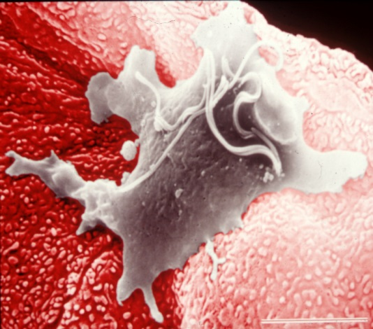
Recent Publications (minimum 5)
- Sutcliffe, S., J.F. Alderete, C. Till, P.J. Goodman, A.W. Hsing, J.M. Zenilman, A.M. DeMarzo, and E.A. Platz. 2009. Trichomonosis and subsequent risk of prostate cancer in the prostate cancer prevention trial. Int’l J. Cancer. 124:2082-2087. PMCID: 19117055.
- Stark, J.R., G. Judson, J.F. Alderete, V. Mundodi, A. Kucknoor, E.L. Giovannucci, E.A. Platz, S. Sutcliffe, K. Fall, T. Kurth, J. Ma, M. Stampfer, and L. Mucci. 2009. Trichomonas vaginalis infection and prostate cancer incidence and mortality: a prospective study in the physician’s health study. J. Nat. Cancer Inst. 101:1-6. PMCID: 19741211.
- Neace, C., and J.F. Alderete. 2013. Epitopes of the highly immunogenic Trichomonas vaginalis α-actinin are serodiagnostic targets for both women and men. J. Clin. Microbiol. 51:2483-2490. Doi: 10.1128/JCM.00582-13. Epub 2013 Apr 24. PMCID: 23616456.
- Neace, C., and J.F. Alderete. 2013. Identification, Characterization, and Synthesis of Peptide Epitopes and A Recombinant Six-Epitope Protein for Trichomonas vaginalis diagnosis. ImmunoTargets and Therapy, 2:91-103. PMCID: 27471691.
- Alderete, J.F. 2017. Epitopes within recombinant α–actinin protein is serodiagnostic target for Trichomonas vaginalis sexually transmitted infection. Heliyon J.3:e00237.
http://dx.doi.org/10.1016j.heliyon.2017.e00237.


Biography
Dr. Alderete received his PhD from The University of Kansas in 1978 at the age of 28. He did postdoctoral research at The University of North Carolina at Chapel Hill. He was at the University of Texas Health Science Center at San Antonio for 30 years before taking a positon at Washington State University. He has published 140 scientific articles and 63 book chapters, invited articles, and press releases. His work has been presented at 157 scientific conferences, and he has given seminars at 90 colleges and universities worldwide. He has served in National Institutes of Health Study Sections, Boards of Scientific Counselors, and National Advisory Councils. He has been a member of several National Academy of Medicine panels. Email: alderete@vetmed.wsu.edu

