Spatiotemporal variability of drinking water quality and the associated health risks in Southwestern towns of Ethiopia
Tadesse Sisay^{1, 2*}, Abebe Beyene¹, Esayas Alemayehu³
¹Department of Environmental Health Sciences and Technology, College of Health Sciences, Jimma University, P.O.Box: 378, Jimma, Ethiopia
²Department of Environmental Health, Wollo University, P.O. Box 1145, Dessie, Ethiopia
³Jimma Institute of Technology (JiT), Jimma University, P.O.Box: 378, Jimma, Ethiopia

Abstract
The failure to provide safe drinking water services to all people is the greatest development setback of the 21st century including Ethiopia. Potential pollutants from various sources are deteriorating drinking water quality in different seasons and associated health risks were not clearly known.
We determined seasonal and spatial variations of urban drinking water characteristics and associated health risks in Agaro, Jimma and Metu towns, Southwest Ethiopia. Seventy-two samples were collected during dry and rainy seasons of 2014and 2015. The majority (87.4%) of physicochemical parameters was found within the recommended limits. However, free residual chlorine in Jimma and Agaro town water sources were lower than the recommended limit and negatively correlated with total and faecal coliform counts (r=-0.585 and -0.638). A statistically significant differences were observed at pH, turbidity and total coliform between dry and rainy seasons (p<0.05). A Kruskal Wallis H test revealed a statistically significant difference in electrical conductivity, total hardness, fluoride, iron and faecal coliform across the study towns (P<0.05). The Agaro town water source was the highest in fluoride concentration (3.15 mg/l). The daily exposure level for high fluoride concentration in Agaro town was estimated between 0.19 to 0.41 mg/kg-day and the average cumulative hazard index of fluoride were > 3.13 for all age groups. Water quality variations were observed in all conventional water treatment systems in the rainy season and further research should focus on its optimization to safeguard the public.

Recent publications
Sisay T., Beyene A., Alemayehu E. (2017). Assessment of drinking water quality and treatment plant Efficiency in southwest Ethiopia. Journal of Environmental Science Pollution Research, 3(3), 208–212, http://www.jacsdirectory.com/jespr.
Sisay T., Beyene A., Alemayehu E. (2017). Spatiotemporal variability of drinking water quality and the associated health risks in Southwestern towns of Ethiopia. Journal of Environmental Monitoring and Assessment, 189:569, tthp://rdcu.be/wQ4D
Sisay T., Gizaw E., Alemayehu E. 2004. Examination of Bactriological and Physical Quality of Raw and locally bottled Milk in cafeterias of Jimma Town. Ethiopian Journal of Health Sciences, Vol 15, No 2, issue No 1029-1857, original article
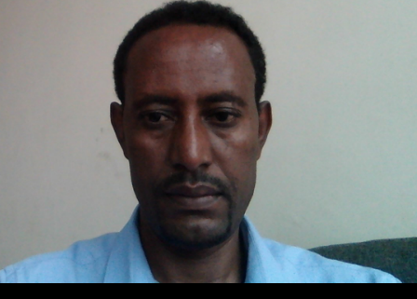

Biography
Tadesse has expertise in delivering Environmental health services in public service sector, immunization services in WHO and worked as STOP polio volunteer in Democratic republic of Laos. He worked as a lecturer and department head for environmental health department and a dead for college of medicine and health science, Wollo University, Ethiopia. His commitment in all institutions was consistent and energetic.
During his PhD study at Jimma University, he did his research on “conventional drinking water treatment plants and water supply services in Ethiopia: integrated performance assessment of seasonal and spatial variations”. Two of the articles published and graduated in 2018.
His research focus on the drinking water treatment plan and supply system evaluation and associated health risks using the model developed by USEPA (USEPA 2008)
Customer satisfaction and their willingness to pay for water supply services and overall performance of the drinking water supply services in Ethiopia was evaluated.

Email: tadessebizu@yahoo.com / tadessebizu@gmail.com

Comments
Thank you for your invitation, and if the article is not much with your conference interest, please feel free to contact me.
I need to learn a lot from worldwide expertise, if you accept my article or as participant.
Thank you so much!

