Severe Alcohol Withdrawal Syndrome: Development of a Risk Stratification Tool and Alternative Treatment Pathway to Support Early Hospital Discharge
Dr. George Benson, RN ProfD, NHSGGC United Kingdom
Statement of the problem: Patients who have alcohol dependence syndrome (ADS) are admitted to hospital just in case they develop severe alcohol withdrawal syndrome (SAWS). The primary alcohol reason for hospital attendance is alcohol withdrawal syndrome (AWS). AWS spans a spectrum that ranges from mild to severe and approximately 10% of patients who have ADS will experience SAWS when they stop drinking. However with no tools available to quickly stratify ADS severity and low risk of SAWS the numbers of short to zero stay hospital admissions are on the increase. The purpose of this study was to develop an AWS risk stratification tool that could identify and support staff to safely discharge low risk patients from the emergency department avoiding unnecessary admission. Methodology & theoretical orientation: The study was conducted in three parts. First: a systematic literature review to identify the variables linked to SAWS development. Second: a retrospective cohort study investigating the statistical significance of these variables in the development of SAWS and third: the development of a risk stratification tool. Findings: Three variables: Glasgow Modified Alcohol Withdrawal Scale (GMAWS), hours since last drink, and Fast Alcohol Screening Test (FAST) were statistically significant and displayed excellent predictability in identifying low risk of SAWS and high risk of SAWS. Conclusions & significance: A simple risk stratification tool was developed using variables collected in the emergency department that would help clinicians to identify those at low risk of SAWS and support their discharge home. Recommendations; to implement the tool into the emergency department for the purpose of early discharge and referral into a home supported alcohol detoxification on day of discharge for patients at low risk of SAWS.
Recent Publications
1.Feeney, C., Harrison, A., Eike, J., Mathew, R., Shirley, S., Indhu, S. And Carter, C. R. (2015). A Simplified Protocol for the Treatment of Alcohol Withdrawal. Journal of Addiction Medicine, 9 (6), 485-490.
2.Goodson, C. M., Clark, B. J. and Douglas, I. S. (2014). Predictors of Severe Alcohol Withdrawal Syndrome: A Systematic Review and Meta- Analysis. Alcoholism Clinical and Experimental Research, 38 (10), 2664-2677.
3.Information Services Division (ISD) Scotland. 2017. Information Service Division. (Available from www.isdscotland.org).
4.Maldonado, J. R., Sher, Y. and Ashouri, J. F. (2014). The “Prediction of Alcohol Withdrawal Severity Scale” (PAWSS): Systematic Literature Review and Pilot Study of a New Scale for the Prediction of Complicated Alcohol Withdrawal Syndrome. Alcohol, 48, 375-90.
5.McPherson, A., Benson, G. and Forrest, E.H. (2012). Appraisal of the Glasgow and Management of Alcohol Guideline: A Comprehensive Alcohol Management Protocol for use in General Hospitals. Quarterly Journal of Medicine, 105 (7), 649-56.
6.Pecoraro, A., Ewen, E., Horton, T., Mooney, R., Kolm, P., McGraw, P. and Woody G. (2013). Using the AUDIT-PC to Predict Withdrawal in Hospitalized Patients. Journal of General International Medicine, 29 (1), 7-9.
7.Sutton, L. J. And Jutel, A. (2016). Alcohol Withdrawal Syndrome in Critically Ill Patients: Identification, Assessment, and Management. Critical Care Nurse, 36 (1), 28-39.
8.Vardy, J., Keliher, T., Fisher, J., Ritchie, F., Bell, C., Chekroud, M., Clarey, F., Blackwood, L., Barry, L., Paton, E., Clark, A. and Connelly, R. (2017). Quantifying Alcohol-Related Emergency Admissions in a UK Tertiary Referral Hospital: A Cross-Sectional Study of Chronic Alcohol Dependency and Acute Alcohol Intoxication. British Medical Journal Open. (Available from http://bmjopen.bmj.com).


Dr. George Benson has his experience in alcohol and drug assessment and treatment. George has been involved in the development and implementation of guidelines for the recognition and treatment of alcohol and drug use disorders. Georges work has been influenced by research, education and practice as a nurse, manager and educator. The current project George is involved in is based on 4 years of academic study and over 25 years of practical experience, developing a model of alcohol detoxification that transcends secondary and primary care. The approach provides patients with the most appropriate treatment at time of need as opposed to availability linking them into community alcohol treatment services best equipped to address their physical and psychological association with alcohol promoting recovery and prolongation of life. George.benson2@ggc.scot.nhs.uk
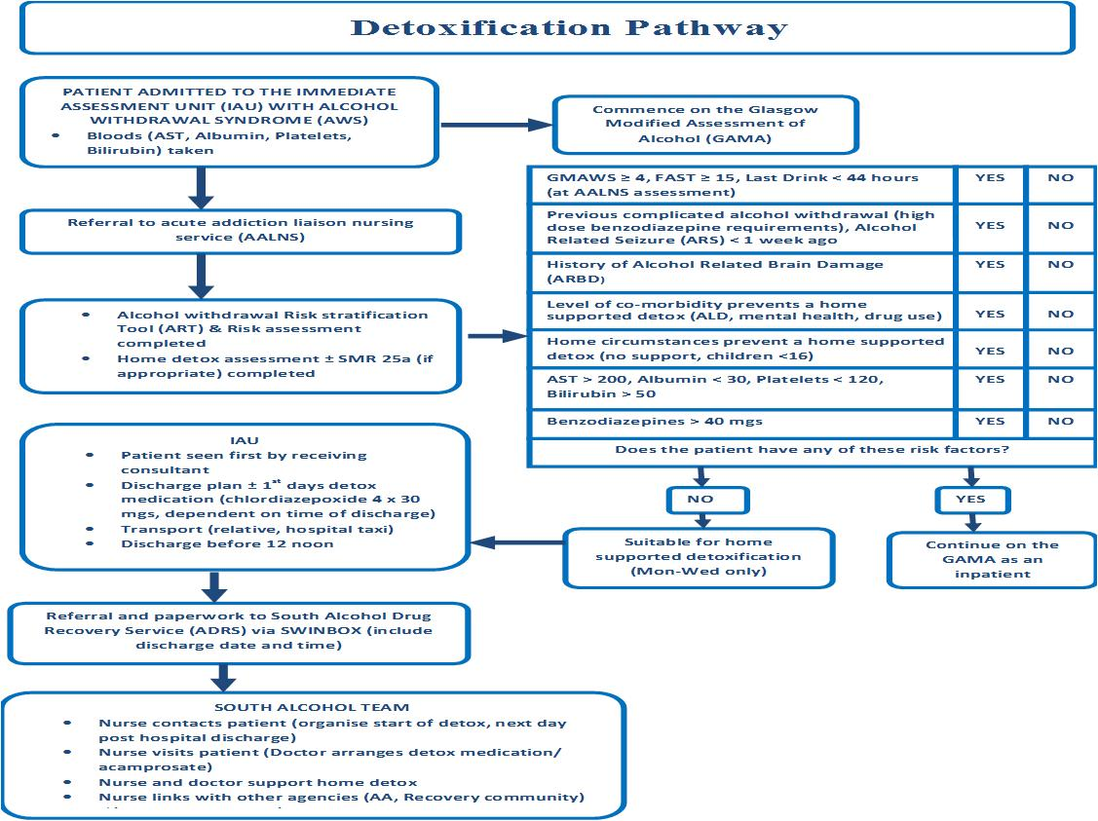

Figure 1. Alcohol detoxification pathway for people presenting at the emergency department of NHS Greater Glasgow & Clyde (NHSGGC)

