Artificial Intelligence in Mental Health Services:
Current Challenges and Future Opportunities
Lu Hua Chen^{1,2}, Tatia M.C. Lee^{1,2}

¹ Department of Psychology, the University of Hong Kong
² The State Key Laboratory of Brain and Cognitive Sciences, the University of Hong Kong

Abstract (not more than 300 words)

Currently, according to the World Health Organization, around 450 million people have affected by mental/ neurological disorders worldwide, with 150 million people suffering from Depression, 25 million people suffering from Schizophrenia, and 90 million people suffering from Drug/Alcohol Dependency, etc. Being one of the most detrimental disorders, mental disorder which accounting for 1/3 functional disabilities is causing numerous family and social economic burdens. While, the appearance of Artificial Intelligence (AI) based on multidimensional datasets has shed new lights on mental health services, from disease risk assessment and diagnosis to prediction of treatment outcome and relapse. For example, the Predicting Response to Depression Treatment Test (PReDicT Test), a smartphone based application which is in its clinical trial to guide treatment in patients with Depression, should initiate significant alteration in the standard antidepressant treatment if successful. Autism, the other example, can be faster screened and diagnosed by AI with 100% sensitivity and 94% specificity. The multidimensional datasets may cover subjects’ information of blood tests, neuroimaging results, symptom records, early life adversities, stressful life events, as well as lifestyle factors, like sport and nutrition. Therefore, machine learning, a computational strategy utilized by AI, is still under developing to incorporate those enormous information to fulfil the proposed research goal and objective. Although there are numerous challenges and risks, AI can still offer a promising future in improving mental health services with careful supervision and navigation.

Keywords—Artificial Intelligence, Machine Learning, Mental Health, Multidimensional Dataset.

Professional Biography (100-150 words)

Dr. Chen is currently a Research Officer at Department of Psychology, the State Key Laboratory of Brain and Cognitive Sciences, the University of Hong Kong, Hong Kong. She got her PhD degree from the University of Hong Kong in 2012 and then she was awarded a post-doctoral research fellowship to work in Department of Psychology, the University of Hong Kong. So far, she has been awarded a number of prizes, like the “Best Free Paper Award” in Hong Kong College of Psychiatrists (HKCPsych) International Mental Health Congress, the “Travel Award” for attending World Life Science Conference held in Beijing, the “Best Paper Award” for an oral presentation at the Hong Kong Croucher Foundation Conference, and the “Best Poster Presentation Award” at the International Master Class on Ageing.

Recent Publications (up to 5)

- Wang BB, Bao SY, Zhang ZG, Zhou XY, Wang J, Fan YH, Zhang Y, Li Y, Chen LH, Jia YZ, Li J, Li MX, Zheng WH, Mu N, Wang LQ, Yu Z, Wong DSM, Zhang YL, Kwan J, Mak, HKF, Ambalavanan A, Zhou SR, Cai WW, Rouleau GA, Yang WL, Rogaeva E, Ma X, George-Hyslop, PS, Chu LW, Song YQ. A rare variant in MLKL confers susceptibility to ApoE ɛ4-negative Alzheimer’s disease in Hong Kong Chinese population. Neurobiology of Aging, 2018, 68:160.e1-7.
- Chan MH, Leung PW, Ho TP, Hung SF, Lee CC, Tang CP, Cheung SK, Ching FY, Chan F, Chen LH, Garcia-Barcelo M, Sham PC. Are psychiatric comorbidities and associated cognitive functions related to treatment response to methylphenidate in boys with attention-deficit/hyperactivity disorder. Neuropsychiatric Disease and Treatment, 2017, 11(13):1071-1080.
- Leung PW, Chan JK, Chen LH, Lee CC, Hung SF, Ho TP, Tang CP, Moyzis RK, Swanson JM. Family-based association study of DRD4 gene in methylphenidate-responded Attention Deficit/Hyperactivity Disorder. PLoS One, 2017, 12(3):e0173748
- Chen LH, Kao PY, Fan YH, Ho DT, Ha JC, Chu LW and Song YQ. The genetic polymorphisms in estrogen metabolic pathway associated with risks of Alzheimer’s disease: evidence from a southern Chinese population. Journal of the American Geriatrics Society, 2017, 65(2):332-339.
- Chen LH, Kao PY, Fan YH, Ho DT, Chan CS, Yik PY, Ha JC, Chu LW and Song YQ. Polymorphisms of CR1, CLU and PICALM confer susceptibility of Alzheimer’s disease in a southern Chinese population. Neurobiology of Aging, 2012, 33(1):210.e1-7.

Paste your Photograph here

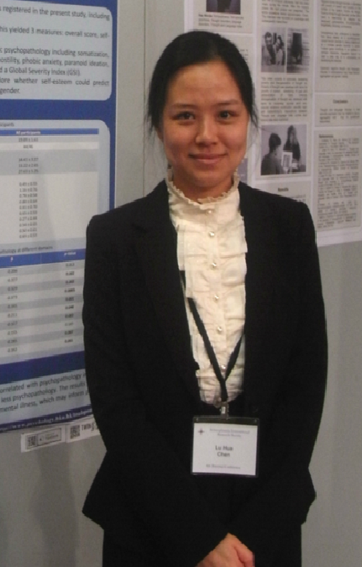

Email Id:
Presenting author details
Full name: Dr. Lu Hua CHEN
Contact number: +852-39178621
Twitter account:
Linked In account:
Session name/ number: Mental Health
Category: (Oral presentation/ Poster presentation): Oral presentation

Any Comments:

