ANATOMICAL MODELS VS NON-TACTILE DISTANCED LEARNING IN OTOLARYNGOLOGY TEACHING
Authors:
Dr Aashish Pandya, MBBCh
Cardiff Medical School, Cardiff University, Heath Park Way, Cardiff, CF14 4YU
Dr Dylan Mistry, MBBCh
Cardiff Medical School, Cardiff University, Heath Park Way, Cardiff, CF14 4YU
Mr David Owens
University Hospital Wales, Heath Park Way, Cardiff, CF14 4XW

Abstract (300 word limit)
Introduction
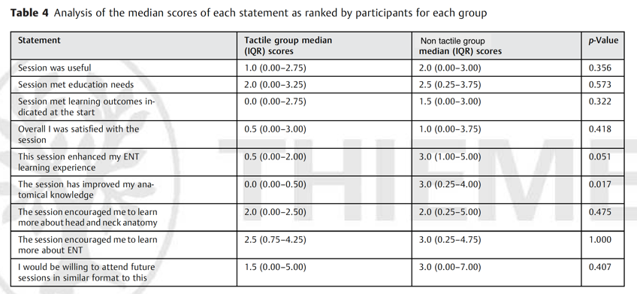
Medical schools in the United Kingdom are under increasing pressure to provide more streamlined, applicable teaching due to rising numbers of trainee doctors, but are failing to meet their educational need for otolaryngology. The recent COVID 19 pandemic has placed additional pressures on medical schools to adapt the medium over which the curriculum is delivered. The use of tactile learning with 3- dimensional models and distanced learning via videoconferencing may provide alternative teaching methods to meet otolaryngology undergraduate learning requirements. This pilot study aimed to assess the differences in undergraduate student attitudes towards tactile learning via non-tactile distanced learning and review their acceptability amongst this cohort.
Methods
Two groups of medical students observed a single educational event on the larynx and management of the airway. The learning opportunity was delivered in a lecture format with the lecturer demonstrating on an anatomical model of the larynx. Group one (tactile group) had an identical model to interact with during the lecture and were present within the lecture theatre; group two (non-tactile group) did not and observed the lecture via video link. Students were asked to rank their opinion to several statements about the session based on an 11-point Likert scale and give qualitative feedback.
Results
All ranked feedback was mainly positive. Tactile learning was equivalent to non-tactile learning based on the ranked feedback from the students statistically, except for improvement in anatomical knowledge, which the students thought tactile learning was superior (p = 0.017). A variety of qualitative feedback was received by both groups.
Conclusions
This pilot study provides evidence for the acceptability amongst students of the use of non-tactile distanced learning to deliver the otolaryngology undergraduate curriculum compared to tactile learning. This can provide the basis for larger studies to assess the educational impact of these different teaching methods.

Image

Recent Publications (minimum 5)

Preece D, Williams SB, Lam R, Weller R. "Let's get physical": advantages of a physical model over 3D computer models and textbooks in learning imaging anatomy. Anat Sci Educ. 2013;6(4):216-224.

Fredieu JR, Kerbo J, Herron M, Klatte R, Cooke M. Anatomical Models: a Digital Revolution. Medical Science Educator. 2015;25(2):183-194.

Howe A, Campion P, Searle J, Smith H. New perspectives--approaches to medical education at four new UK medical schools. Bmj. 2004;329(7461):327-331.

Powell J, Cooles FA, Carrie S, Paleri V. Is undergraduate medical education working for ENT surgery? A survey of UK medical school graduates. J Laryngol Otol. 2011;125(9):896-905.

Ferguson GR, Bacila IA, Swamy M. Does current provision of undergraduate education prepare UK medical students in ENT? A systematic literature review. BMJ Open. 2016;6(4):e010054.

Alnabelsi T, Al-Hussaini A, Owens D. Comparison of traditional face-to-face teaching with synchronous e-learning in otolaryngology emergencies teaching to medical undergraduates: a randomised controlled trial. Eur Arch Otorhinolaryngol. 2015;272(3):759-763.

Biography (150 word limit)
The rationale behind this project was to explore alternative methods of teaching particularly aimed an anatomy teaching. Current teaching methods need to adapt to the increasing pressures facing the medical curriculum. These include; increasing student numbers, larger geographical location over which placements are spread, and cutbacks to both time and money allocated to teaching anatomy. The use of anatomical models in an virtual environment has yet to be fully explored. This study acts a foundation on which further studies can build upon when considering tactile and virtual anatomical teaching. Given the recent COVID- 19 pandemic more reliance has been placed on virtual teaching sessions and further studies are needed to evaluate how teaching anatomy can adapt to this change in interface. Mr Owens a ENT surgeon at University Hospital Wales has dedicated himself to improving teaching within the department and this body of work is a reflection of his efforts.

Email: Aashish.pandya@nhs.net

Notes/Comments:

