Radiographic Calibration Ball Utilisation in Hip fracture Patients - Evaluation and Quality Improvement within a Tertiary Orthopaedic Centre
Dr Yenuksha Amarasena, Foundation Year 2, Kings College NHS Trust, UK

Dr Raunak Rao, Kings College NHS Trust, UK, Dr Grace Poole, Kings College NHS Trust, UK, Dr Eesree Kalikiri, Kings College NHS Trust, UK, Mr Langhit Kurar, Kings College NHS Trust, UK, Mr John Williams, Kings College NHS Trust, UK, Mr Matthew Gee, Kings College NHS Trust, UK

Abstract
Introduction
Use of the calibration ball with radiographs, is a standard preoperative investigation to help select the prosthesis for hip arthroplasties.[1,2]. Calibration optimises geometric parameters minimising intra- and postoperative complications [3]. Project was designed to assess use of this technique as standard care at a tertiary orthopaedic centre.
Methods
We used Plan-Do-Study-Act quality improvement methodology. Patients presenting to A&E with suspected hip fractures fulfilling the inclusion criteria were screened over a period of time. The intervention undertaken was to educate and highlight the need for all patients to have ball calibration x-rays to be performed for suspected hip fractures. The intervention consisted of oral presentations to the radiology and orthopaedic departments. Primary outcome measures assessed were the proportion of (a) X-Rays including a calibration ball, (b) Patients requiring additional imaging with a calibration ball (c) Hip arthoplasties performed without a calibration ball.
Results
There was a significant difference in mean age between the pre- and post-intervention populations (64.4 ± 20. 0 vs. 78.5 ± 10.5, p<0.001) . There were no significant differences in fracture type (p=0.17) or operation (p=0.32) between groups. We found a greater proportion of X-Rays with calibration balls post-intervention (3% vs 40%, p<0.001) and fewer repeat X-rays requiring a calibration ball (69% vs 23%, p=0.026). There was a significant reduction in proportion of patients receiving operative management without a calibration ball (37% vs 13%, p = 0.02).
Conclusions
Departmental presentations improved calibration ball utilisation and reduced the proportion of patients requiring repeat X-rays. This intervention decreased repeat radiation exposure and the proportion of arthroplasties performed without calibration balls. Further possible interventions include hospital electronic order modifications, prompting selection of a ‘calibration ball inclusion’ option when querying hip fractures.

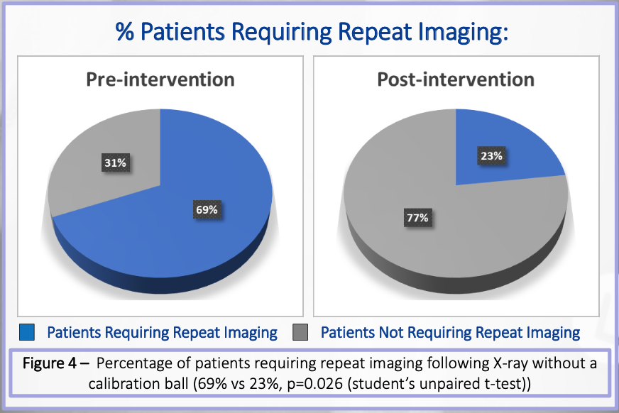
Image
References
- Boese CK, Lechler P, Rose L, Dargel J, Oppermann J, Eysel P, et al. Calibration markers for digital templating in total hip arthroplasty. PLoS One. 2015
- Holliday M, Steward A. Pre-operative templating for total hip arthroplasty: How does radiographic technique and calibration marker placement affect image magnification? J Med Radiat Sci. 2021
- Stigler SK, Müller FJ, Pfaud S, Zellner M, Füchtmeier B. Digital templating in total hip arthroplasty: Additional anteroposterior hip view increases the accuracy. World J Orthop. 2017

Presentations & Publications
Radiographic Calibration Ball Utilisation in Hip fracture Patients - Evaluation and Quality Improvement within a Tertiary Orthopaedic Centre - Regional presentation, Kings College Hospital NHS Trust
Multiple Myeloma & Liver failure screening in Orthopaedics and Ortho-geriatrics - Regional presentation, Kings College Hospital NHS Trust
COVIDSurg Collaborative; GlobalSurg Collaborative. Timing of surgery following SARS-CoV-2 infection: an international prospective cohort study. Anaesthesia. 2021 Jun;76(6):748-758. doi: 10.1111/anae.15458. Epub 2021 Mar 9. PMID: 33690889; PMCID: PMC8206995.


Biography
I have gained valuable surgical experiences working within the orthopaedic team at a major trauma centre. While showing interest in surgical techniques I was also passionate in improving patient safety. During my orthopaedic rotation I led multiple audits and quality improvement projects. My work on calibration balls, was closely collaborated with the radiology department to implement active changes to hip fracture management pathways within the hospital.

DR YENUKSHA AMARASENA Email: Y.AMARASENA@NHS.NET
Tel: +44 (0) 7445207283 Presentation type: Poster

