The Profound Healing Impact of Mind Body Medicine and Why It’s Important for Our Times.

With Dr. Moshe Daniel Block, ND (Naturopathic Doctor), HMC (Homeopathic Master Clinician), VDP – Vis Dialogue Practitioner

Abstract

I will illustrate in this lecture the discrepancies, strengths and weaknesses between the Three Models of Practicing Medicine – namely Allopathic, Systems-based, and Holistic. First published in my book The Revolution of Naturopathic Medicine in 2004 and then deepened in my next published book, Holistic Counseling – Introducing the Vis Dialogue in 2018, the emphasis of this lecture is to establish the power of the Holistic model and to illustrate with powerful case examples how spontaneous healing can occur when the real root cause of an illness is addressed in the mental-emotional sphere.

Recent Publications
- Block, Moshe Daniel, book title= Holistic Counseling - Introducing "The Vis Dialogue": Breakthrough Healing Method Uniting The Worlds Of Mind-Body Medicine & Psychology, Psyche Books, 3/25/2016
- Block, Moshe Daniel, book title= The Revolution of Naturopathic Medicine, Remaining True to Our Philosophy, Collective Coop Publishing, 3/12/2014
- Block, Moshe Daniel – “ESTABLISHING THE MIND-BODY CONNECTION IN THE TREATMENT OF AUTO-IMMUNE ILLNESS” NDNR -Naturopathic Doctors News and Review, March 1 2011,
- Block, Moshe Daniel – “HOLISM IN AUTOIMMUNE DISEASE: WORKING IN HARMONY WITH THE HEALING POWER OF NATURE” NDNR -Naturopathic Doctors News and Review, April 3 2014
5. Block, Moshe Daniel – “MANAGING MIND-BODY MEDICINE IN A WORLD OF OBSTACLES” NDNR -Naturopathic Doctors News and Review, June 20 2013

Photograph

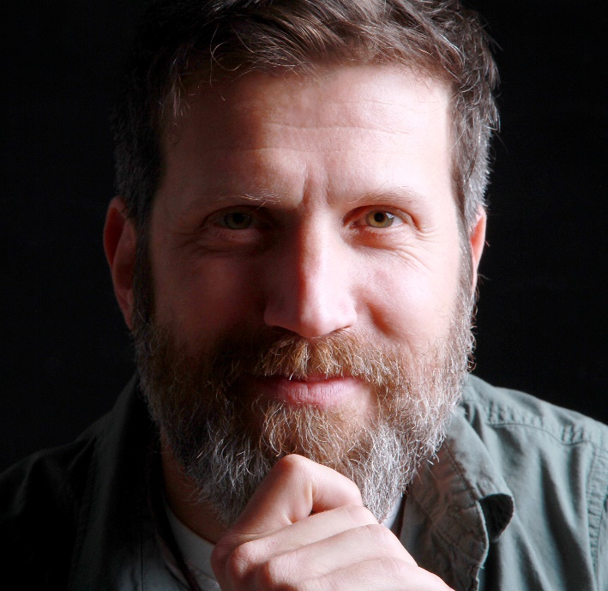
Biography of Dr. Moshe Daniel Block, ND, HMC, VDP

Moshe Daniel Block, ND, HMC is the author of The Revolution of Naturopathic Medicine: Remaining True to Our Philosophy, a book about the philosophy and practice of naturopathic medicine, and Holistic Counseling – Introducing the Vis Dialogue, a book about a breakthrough healing method uniting the worlds of Mind-Body Medicine & Psychology. He graduated from the Canadian College of Naturopathic Medicine (Toronto, Ontario) in 2000. Dr Block then went on to complete the Homeopathic Master Clinician course with Louis Klein, FSHom, in 2003. He specializes in autoimmune illness and myasthenia gravis, a disease he was personally diagnosed as having and from which he has healed himself. He teaches the very wisdom and knowledge that helped him heal himself and others in his Holistic Counseling professional program (holistic-counseling.ca). He has also founded the healing course Counsel-thyself.com.

Email: moshe@nddoctor.net

