Emotions, Memories and Healing-Healing the Past Frees Your Future
Erin Marfongella Certified LifeLine Practitioner
Erin Marfongella Certified LifeLine Ignite Instructor

Epigenetics has proven that emotionally charged memories and unprocessed emotions are a significant cause of symptoms and dis-ease in our bodies and stress in our lives and relationships. When exposed to a stressful environment or situation it becomes the job of the subconscious mind to “protect us” in that moment. It does so by taking a snapshot of our environment; including what we see, feel, hear, taste or smell then it compartmentalizes that information and detaches it from our consciousness to allow us to survive in that moment. Because these emotions and memories are not processed naturally from our short term to long term memories, they resurface again and again throughout our lifetime. Have you noticed patterns of stress or illness that reoccur in your life? Maybe different faces, but the story is the same? Let me introduce you to The LifeLine Technique®. The LifeLine Technique® is an advanced holistic healing system. It is a science, philosophy, and quantum technology that bridges the gap between the Conscious and Subconscious mind. The cornerstone of The LifeLine Technique® is how it views symptoms, stress and disease. Rather than something being wrong or broken with a person - it views those same symptoms, stresses and disease as the language your body and subconscious are using to awaken you to the power of transformation enabling you to create sustainable change in your life. By utilizing Muscle Reflex Testing, we can pinpoint, and release trapped emotions and memories being held in the body. In releasing the memories and emotions that are no longer serving you, your body is brought back into a state of energetic balance, enabling it to heal naturally, as it was intended.

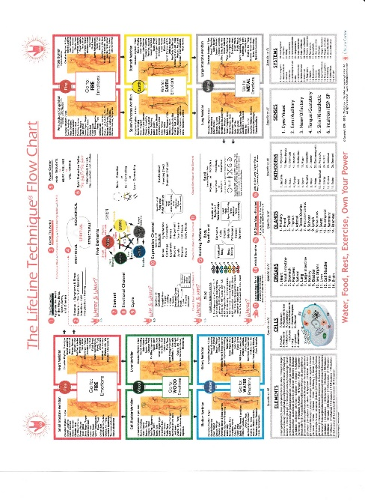

Biography:
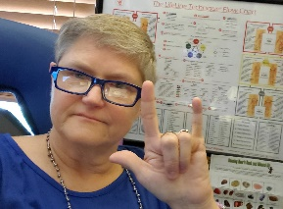

Erin Marfongella became interested in The LifeLine Technique® in 2007, starting out as a client after she was in a career ending crash while working in the ambulance, which resulted in crippling injuries and serious depression. Erin credits The LifeLine Technique® with truly saving her life. After her husband was diagnosed with cancer, she decided to become a practitioner herself. Erin became certified in The LifeLine Technique® in 2018 and an Ignite program instructor in 2019. In addition to seeing private clients Erin volunteers her time working with students in the LifeLine certification program and with wounded Veterans and injured first responders.

