Studies on RukshaGuna of VataDosha and its role in Respiratory system Infections
DrArpita Sarkar, BAMS, MD(Ayu),J B Roy State Ayurvedic Medical College and Hospital, India

Abstract (300 word limit)
According to Ayurveda, RukshaGuna is one of the essential VataGuna and it perform the action of Shoshan karma. In broad perspective Shoshan may taken as the exchange of various materials in between the cell and respective environment. According to the mechanism, this cellular exchange is classified into two major groups ,i.e. Diffusion and active transport. Bodily substance or solution require exchange in between intra and extra cellular field to sustain homeostasis. These essential mechanisms are mediated by the physical property of cell molecules along with innumerable factors. The entity of RukshaGuna may lie on physical properties of cell molecules and certain dependent factors.However this fundamental subject is rarely studied to find out precise physiological or pathological explanation. This study is planned to evaluate the etymological and syntactical derivation of theGuna of Vatadosha, the biophysical and molecular basis of the RukshaGuna and with special emphasis on the effect of increased RukshaGuna in Respiratory system. Hence the main aim of the study is to compile and analyse the physiological, pathological aspects of RukshaGuna and validate it’s effect on Respiratory system.

Image
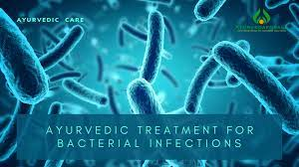
RUKSHA AAHAR (Food)
RUKSHA VIHAR (Lifestyle)

RUKSHA
(GUNA VRIDDHI)

VATA VRIDDHI
INVITE INFECTION

Recent Publications (minimum 5)
C (2009) The neuropathology of alcohol-related braindamage. Alcohol Alcohol 44:136-140.
- Heilig M, Egli M (2006) Pharmacological treatment of alcohol dependence: Target treatment and target mechanisms. Pharmacology and therapeutics 111:855-876.
- LiX, SchwachaMG, ChaudryIH, ChoudhryMA (2008)Acutealcohol intoxication potentiates neutrophil-mediated intestinal tissue damage after burn injury. Shock 29:377.
- Room R, BaborT, Rehm J (2005) Alcohol and public health. Lancet
365: 519-530.
5. Sullivan EV, Zahr NM (2008) Neuroinflammation as a neurotoxic mechanism in alcoholism: Commentary on “Increased MCP- 1 and microglia in various regions of human alcoholic brain”. Experimental neurology 213:10-17.

Photograph

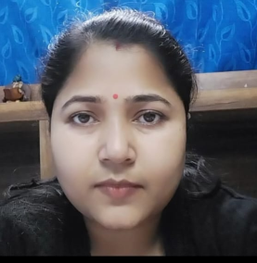

Biography (150 word limit)
Dr. Arpita Sarkar her expertise in evaluation and passion in improving the health and wellbeing. Her open and contextual evaluation model based on clinical experience and literary studies createsnewpathwaysforimprovinghealthcare.Shehasbuiltthismodelafteryearsofexperienceinresearch,evaluation,teachingandadministration both in hospital and education institutions. She has completed BAMS from J B Roy State Ayurvedic Medical College and Hospital and MD(Ay) in Samhita and Siddhantfrom IPGAE&R at S.V.S.P. Kolkata. At present she is working as an Assistant Professor in Department of Sharirkriyaar J B Roy SAMC&H. Before that she was working as an Assistant Professor in Department of Samhita and Siddhant at Shri DhanwantriAyurvedic Medical College and Research Centre. She is also attached with L.N. Maity International Ayurvedic Medical Research Foundation for 12 years. She wrote for various journals and presentedher research works in several international seminars.
Email: drXXXXXXX@xxxmail.com

Notes/Comments:

