Abstract Title: Documentation of Ethnomedicinal knowledge and medicinal plants of rural Arunachal Pradesh, India

Sumpam Tangjang & Tonlong Wangpan
Department of Botany, Rajiv Gandhi University, Rono Hills-791112, Doimukh, Arunachal Pradesh, India

Abstract

Arunachal Pradesh is one of the remotest and poorest states in India due to its predominantly challenging rugged topography, inhospitable mountainous terrain, incessant rains and harsh climatic conditions. The state’s inhabitants are predominantly rural representing twenty-six recognized major tribes of India and have high diversity of indigenous knowledge on plant-based resources. The Arunachal Himalaya is considered as the world’s richest store house of medicinal plants and even today, a large portion of rural indigenous folk depends on its rich biodiversity for their livelihood, nutrition and health. There is a vast scope for this region emerging as a major player globally in herbal-based medicinal products. Plant-based traditional medicines are considered potential source of therapeutic aids and have significant role in rural healthcare system due to their negligible side effects and cost-effectivity. The traditional knowledge on utilizing the plant resources as medicines, however, differ from tribe to tribe and is passed down through oral traditions without any written record. In the present study, a preliminary survey in the East Siang district of Arunachal Pradesh, we recorded a total of 143 plant species being used as traditional medicines for curing different diseases. The traditional herbalists has reported to cure a dreaded diseases like cancer and diabetes. It is expected that the information gathered in the present study would not only help in providing opportunities, but also holds potential for policy formulation on herbal medicines for the pharmaceutical sector in finding new therapeutic agents, safeguarding from biopiracy and above all sustainable utilization. Findings of this documentation study can also be used as an ethnopharmacological basis for selecting plants for future phytochemical and pharmaceutical studies. It requires urgent systematic investigation using biotechnological tools to authenticate and develop new novel drugs from the rich bio-resources of the region. Such study is expected to reveal the medicinal plant heritage of the tribal population of this region, along with their cultural ethnomedicobotanical knowledge and their use pattern.

Keywords— Ethnomedicine, Herbalists, Rural health care system, Traditional knowledge,

Professional Biography (100-150 words)

Prof. Sumpam Tangjang has completed his PhD at the age of 27 years from Rajiv Gandhi University, Rono Hills, Doimukh, Arunachal Pradesh, India and postdoctoral studies from School of Forest Resources and Conservation, University of Florida, Gainesville, USA. Presently, Prof. Tangjang is the Co-ordinator of Department of Food Technology, Rajiv Gandhi University and Deputy Chairperson of Institutional Ethics Committee, Tomo Riba Institute of Health & Medical Sciences, Government of Arunachal Pradesh, India. Prof. Tangjang is also a member of National Assessment and Accreditation Council (NAAC). He has published more than 40 research papers in International and National Journals of repute, has been serving as a Reviewer for a number of Journal of repute and is a member of some reputed societies. Prof. Tangjang is a recipient of Council of Scientific and Industrial Research (CSIR) Fellowship and Department of Biotechnology (DBT) Overseas Associateship.

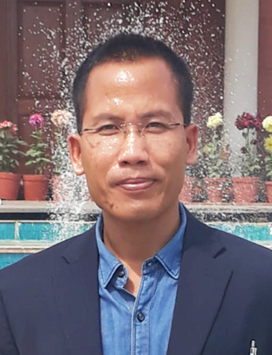
Email Id: sumpam@gmail.com

Any Comments:

