STRUCTURAL PHYSICAL ANALYSIS OF THE PSEUDOTERNARY AND NANOESTRUTURED SYSTEM COMPOSED BY SOYBEAN PHOSPHTYILCOLINE AND HYDROGENATED CASTOR OIL
Lígia de Souza Fernandes¹, Anselmo Gomes de Oliveira¹, Marcelo G. de Freitas Araújo², Maria Virginia Scarpa¹

¹ São Paulo State University "Júlio de Mesquita Filho", School of Pharmaceutical Sciences, Araraquara, São Paulo, Brazil.
² Federal University of São João Del-Rei, Campus Centro Oeste-Dona Lindu, Divinópolis, Minas Gerais, Brazil.

Pseudoternary and nanostructured systems are important resources to increase the solubility and transport lipophilic drugs, besides promoting controlled release of the drug, they can still increase their time permanence in the place of action. The work objective was to evaluate the physical structure of the pseudoternary and nanostructured system composed by soybean phosphatidylcholine and hydrogenated castor oil (tensoactive / cosurfactant, 50:50 ratio), capric triglyceride (oily phase) and acetate buffer pH 4.5 (aqueous phase) for intravaginal administration of drugs using polarized light microscopy (PLM), X-ray diffraction (XRD), small angle x-ray scattering (SAXS) and rheological behavior. PLM was made using polarized light microscope with magnification of 10 and 20 times. XRD and SAXS were evaluate the diffracted beams intensities in relation of the diffraction angles and the rheological behavior was evaluated by continuous and oscillatory tests using a plate/plate geometry (20 mm diameter) and rheometer at 30ºC. The results of the PLM shows a anisotropic structures that suggest crystals and "malt of crosses" showing a mixture of crystals and lamellar liquid-crystalline mesophase. Diffractograms presented fine and defined peaks, which also show crystalline structures probably from system components. SAXS analysis presented the 1:2:3 ratio in the interplanar distances, which sugest lamellar mesophase. The results obtained with MLP, XRD and SAXS are complementary because the lamellar mesophase arrangements and the presence of many crystalline structures were observed in all techniques. Pseudoternary and nanostructured system presented non-Newtonian, anti-thixotropic and pseudoplastic rheological behavior; oscillatory rheological analysis showed the predominantly of the elastic behavior. These behaviors are advantageous for intravaginal administration because at the time application the system are "fluid" and after the tension applied, it is able to restructure itself by acquiring high viscosity again and promoting greater contact with the vaginal mucosa.

Keywords—polarized light microscopy, rheological behaviour, small angle x-ray scattering, X-ray diffraction.

Figure 1. Photomicrograph of the pseudoternary and nanostructured system using 10x magnification (PLM).
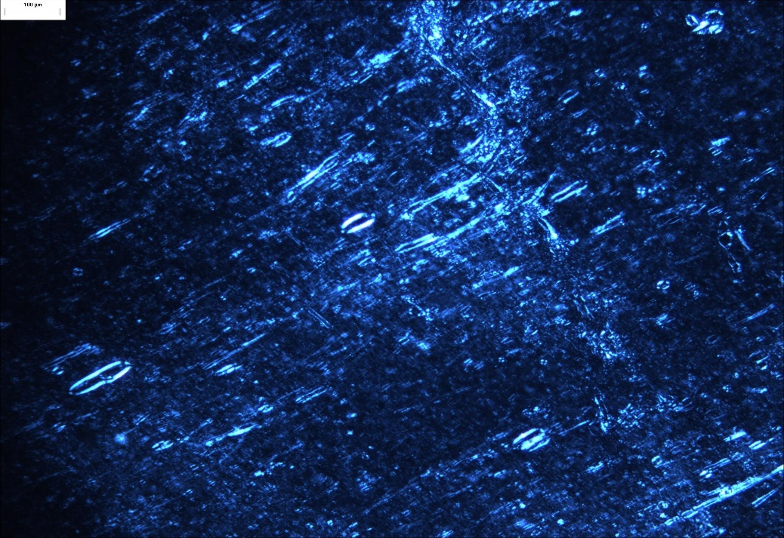

Figure 2. Photomicrograph of the pseudoternary and nanostructured system using 20x magnification (PLM).

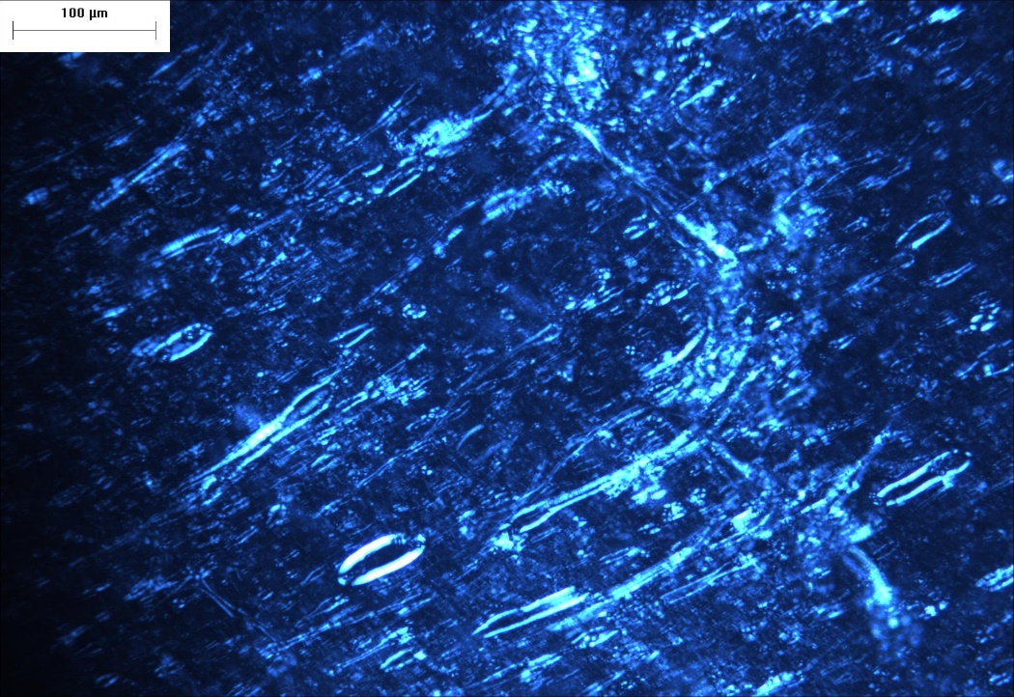

Graphic 1. Diffractogram of the pseudoternary and nanostructured system.

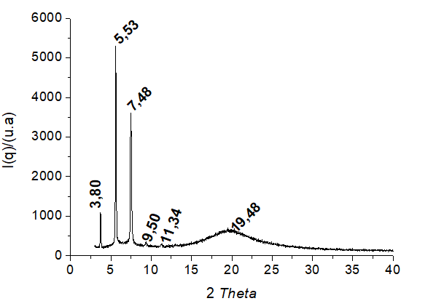
Graphic 2. Diffractogram of the soybean phosphatidylcholine.

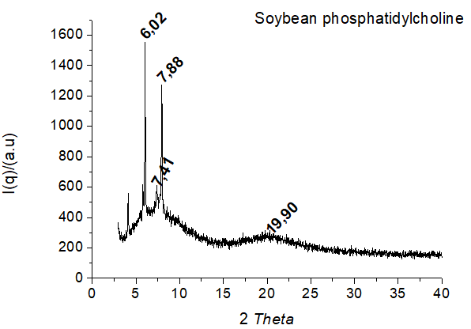

Graphic 3. Diffractogram of the hydrogenated castor oil.

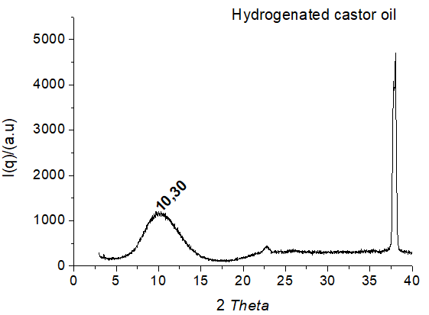

Graphic 4. SAXS curve of the pseudoternary and nanostructured system and interplanar distances.

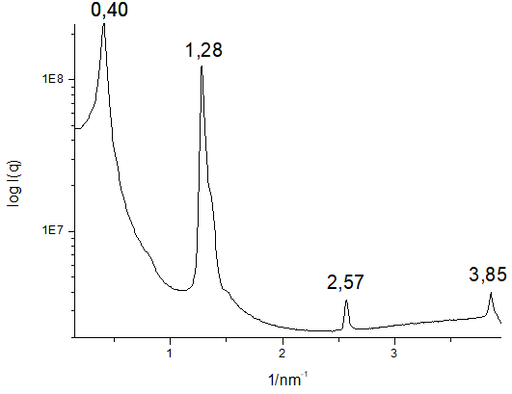

Graphic 5. Flow curves of the pseudoternary and nanostructured system.

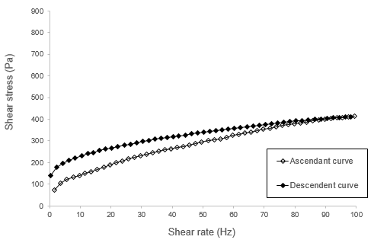

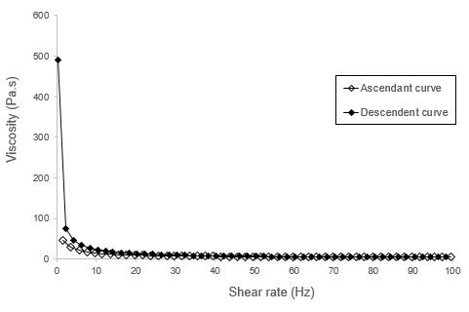

Graphic 6. Stress sweep at 30ºC ± 1.
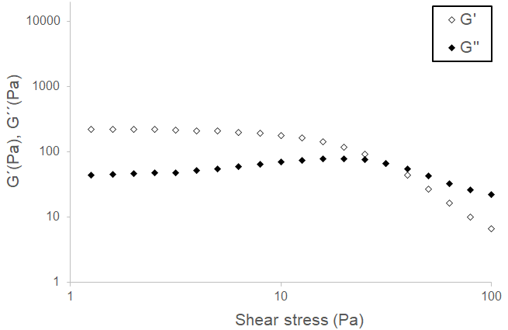

Graphic 7. Frequency sweep at 30ºC ± 1.

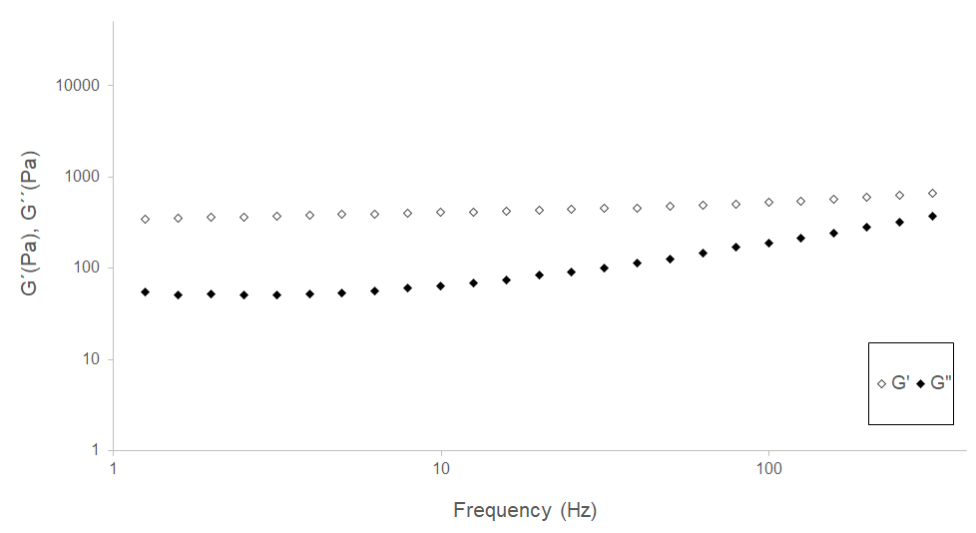

Professional Biography

Lígia de Souza Fernandes has master's degree at the Paulista State University "Júlio de Mesquita Filho"(Faculty of Pharmaceutical Science) and currently is a doctoral student (PhD student) in the same university. Your advisor is Maria Virginia Scarpa and they research is development of controlled release systems. She has published one article in an internationally renowned journal. During the master's degree she developed a partnership with the University of Porto (Portugal). She worked in national and multinational pharmaceutical industry in R&D area and physical-chemical quality control. CAPES fund your research since master´s degree.
This link shows her curriculum in detail: http://buscatextual.cnpq.br/buscatextual/visualizacv.do?id=K4200836D3

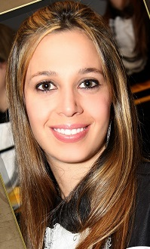

Email Id:

