Antibiotic Susceptibility Pattern of Salmonella Isolated from Enteric Fever Suspected Patients
Shrestha. B, Msc Microbiologist, HAMS Hospital, Kathmandu, Nepal

Abstract
Background: Enteric fever is one of the most common diseases encountered worldwide and is endemic in Nepal. This study was conducted to access antibiotic susceptibility pattern of Salmonella isolates from culture positive cases of enteric fever.
Methods: Altogether 505 blood samples were collected from patients clinically suspected of enteric fever attending HAMS Hospital. All blood samples were cultured by BACTEC method and sub cultured in blood agar and MacConkey agar plates. All isolates were identified by colony characteristics, biochemical tests and serotyping methods. Antibiotic susceptibility test was performed by modified Kirby Bauer disc diffusion method interpreted with CLSI guideline.
Result: Isolation rate of Salmonella species was 3.6%. Among 18 Salmonella isolates, 10 were S. typhi, 8 were S. paratyphi A. The prevalence rate of infection was high among the age group 11-20 years (50%) and among the male patients. However, there was no significant association of enteric fever with gender of patients (p=2.47). All 18 isolates were sensitive to Amoxycillin, Azithromycin, Ceftriaxone and Chloramphenicol, Ciprofloxacin and Ofloxacin. Majority of isolates were sensitive to Cefixime (94.4%), Cotrimoxazole (94.4%) and Cephotaxime (90%). There were no any MDR isolates. Higher percentage of isolates was resistant to Nalidixic acid (87.5%).
Conclusion: The decreased susceptibility to Fluroquinolones of S. typhi and S. Paratyphi A can be correlated with resistance to Nalidixic acid. Commonly used third generation Cephalosporins and rolled back first line drugs be the choice in case of NARS isolates.

Key words: Enteric fever, Salmonella, Multidrug resistance (MDR), NARS
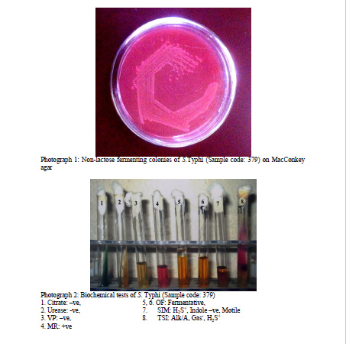
Recent Publications
1. Karki AB, Bhatta1 DR, Shrestha B , Khatri B, Rai KR, Mukhiya RK and Lekhak B (2013). Higher Nalidixic acid resistance pattern of Salmonella isolates from enteric fever patients in Kathmandu Model Hospital, Nepal.
2. Karki S, Shakya P, Cheng AC, Dumre SP, Leder K (2013). Trends of etiology and drug resistance in enteric fever in the last two decades in Nepal: a systematic review and meta-analysis. Infect Dis Soc of Am. Published by Oxf Univ Press.
3. Mir BA, Sirwar SB and Indupalli AS (2013). A comparative study of conventional method versus BACTEC method in bacteriological profile of septicemia. Int J of Bioassays: 02 (12), 1541-1545
4. Clinical and laboratory Standards Institute (CLSI) (2012). Performance Standards for Antimicrobial Susceptibility Testing, Twenty-second Informational Supplement, 31(1): CLSI document M100-S22. Wayne, PA.
5. Adhikari D, Acharya D, Shrestha P and Amatya R (2012). Ciprofloxacin susceptibility of Salmonella enterica serovar Typhi and Paratyphi A from blood samples of suspected enyrtic fever patients. Int Infect Microbial 1(1): 9-13.
6. Centre for Disease Control and Prevention (CDC) (2013). Antibiotic Resistance Threats in the United States, 2013, pp 85-86.
7. Rajbhandari E (2015). Bacteriological analysis of enteric fever and its antimicrobial susceptibility pattern in children attending Kathmandu Model Hospital. M.Sc Dissertation Submitted to the National College affiliated to Tribuvan University, Kathmandu, Nepal.

Photograph


Biography
Bijayata Shrestha completed her Masters Degree in Microbiology (Medical) at the age of 28 years from Tribhuwan University, Nepal. She started working in HAMS hospital, Kathmandu, Nepal in 2009 A.D. right after completing her Undergraduate degree in Medical Laboratory Technology (BMLT) from Rajiv Gandhi University of Health Sciences, India. She is currently designated as in-charge of Pathology department in the Hospital and her duties and responsibilities include QC analysis, laboratory report authorization and staff duty roster maintenance. Besides, She is also working as a lecturer to PCL Nursing students in HAMS Nursing College since 2010 A.D.
Email: bijetaa.shrestha@gmail.com, bijeta_shrestha@hotmail.com

