Abstract
The burden of economization - and the opportunities of the "culture of charity"
Andreas Pawlas, Department of Theology, University of Tartu/Estonia

Abstract (not more than 300 words)
Not only in Germany Diaconia/Caritas and Protestant/Roman Katholic Churches are large service providers of medical and social assistance. But at the same time they often find economic thinking as a burden or even a nuisance in their work, for it is regarded as something “not authentic” in the aid and assistance to the poor, miserable and needy as successors in the love of Jesus Christ. Economic thinking, however, must be understood as a careful treatment of the entrusted goods and is justified in the sense of the Creation faith and the "two-nature" doctrine of Christ. It must be considered as an important expression of the limitations of all earthly human life.
Overall, economic profit-oriented thinking has not only developed as a hallmark of modernity, but must also be regarded as extremely successful. But it should not be overlooked that an exclusively economic profit-oriented attitude easily can turn in greed and avarice and that it makes blind not only for the responsibility to one’s neighbor and but also for essential risks. Therefore many companies went to develop their own “corporate culture”, in which should be deployed the ethical principles of the companies. However in the companies of the Diaconia/Caritas it is not necessary to develop new ethical principals because diaconal work should be founded in the “culture of charity” of Christianity. And the result of this culture are - within the given economic framework - not only responsible and credible services and aids in medicine and social welfare but also committed employees.

Keywords
Business Ethics, Diaconia, Charity, Corporate Culture

Professional Biography (100-150 words)
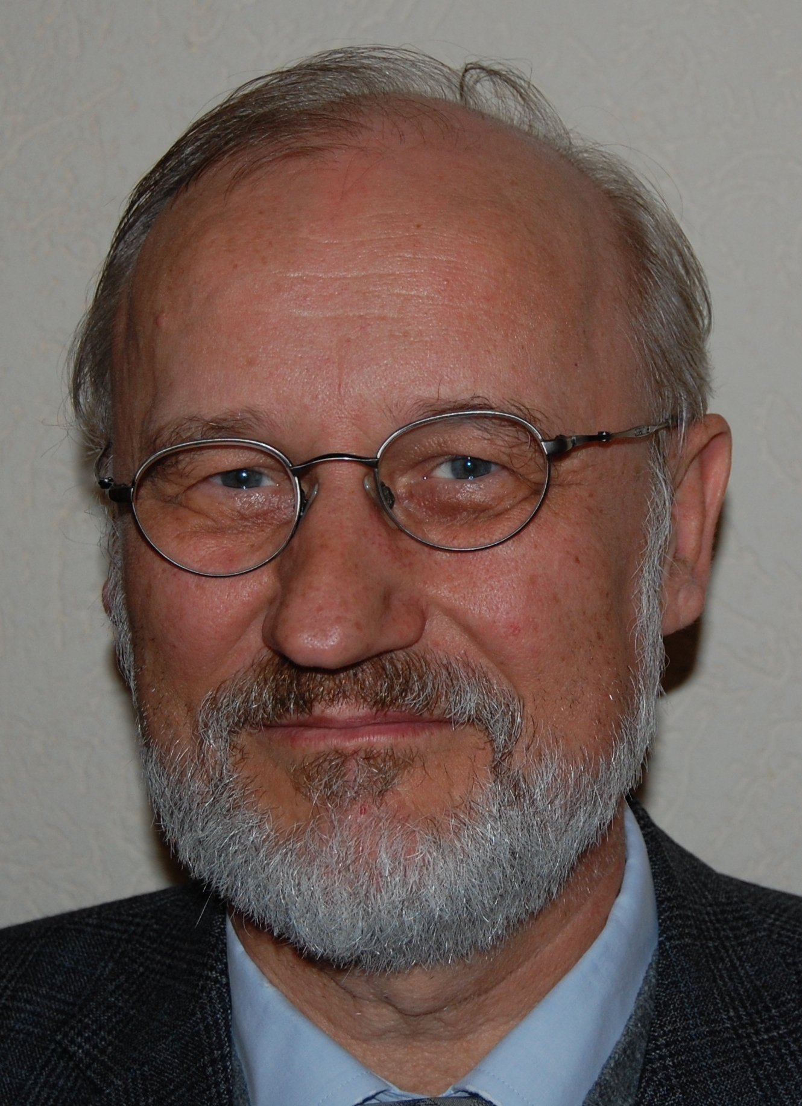
Andreas Pawlas graduated in business administration from the University of Hamburg in 1975 (Dipl.-Kfm.) And received his doctorate there in 1979 (Dr. rer. Pol.). After studying theology in Hamburg, he became a pastor in Lauenburg/Elbe from 1982-1987. He was next to 1981-1998 lecturer at the University of the Federal Armed Forces Hamburg and later in Tartu/Estonia and Kiel. He became a military dean at the Leadership Academy of the German Armed Forces in Hamburg from 1987-1995 and was also Managing Director 1991-2003 of the Luther-Gesellschaft e.V. From 1995-2011 he was pastor in Barmstedt and managing director of various diaconal institutions. He is professor of the University of Tartu/Estonia.
He has written several books and hundreds of articles mainly on business ethics and peace ethics.

Mail: Andreas.Pawlas@web.de

