Title: Development of bacterial cellulose based microbioreactors for the continuous cell and tissue culture
Cecília Cristelo¹, Salomé Leal¹, Sara Silvestre², Elvira Fortunato², Aureliana Sousa³, Anabela Alves¹, Miguel Gama¹
¹ Centre of Biological Engineering, University of Minho, Braga, Portugal
² Universidade Nova de Lisboa, Faculdade de Ciências e Tecnologias, Lisboa, Portugal
³ INEB – Biomedical Engineering Institute, Porto, Portugal

Abstract: 300 words
Bacterial Cellulose (BC) represents a source of highly pure and biocompatible cellulose, with huge technological potential in many fields - biomedical, composites, textiles, food and cosmetics textiles - but currently still rather underexploited [1,2,3]. This presentation will overview the status of BC biotechnology and describe a novel approach towards the development of a cellulose-based device for the continuous culture of animal cells and tissues.
A new strategy for the surface modification of BC through the combination of oxygen plasma deposition and silanization with trichloromethyl silane (TCMS) is described. The combined use of the two techniques modifies both the surface roughness and energy and therefore maximizes the hydrophobic effect obtained. These modified membranes were characterized by SEM (Figure 1), water contact angle (CA) measurements, FTIR-ATR and XPS, and its cytotoxic potential was investigated using both indirect and direct contact studies with cells. The results obtained suggest an effective conjugation of TCMS to the surface of BC and the production of a highly hydrophobic surface, with a water contact angle of approximately 130º. We also demonstrate that this is a stable and durable surface modification strategy, since BC remained hydrophobic even after 6 months, in dry conditions or after being submerged in distilled water for about a month. Importantly, this surface modification revealed no short-term cytotoxic effects on L929 and hDNFs cells.
This material was used for the construction of a BC-based well plate for cell culture, which can be supplied continuously with culture medium, allowing long term studies (ranging from days to weeks) to be performed, using alginate scaffolds as described previously [4,5].

Image: 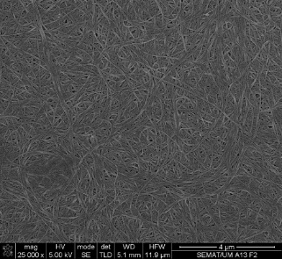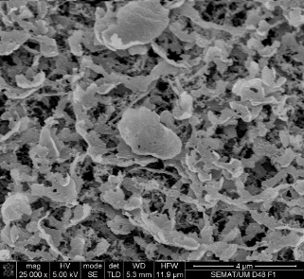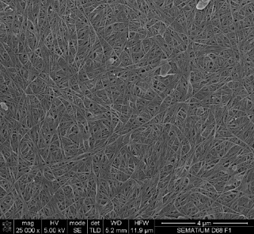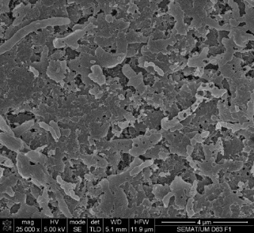
A
D
C
B
Figure 1. SEM micrographs of produced BC membranes. A – Non-treated membrane, B – O₂ plasma-treated membrane, C – silanized membrane without O₂ plasma treatment and D – silanized membrane with O₂ plasma pre-treatment (mag 25000x, scale bar = 4 µm).
Recent Publications:
- Gama, Miguel; Dourado, Fernando; Bielecki, Stanislaw, Bacterial Nanocellulose: From Biotechnology to Bio-Economy, Elsevier, 2016. ISBN: 9780444634580
- Klemm, Dieter; Cranston, Emily D.; Fischer, Dagmar; Gama, Miguel; Kedzior, Stephanie A.; Kralisch, Dana; Kramer, Friederike; Kondo, Tetsuo; Lindström, Tom; Nietzsche, Sandor; Petzold-Welcke, Katrin; Rauchfuß, Falk, (2018) Nanocellulose as a natural source for groundbreaking applications in materials science: Today’s state, Materials Today, 21(7), 720-748
- Miguel Gama, Paul Gatenholm, Dieter Klemm, Bacterial Nanocellulose: a Sophisticated Multifunctional Material, Florence KY: CRC Press, 2012. ISBN: 9781439869918, 91-112
- Maia FR, Fonseca KB, Rodrigues G, Granja PL, Barrias CC (2014) Matrix-driven formation of mesenchymal stem cell-extracellular matrix microtissues on softalginate hydrogels. Acta Biomater. 10(7):3197-208.
- Branco da Cunha C, Klumpers DD, Li WA, Koshy ST, Weaver JC, Chaudhuri O, Granja PL, Mooney DJ. Influence of the stiffness of three-dimensional alginate/collagen-I interpenetrating networks on fibroblast biology. Biomaterials. 2014 Oct;35(32):8927-36.

 Biography:
Miguel Gama authored a total of 270 scientific works, including original papers in international journals, review papers, book chapters and articles published in conference proceedings, corresponding to an h-factor of 39. Invited scientist, Programa CAPES Ciência sem Fronteiras, UFRN, Brasil, 2013-2015. Visiting Professor of the Universities of Shanghai and Tehran University of Medical Sciences.The current main focus of scientific and entrepreneurial activity is related to the ambition of contributing to the translation of Bacterial NanoCellulose to the bioeconomy. With that purpose, has been involved in the edition of books and the organization of Symposia dedicated to this topic. Created a spinoff with the goal of developing a technology for the large scale production of this material and recently filled two patents on i) the process for BNC production and on ii) product formulations with potential application in the cosmetics, food, composites and pharmaceutical industries (Orcid.org/0000-0002-5655-0015; Google academic: http://scholar.google.pt/citations?hl=pt-PT&user=hewKdYoAAAAJ&cstart=0&pagesize=20 ).
Email: fmgama@deb.uminho.pt

