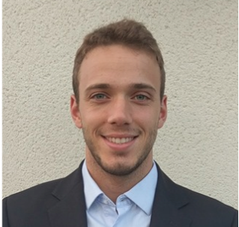

Fabrication of electroactive collagen scaffolds for chronic wound healing applications
Tom Walet, master thesis, EPFL, Switzerland

Abstract
Chronic wounds are commonly described as wounds that failed to proceed through the phases of healing in an orderly and timely manner despite standard medical procedures. Recent discoveries have demonstrated that the presence of a conductive biomaterial promoted cellular activities, including fibroblasts and keratinocytes that are highly involved in the overall healing process. However, most of the wound dressings in the current market are generally lacked of this electroactive functionality. Hence, there is a need to incorporate the electroactive into the existing dressings to improve the wound healing process, particularly for chronic wounds. In general, conductive polymers, such as polypyrrole (PPy) have received great interest in that matter due to their excellent biocompatibility and conductivity upon doping. Therefore, the aim of this study was to polymerize PPy onto one of the commonly used dressings (i.e. collagen dressing) to create a biocompatible and electroactive collagen/PPy scaffold. In addition, metal dopant, such as copper(II) chloride (CuCl₂) was incorporated to further enhance the overall conductivity. In this study, collagen was successfully extracted from bullfrog (Rana Castebeiana) skin and crosslinked with 1,4-butanediol diglycidyl ether (BDE) to enhance the overall thermal and chemical stability of the extracted collagen for the subsequent PPy polymerization. PPy was then polymerized onto BDE-crosslinked collagen scaffolds via a template polymerization process to produce the electroactive scaffolds (BDE-COL/PPy). The BDE-COL/PPy scaffolds exhibited a conductivity of approximately 4.8 S/cm and demonstrated good cytocompatibility by supporting the attachment and proliferation of human immortalized non-tumorigenic keratinocyte cells (HaCaT). The BDE-COL/PPy was then doped with CuCl₂ according to the optimized cytocompatible range of concentrations conducted in this study, and successfully showed an increased in the overall conductivity.

Key words: Chronic wounds, conductive polymer, polypyrrole, collagen, HaCat cells

Image
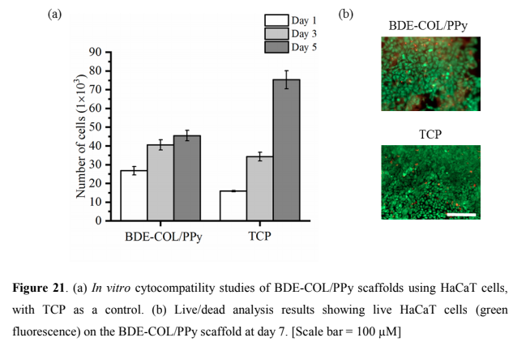
Recent Publications

Biography
Tom Walet carried out his studies at the EFPL in Switzerland obtaining a bachelor in material science and engineering. He then obtained a master in the same discipline along with a minor in biomedical technologies after carrying out his master thesis in NTU, Singapore.

Presenting author details
Full name (As per the passport): Tom Walet
University/Industry/Organization name: Ecole Polytechnique Federale de Lausanne (EPFL)
Designation: (Director/Prof/Assistant or Associate prof/Researcher/Student): Esther Amstad & Cleo Choong (NTY, Singapore)
Country: France
Mobile number (country code – number) : +33 6 84 87 63 62
Email: walettom@gmail.com
Category (Oral presentation/ Poster presentation/Young researcher forum/E-poster): oral presentation
Research interest: Biomaterials
Your profile page URL in your department:
Year of birth: 1994
Linked In/Facebook/twitter account: https://www.linkedin.com/in/tom-walet/

Note: Please fill up the Red mark fields so that it would be easier for us to cite your details in the conference particulars. (Please do not forget to fix your photo and Logo above the title)

