


The use of indentation hardness tests for determining the mechanical properties of materials
Ing. Maxim Puchnin, Ph.D., CZ

Abstract
Determining the material properties of all objects is one of the basic requirements for technical practice. The defined material properties by Supplier is a business card of this material, based on which the material is predetermined for specifically stressed components or technological processes. These are, for example, the following data: yield strength R_{e} and R_{p0.2}, tensile strength R_{m}, Young modulus E, strain hardening exponent n and coefficient K. In basic technical practice, standard destructive methods are used for their measurement. For example, a standard static tensile test uses specially produced standardized bars that are axially loaded into the final tear. These mechanical tests are carried out on universal tensile testing machines of various loads and sizes.
The developed instrumental measuring system for determining the mechanical properties of materials by the indentation method may be an alternative way to quickly and non-destructively measurements the required parameters of engineering materials or constructions.

Key words: Mechanical properties, indentation tests, non-destructive methods, finite element method, electron microscopy, light microscopy, microstructure, plastic deformation

Image
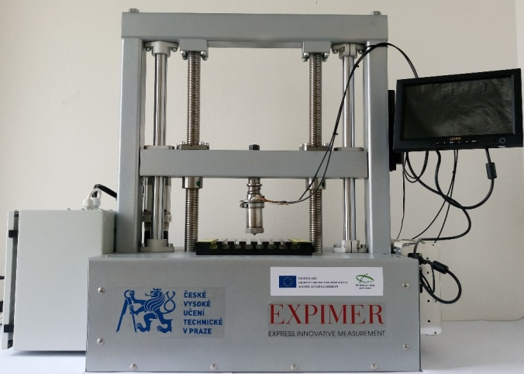
Figure 1 Experimental equipment
Recent Publications (minimum 5)
- PUCHNIN, Maxim, TRUDONOSHYN, Oleksandr, PRACH, Olena. Use of the ABI technique to measure the mechanical properties of aluminium alloys: Effect of chemical composition on the mechanical properties of the alloys. Materiali in tehnologije / Materials and technology, 2016, Volume 50, Issue 2, Pages 247-252. ISSN 1580-2949.
- TRUDONOSHYN, Oleksandr, PUCHNIN, Maxim, PRACH, Olena. Use of the abi technique to measure themechanical properties of aluminium all-oys: effectof heat-treatment conditions on the mechanicalproperties of alloys. Materiali in tehnologije / Materials and technology, 2016, Volume 50, Issue 3, Pages 427-431. ISSN 1580-2949.
- PUCHNIN, Maxim, TRUDONOSHYN, Oleksandr, PRACH, Olena, PEŠLOVÁ, Františka. Comparison of ABI Technique and Standard Methods in Measuring Mechanical Properties of Aluminium Al-aloys Manufacturing Tech-nology, 2016, Volume 16, Issue 3, pp. 600-607. ISSN 12132489.
- PUCHNIN, M.,ANISIMOV, E.,CEJP, J.,KUNKA, I.,VICENS, S. Ad-vantages of express-methods in investigation of mechanical and physical proper-ties of aluminum alloys. Manufacturing Technology, 2014, Volume 14, Issue 2, Pages 234-238. ISSN 12132489.
- ANISIMOV, Evgeniy, PUCHNIN, Maxim. Reduction of Elastic Modu-lus of Titanium Alloy Ti-6Al-4V by Quenching. Key Engineering Materials, 2014, Volume 586, Pages 15-18. ISSN 10139826.
- ANISIMOV, E., MANAK, J., PUCHNIN, M., SACHR, P. The effect of microstructural features on mechanical properties. Key Engineering Materials, 2014, Volume 606, Pages 47-50. ISSN 10139826.

Presenting author details
Full name (As per the passport): Maxim Puchnin
University/Industry/Organization name: MODELÁRNA LIAZ spol. s r.o.
Designation: (Director/Prof/Assistant or Associate prof/Researcher/Student): Ph.D.
Country: Czech Republic
Mobile number (country code – number): +420774260534
Email: maxim.puchnin@modelarna-liaz.cz
Category (Oral presentation/ Poster presentation/Young researcher forum/E-poster): Oral presentation
Research interest: new technology, engineering, microscopy
Your profile page URL in your department:
Year of birth: 1986
Linked In/Facebook/twitter account:

Note: Please fill up the Red mark fields so that it would be easier for us to cite your details in the conference particulars. (Please do not forget to fix your photo and Logo above the title)

