



Joint Pricing and Inventory Tactics under Coordinating Agreements in Supply Chains
Mahsa Noori-daryan, School of Industrial and Systems Engineering, College of Engineering, University of Tehran, Tehran, Iran

Abstract
Recently, companies tend to apply incentive contracts to persuade buyers to order more, in order to increase own selling scales which leads to improve their market share and subsequently enhance their market power. Thereupon, this research develops an economic production quantity (EPQ) model in a single-manufacturer single-retailer supply chain where quantity discount contract and transportation costs with freight discount contract are incorporated into the model. Here, it is deemed that demand depends on selling price and shortage is not permitted. The leader-follower game is considered between the supply chain members in which the manufacturer is follower and the retailer is leader. This research aims to optimize the total profit of the chain respect to the selling price and order quantity of the manufacturer and the retailer. Finally, in order to clarify the applicability of the model a numerical example is presented and also the effects of optimal decision policies on the decisions of the chain's partners are examined. We find that incentive contracts as quantity and freight discount contracts benefit all the chain members and also customers and consequently improve the total profit of the chain.

Key words: Pricing, Inventory, Free-shipping Policy, Quantity discount Contract, Supply Chain, Game Theory,

Image

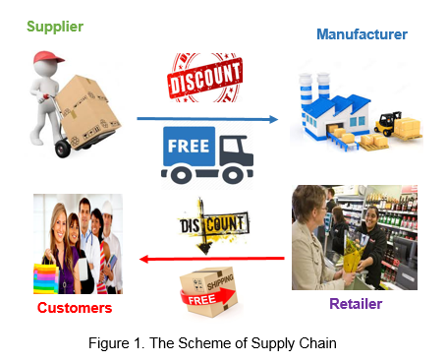

Recent Publications
- Hafezalkotob A, Babaei MS, Rasulibaghban A, Noori-daryan M (2014) Distribution Design of Two Rival Decentralized Supply Chains: a Two-person Nonzero Sum Game Theory Approach. International Journal of Engineering 27(8):1233-1242.
- Taleizadeh AA, Noori-daryan M (2015a) Pricing, manufacturing and inventory policies for raw material in a three-level supply chain. International Journal of System Science 47(4): 919–931.
- Taleizadeh AA, Noori-daryan M, Cárdenas-Barrón LE (2015b) Joint optimization of price, replenishment frequency, replenishment cycle and production rate in vendor managed inventory system with deteriorating items. International Journal of Production Economics 159: 285–295.
- Taleizadeh AA, Noori-daryan M, Tavakkoli-Moghaddam R (2015c) Pricing and ordering decisions in a supply chain with imperfect quality items and inspection under buyback of defective items. International journal of Production Research 53(15): 4553-4582.
- Taleizadeh AA, Noori-daryan M (2016) Pricing, inventory and production policies in a supply chain of Pharmacological products with rework process: a game theoretic approach. Operational Research: An International Journal 16:89–115.
- Noori-daryan M, Taleizadeh AA (2016) Coordinating Pricing and Ordering Decisions in a Multi-Echelon Pharmacological Supply Chain under Different Market Power using Game Theory. Journal of Industrial and Systems Engineering 9(1):35-56.
- Taleizadeh AA, Noori-daryan M, Govindan K (2016) Pricing and ordering decisions of two competing supply chains with different composite policies: a Stackelberg game-theoretic approach, International journal of Production Research 54(9): 2807–2836.
- Taleizadeh AA, Babaei MS, Niaki STA, Noori-daryan M (2017) Bundle pricing and inventory decisions on complementary products. Operational Research: An International Journal doi: 10.1007/s12351-017-0335-4.
- Noori-daryan M, Taleizadeh AA, Govindan K (2017) Joint replenishment and pricing decisions with different freight modes considerations for a supply chain under a composite incentive contract. Journal of the Operational Research Society, In Press.
- Noori-daryan M, Taleizadeh AA, Jolai F (2017) Analyzing Pricing, Promised Delivery Lead time, Supplier-Selection, and Ordering Decisions of a Multi-National Supply Chain under Uncertain Environment. International Journal of Production Economic, In Press.
- Noori-daryan M, Taleizadeh AA (2016). Optimizing Pricing and Ordering Strategies in a Three-Level Supply Chain under Return Policy. Journal of Industrial engineering International, In Press.

Biography
Mahsa Noori-daryan is a Ph.D student of university of Tehran. She has received her M.Sc. degree in industrial engineering from South Tehran Branch of Islamic Azad University and B.Sc. degree in physics from Science and Research Branch of Islamic Azad University. Her research interests are in supply chain management, inventory control and operation research, Pricing and game theory. She has published several papers in reputable journals and he serves as a reviewer for a number of international journals. She has received the best paper rewards of the first international conference of tools and technique management in 2014.

Presenting author details
Full name (As per the passport): Mahsa Noori-daryan
University/Industry/Organization name: University of Tehran
Designation: (Director/Prof/Assistant or Associate prof/Researcher/Student): Student
Country: Iran
Mobile number (country code – number): 09122218183
Email: m.nooridaryan@ut.ac.ir
Category (Oral presentation/ Poster presentation/Young researcher forum/E-poster): E-poster
Research interest: Supply Chain Management, Pricing, Inventory, Game Theory
Your profile page URL in your department:
Year of birth: 1996
Linked In/Facebook/twitter account: https://www.linkedin.com/in/mahsa-noori-daryan-039a23b2/

Note: Please fill up the Red mark fields so that it would be easier for us to cite your details in the conference particulars. (Please do not forget to fix your photo and Logo above the title)

