

Development of 800MPa Grade Nb-Ti-Mo Microalloyed Hot-rolled High Strength Steel
Yajun Hui, Master, Technology Institute of Shougang Group Co., Ltd., Beijing, China
Baoliang Xiao, PhD, Technology Institute of Shougang Group Co., Ltd., Beijing, China
Hui Pan, Master, Technology Institute of Shougang Group Co., Ltd., Beijing, China
Kun Liu, PhD, Technology Institute of Shougang Group Co., Ltd., Beijing, China
Kezhi Linghu, PhD, Technology Institute of Shougang Group Co., Ltd., Beijing, China

Abstract (300 word limit)
The microstructure, properties and strengthening mechanism of the 800MPa grade Nb-Ti-Mo microalloyed hot-rolled high strength steel were investigated by utilizing optical microscope (OM), scanning electron microscopy (SEM) and transmission electron microscopy (TEM). The results show that the matrix of the steel is a fine ferrite single phase with a large number of ultra-fine precipitates. The size of the ferrite is fined to 1.8~2.6μm. There were there kinds of precipitates with obvious different sizes in ferrite matrix, one was some large particles with size of 100~150nm, which was compound carbonitride of Ti, Nb and C, S, these particles was distributed in the interior of ferrite grains. The other one was compound carbonitride of Ti, Nb and C with the size of 10~50nm, which distributed in the interior of ferrite grains, too. Another kind of precipitates was nanometer sized particles, which were smaller than 10 nm, the composition of these particles was compound carbonitride of Ti, Nb, Mo and C, these particles precipitated in chains or dispersed in the interior of ferrite grains, which led to a strong precipitation hardening increment up to 300MPa. The steels are mainly strengthened by grain refinement hardening and precipitation hardening. The variation of coiling temperature causes a significant difference in strength. When coiling temperature is 600℃, the optimum mechanical properties was obtained, the yield strength, tensile strength and the elongation was 790, 870 and 23%, respectively.
Key words: Hot-rolled high-strength steel, Strengthening mechanism, Nanometer-sized carbide, Precipitation-strengthening

Image
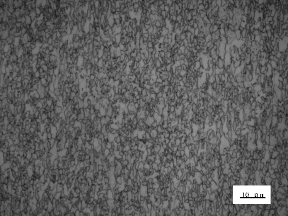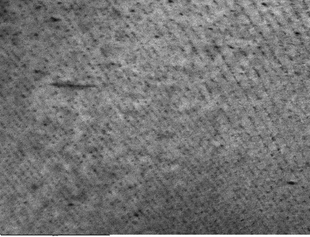
Fig.1 Microstructure and precipitates of the steel
Recent Publications (minimum 5)
- Yajun HUI, (2017) Strengthening Mechanism of 600 MPa Grade Nb-Ti Microalloyed High Formability Crossbeam Steel. ACTA METALLURGICA SINICA 53(8):937-946.
- Yajun HUI, (2017) Study on Heating Schedule of 1000 MPa Grade Nb-Ti Microalloyed Ultra-High Strength Steel. ACTA METALLURGICA SINICA 53(2):129-139.
- Yajun HUI, (2015) Study on strengthening mechanism of 650MPa grade V-N microalloyed automobile steel. ACTA METALLURGICA SINICA 51(12):1481-1488.
- Yajun HUI, (2018) Analysis on stamping crack of 600 MPa grade crossbeam steel. MATERIALS SCIENCE AND TECHNOLOGY 26(3): 45-50.
- Yajun HUI, (2015) Austenite grain coarsening behavior of titanium microalloyed high strength steel. TRANSACTIONS OF MATERIALS AND HEAT TREATMENT 35(12):140-145.
- Yajun HUI, (2016) Strain induced precipitation of second phase in titanium microalloyed IF steel. Iron and Steel 51(1):82-89.
- Yajun HUI, (2016) Study on Strain-Induced Precipitation in Ti Microalloyed Interstitial-Free Steel. Journal of Iron and Steel Research, International 23(4):90-97.

Biography
Hui Yajun has a deep understanding of metallurgical theory, mainly researching and developing hot-rolled automobile structural steel and high-strength steel, and has in-depth research on the mechanism of metal.
Presenting author details
Full name (As per the passport):Yajun HUI
University/Industry/Organization name: Technology Institute of Shougang Group Co., Ltd.
Designation: (Director/Prof/Assistant or Associate prof/Researcher/Student): Researcher
Country: China
Mobile number (country code – number) :13222085000
Email: huiyajun2013@sina.com
Category: Young researcher forum
Research interest: Development of hot-rolled automobile structural steel and high-strength steel.

