ATMOSPHERIC LASER PRODUCTION OF CHROMIUM OXYCARBIDE COATINGS FROM A Cr₂₃С₆ CERAMICS

I. V. Mel’nikov^{1,2}, Ya. S. Fironov², M. Vlasova³, M. Kakazey³, M. C. Reséndiz-González³, S. I. Kondrashenko¹, and D. A. Ryabtsev¹

¹ Center for Engineering and Technology, Moscow Institute of Physics and Technology, Pervomayskaya ul. 3, Dolgoprudny, Moscow Region 141700, Russian Federation
² School of Radio Engineering and Computer Technology, Moscow Institute of Physics and Technology, Pervomayskaya ul. 3, Dolgoprudny, Moscow Region 141700, Russian Federation
³ Center for Research in Engineering and Applied Sciences, Morelos State Autonomous University (CIICAp-UAEMor), Av. Universidad 1001, Cuernavaca, Mexico

Abstract

This paper reveals features pertinent to Cr₂₃С₆ ceramics ablated with a 1070-nm quasi-cw fiber laser with 1 kW of the average power in an open-air condition. The chromium oxycarbides Cr_{x}C_{y}O_{z} , where the chromium content varies as (0.3-0.8), carbon – as (0.03-0.3), and oxygen – as (0.61-0.26), correspondingly, are found to be a major compound extensively formed in the ablation crater, ejected out into the atmosphere, and deposited onto a substrate afterwards in a globule- or pyramid-type form. The coalescence is shown to be somewhat reminiscent of a fractal growth for the mold and ablation products and its follow-up is deposition that, in turn, is shown to have feature of a size/shape separation

Keywords: chromium-carbide ceramics, laser ablation, quasi-cw fiber laser, chromium oxycarbides

*Corresponding author; Tel./Fax: +52 777 329 70 80
E-mail address: vlasovamarina@inbox.ru (Vlasova Marina.)

- Introduction

Nowadays, the pulsed-laser chemical vapor deposition (PLCVD) has been proved to be one of a few technologies both for a thin-film and nm-multilayer thickness in a component manufacturing for UV-lasers, UV-LEDs, photodiodes, and spintroncs [1-3]. Apart of those, the PLCVD has been widely exploited in combinatorial material science since it enables sintering a great deal of different composition materials that involve higher oxides, which are phase intermediate to basic ones [5, 6]. This allows to create a continuous line of novel materials with novel properties what can be attained for both oxide and oxideless compounds not only by the PLCVD [7-8], and by metal-organic chemical-vapor deposition (MOCVD) [10-12], and by PL-MOCVD [13-16], too.
The MOCVD approach has been exploited towards making up a Cr_{x}C_{y}O_{z} coating on steel in order to improve both a wear resistance and micro-hardness for a complex mold [17-20]. However, it seems to be tempting to suggest these ceramics to be directly deposited on the (structurally and compositionally complex) metal/steel surface by the laser heating-evaporation treatment of the chromium-carbide target in an oxygen/air atmosphere. This is why our paper is aimed at analysis of the specific laser ablation of such targets, which are morphology and phase estimates of the ablation products deposited both on the target and substrate.
The paper is organized as follows: Section 2 presents design of samples and methods of treatment and analysis; Section 3 gives main results obtained and places an appropriate set of discussions around, and Section 4 summarizes our findings.

2. Research design and methods
The laser treatment is done with a single-mode fiber laser model YLS-1000-SM (IPG Photonics) that operates at 1070 nm and 1-kW average power; quasi-cw with a 2-ms pulse width and 250-Hz repetition rate reached by a direct pump switch (DC-current modulation). Samples are treated for 2 seconds in the atmosphere without making use of an air or inert gas blow and, in order to avoid damage, are preliminary heated up to 200 ° C. The Cr₂₃С₆ samples exploited in this paper have a cylindrical form with 5-mm diameter and 8-mm height.
This treatment results in a 2-mm crater formed on the sample surface that seems to be natural for a kW-laser drilling. The evaporation/ablation products are deposited on a sital substrate paralleled to the sample surface at 70 and 75 mm. The analysis of samples and ablation products is performed with an XRD Siemens D-500 and SEM Hitahi SU5000; microanalysis is performed with Bruker XFlash 6/60.

- Results and discussions
This Section presents morphology and chemical analysis for products that are emerging when Cr₂₃C₆ ceramics are laser-treated what is given from the standpoint of having chromium-oxycarbide micro- and nano-films with required composition, morphology, and thickness. These seems to offer valuable recommendations for industrial manufactures of, e.g., high-endurance metal cutters and electronic components.
The X-ray diffraction analysis presented in Fig. 1, shows that before the laser treatment the sample consists mainly of Cr₂₃C₆ with a small admixture of Cr₇C₃ and Cr₃C₂. The treatment leads to the major ceramic transformation to the amorphous phase with the diffraction maximum at 2Ө~30º. Fig. 1 also shows the amorphous phase pertinent to the ablation products that are deposited at the substrate with diffraction maximum at 2Ө~20º and corresponding set of peaks.
The laser treatment of the samples for two seconds leads to the formation on the surface of samples of the crater with a characteristic size of 2 mm, which is typical for the laser drilling mode and does not depend on whether the laser operates in a continuous or quasi-impulse mode. Fig. 2a shows that in the crater where the ceramics is getting predominantly melted, the mold is partially ejected as droplets of various sizes what indicates the temperature rise in excess of 1520 ° C (melting point of Cr₂₃C₆). These SEM studies presented in Figs. 2b through 2d show ablation products precipitated at the sample surface as one of the two different type, which either are pyramids, globules or something similar or look like loose clusters of disordered fibers, with the first type being available in the close vicinity to the crater, and the second – on its periphery, correspondingly.
These loose cluster also dominate all over the substrate, however, Fig. 3 reveals there is an impregnations of spherical particle which typical linear size is d ≤ 2 μm underneath a loose layer of cauliflower-type collections of fibers. This can stem from two available mechanisms of plum dynamics, thermal and ablative, what, in turn, dictates the arrival time for all products generated in the plume. That is, the precipitation of heavy globules with excessive chromium which a due to the ablation-type dynamics comes first, and then the one that consists of cauliflower-type fibers rich with carbon and its oxides follows up on its top.
The dynamics of globules is presented in Fig. 4. That is, the growth of globules on the target surface starts out from disordered nanofibers that rise up accidentally at the first step (see Fig. 4a). In the next stage, the close proximity and intersection of nanofibers as well as nanoparticle deposition serve as a globule seed and takes a form of a cauliflower loose array that is followed by the fractal-type coalescence (see Fig. 4c) and crystallization of globules (see Figs. 4 d and e), accordingly [9, 10, 16, 22-24]. A noticeable feature of the larger-size globules is a continuous, gradual growth of a dense shell comprising of pyramidal micro-crystallites. In turn, each that globule keeps making those loose nanoparticles and nanofibers deposited on its convex surface (compare Fig. 4e vs 4f) [25]. Simultaneous appearance of a few such spots of deposition yields to the complicated morphology of the growing globule (see Fig. 4g).
The EDS results demonstrate the presence of chromium, oxygen, and carbon at different rations as deposition products both on sample and substrate. In turn, the non-irradiated surface seemed to reveal no other species but chromium and carbon (see Table 1). The excessive presence of oxygen means availability of the corresponding process in the processing volume. That is, the oxygen concentration grows up near the crater whereas the concentration of carbon falls down accordingly (see zone 1 in Table 1). This can be interpreted as an atmosphere enriched with CO(CO₂) is created in the crater that prevents chromium carbide from being oxidized completely. What is more, this atmosphere has a carbon composition alternating along the crater vertical, i.e. CO dominates at the bottom, and CO₂ at the top of the crater, correspondingly. This is probably why the crater ejects a variety of different oxides that are different sets of Cr_{x}C_{y}O_{z}. At shorter distances from the crater, the target accommodates ablation products which are less oxidized or even non-stoichiometric (zone II in Table 1). In the deposition zone III, which is at a considerable distance from the crater, there is an excessive concentration of oxygen and inadequately small concentration of carbon. This is also typical for products deposited on the substrate what, all together, can be interpreted as an “oxide oxidation” up to Cr₂O₃, which extra proof is a green coloration revealed both by the substrate and distant areas of the target.
Therefore, the results obtained show that the ceramic atmospheric processing with a quasi-cw laser sets up a chromium-carbide dissociation in the high-temperature zone in accordance with a PLCVD-type mechanism [10, 11, 13-16]. In this process, the products of the Сr₂₃C₆ dissociation turned out to be chromium oxicarbides Cr_{x}C_{y}O_{z} with different metrics x, y, and z, which depend on the plasma-discharge composition inside the crater and so on its depth/ Given the distance to the substrate also make a contribution of its own what implies the deposited structure can to have an alternating composition like globules/pyramids where pyramids could be of chromium only.
Finally, a few words should be spoken out around appearance of chromium oxide and oxycarbides while the Cr₂₃C₆ target is irradiated by the quasi-cw fiber laser. From a number of processes of evaporation-dissociation of chromium carbides and/or their oxidation that might occur in the plume, only a small portion of reactions are likely to have happened there [25, 26]:
1/9Cr₂₃C₆ ↔ 2/9 Cr₇C₃ + Cr_{gas};
2/5Cr₇C₃ ↔ 3/5 Cr₃C₂ + Cr_{gas};
1/9Cr₃C₂ ↔ 2/3 C_{gas} + Cr_{gas};
4/69Cr₂₃C₆ + O₂ = 46/69 Cr₂O₃ + 8/23C;
4/81Cr₂₃C₆ + O₂ = 46/81 Cr₂O₃ + 8/27CO;
4/93Cr₂₃C₆ + O₂ = 46/93 Cr₂O₃ + 8/31CO₂;
4/21Cr₇C₃ + O₂ = 2/3 Cr₂O₃ + 4/7C;
4/27Cr₇C₃ + O₂ = 14/27 Cr₂O₃ + 4/9CO;
1/2Cr₃C₂ + O₂ = 3/2 Cr + CO₂;
Cr₃C₂ + O₂ = 3Cr + 2CO.
The availability of a high-temperature heating going on inside (or in the vicinity) of the crater seems to be a straightforward prerequisite to these processes. The carbon departure along grain boundaries makes these zones enriched with oxygen what prompts Cr₂₃C₆ to transform into an oxycarbide. Such an appearance of Cr, CO, and C both as atoms and as cluster-type particles hence, at first, is quite expected logically and, at the second glance, raises up concentration of carbon oxides outside the processing zone.
However, departing from the crater, both vertically and horizontally, makes the gas composition thermodynamic again, that is, it follows temperature gradient and so defines the collision frequency, and, synthesis of whole bunch of chromium oxicarbides, which, in turn, are a subject of coalescence. Some of those oxicarbides are able to reach the substrate while the others have to turn back to the target and deposit there. The flight distance is relatively small for the mold and large clusters what prevents those from reaching the substrate and so get those deposited in the vicinity of the crater. On contrary, smaller particulates, nanoparticles and nanofibers, have larger flight/collision distance and so become predominantly deposited on the periphery of the target and on the substrate, too.

4. Conclusion
In conclusion, products of the quasi-cw laser ablation/deposition of Cr₂₃C₆-based ceramics in the air are thoroughly studied with XRD, EDS, and microanalysis tools. In this type of laser-assisted spray technology the main processes that take place in the processing zone are the high-temperature melting and evaporation. In turn, these are accomplished with intense splashing, dissociation of chromium carbide, and filling in the crater with CO and CO₂ that decrease the O₂ concentration there and slow down the oxidation processes accordingly. The availability of atoms Cr and C as dissociation products in the crater facilitates the PLCVD-type synthesis of both non-stoichiometric chromium oxycarbides (Cr_{x}C_{y}O_{z} with different x, y, and z) and chromium oxides in the form of nano-clusters in the variety of shapes like cauliflower-shaped disordered fractal arrays. Moreover, the Cr_{x}C_{y}O_{z} flight through the air not only accomplishes with its oxidation up to a chromium oxide and its coating on the substrate features a “particle size” separation. These results can be exploited in rising up Cr_{x}C_{y}O_{z} coatings for a metallic hardware masterpiece.

References
[1] Chrisey D B and Hubler G K (eds) 1994 Pulsed Laser Deposition of Thin Films (New York: Wiley).
[2] Christen H M, Silliman S D and Harshavardhan K S 2002 Epitaxial superlattices grown by a PLD-based continuous compositional-spread technique Appl. Surf. Sci. 189 216−221.
[3] Christen H M and Eres G 2008 Recent advances in pulsed-laser deposition of complex oxides J. Phys.: Condens. Matter 20 264005
[4] Keller D A Ginsburg A Barad H-N et al Utilizing Pulsed Laser Deposition Lateral Inhomogeneity as a Tool in Combinatorial Material Science 2015 ACS Comb. Sci. 17 209–216
[5] Christen H M Ohkubo I Rouleau C M et al 2005 A laser-deposition approach to compositional-spread discovery of materials on conventional sample sizes Meas. Sci. Technol. 16 21−31.
[6] Baoshuai Du Anoop Samant N Sameer Paital R and Narendra Dahotre B 2008 Pulsed laser synthesis of ceramic–metal composite coating on steel, J. Appl. Surf. Sci. 255 3188–3194
[7] Caricato A P Luches A Martino M et al 2010 Deposition of chromium oxide thin films with large thermoelectromotive force coefficient by reactive pulsed laser ablation J. Optoelectron Adv Mat 12 427 – 431
[8] Christiansen K Luenenbuerger M Schineller B et al 2002 Advances in MOCVD technology for research, development and mass production of compound semiconductor devices Opt-Electron Rev 10 237–242
[9] Douard A Maury F Jorcin J B et al 2007 Reactivity of Cr(CO)₆ in atmospheric pressure CVD processes for the growth of various metallurgical coatings Rev Adv Mater Sci. 15 24-32
[10] Douard A Bernard C and Maury F 2008 Thermodynamic simulation of atmospheric DLI-CVD processes for the growth of chromium-based hard coatings using bis(benzene)chromium as molecular source Surf Coat Technol 203 516-520
[11] Fillit R Y Maury F and Schuster F 1991 Structural characterization of chromium carbide coatings deposited by MOCVD: evidence for a cubic metastable CrC_{1-x} In: Proceeding of the. 8th Intern Conf Ion and Plasma Assisted Techniques (IPAT Brussels) 50-55
[12] Carta G Natali M Rosseto G et al 2005 A comparative study of Cr2O3 thin films obtained by
MOCVD using three different precursors Chem Vapor Depos 11 375-380
[13] Nowak R Konstantinov L and Hess P 1989 Laser induced chemical vapor deposition of
chromium films from chromium hexacarbonyl using a KrF excimer laser Appl Surf Sci 36 177-184
[14] Sandana V E Rogers D J Hosseini Teherani F R. et al 2009 Comparison of ZnO nanostructures grown using pulsed laser deposition, metal organic chemical vapor deposition, and physical vapor transport J. Vac. Sci. Technol. B 27 1678-1683
[15] Rabiee Golgir H 2017 Laser-Assisted Metal Organic Chemical Vapor Deposition of Gallium Nitride" , Thesis PhD The Graduate College at the University of Nebraska USA.
[16] Douard A and Maury F 2005 Chromium-based coatings by atmospheric chemical vapor deposition at low temperature from Cr(CO)₆ Surf Coat Technol 200 1407 – 1412
[17] Mazumder J 1996 Laser assisted surface coatings In: Stern K.H. (eds) Metallurgical and Ceramic Protective Coatings (Springer Dordrecht)
[18] Kim T H and Kim B C 1992 Chromium carbide laser-beam surface-alloying treatment on stainless steel J Mat Sci 27 2967 - 2973
[19] Chen J Wang S-H and Xue L 2012 On the development of microstructures and residual stresses during laser cladding and post-heat treatments J Mater Sci 47 779–792
[20] Wu S Guo B Li T and Gui D 2015 Oxidation of chromium carbide coated Q235 steel in wet and dry air at 750 ºC Construct Build Mater 81 11–14.
[21] Martin. W Chu Y.-H Ramesh R 2010 Advances in the growth and characterization of magnetic, ferroelectric, and multiferroic oxide thin films, Mater Sci Engineer R 68 89–133
[22] Mandelbrot B B 1977 Fractals: Form, chance and dimension (San Francisco: Freeman)
[23] Vicsek T 1991 Fractal growth phenomena (Singapore World Scintific)
[24] Mikhailov E F Vlasenko S S 1994 Formation of fractal structures in the gas phase Adv Phys Sci 165 263-283
[25] Allahyarov Sandomirski K Egelhaaf S U Löwen K 2015 Crystallization seeds favor crystallization only during initial growth Nature Commun 6 7110
[26] Kosolapova T Y 1971 Carbides (Plenum Press, New York)

Table 1. Spatial distribution of chemical components across the sample/substrate surface

Analyzed area | Chemical element concentration,  wt.% |  |  | Composition
 | C | O | Cr
Fresh fracture | 3.22  8.64 | 0.56  1.17 | 96.22  90.18 | Close to Cr₂₃C₆
Irradiated surface

Crater wall  near the surface  at the bottom | 1.76  5.91  6.14  7.88 | 17.85  30.83  25.70  28.07 | 80.39  63.27  66.42  63.30 | Cr_{x} C_{y}O_{z}  x~ (0.81-0.63),  y~ (0.087- 0.02),  z~ (0.28-0.18)
Sample surface near the crater  at the crater edge  at 1-mm from the edge | 2.18  6.76  5.29  6.97 | 32.49  6.19  15.71  15.84 | 65.33  87.05  79.00  77.19 | close to Cr₂O₃  Cr_{x} C_{y}O_{z}  x~ (0.88-0.77),  y~ (0.077-0.053),  z~ (0.16- 0.04)
At 1.5 mm from the crater  sample edge | 5.08  3.00  3.43  1.08 | 35.02  24.05  26.30  33.53 | 59.90  72.95  70.27  65.39 | Cr_{x} C_{y}O_{z}  x~ (0.73-0.60),  y~ (0.05-0.01).  z~ (0.35- 0.24),  close to Cr₂O₃

 | Ablation products
Different sites across the substrate | 1.45  1.69  3.52  4.57  2.55  2.61  5.91 | 25.68  18.78  39.24  54.55  59.38  60.87  60.80 | 73.47  79.78  57.24  40.87  38.07  36.52  33.29 | close to CrO  close to CrO+Cr  close to CrO₂  close to CrO₄  Cr_{x} C_{y}O_{z}  x~ (0.74-0.33),  y~ (0.06-0.015),  z~ (0.61- 0.26)

Figure captions

Fig. 1. Fragments of X-ray diffraction pattern of the used chromium carbide ceramics. (a) fracture of specimen; (b) surface of ceramics after irradiation; (c) precipitated products of ablation.

Fig. 2. SEM micrographs of ceramic surface covered with deposited products of ablation at different distance from crater .

Fig. 3. SEM micrographs of precipitated ablated products at different magnification

Fig. 4. SEM micrographs of different stages of globules fractal growth

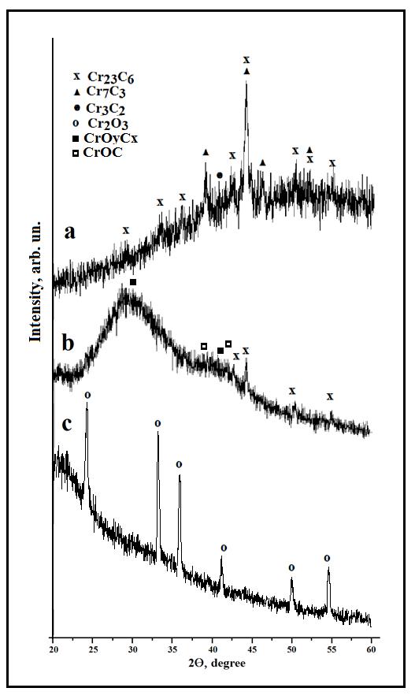

Fig. 1. Fragments of X-ray diffraction pattern of the chromium carbide ceramics used in the experiment: (a) fracture of specimen; (b) surface of ceramics after the laser irradiation; (c) precipitated ablation products.

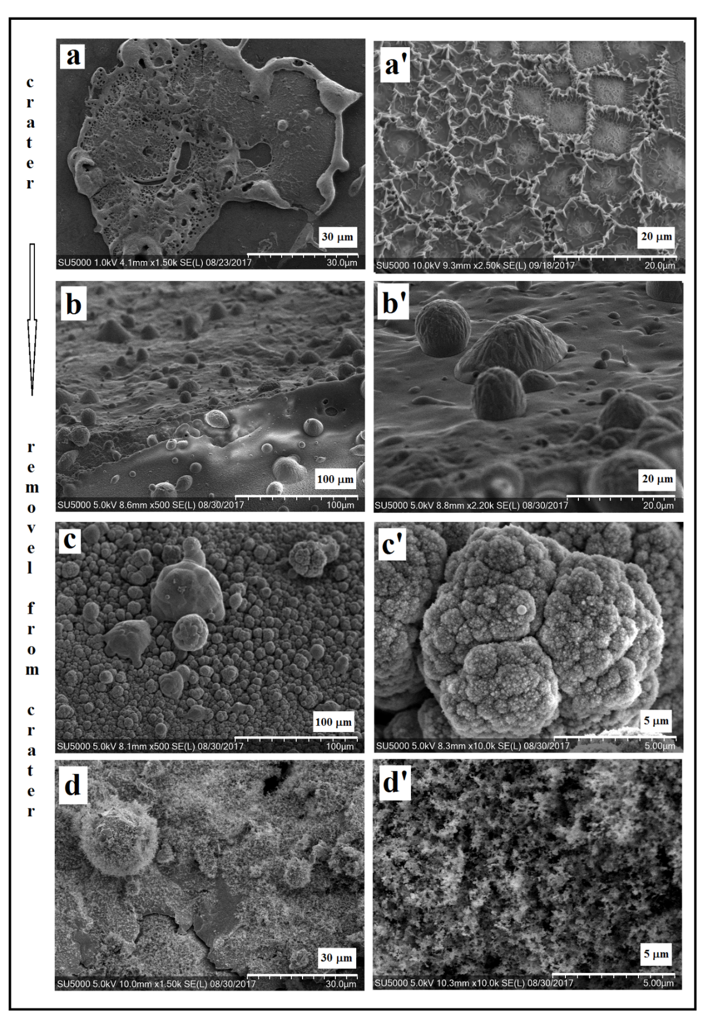
Fig. 2. SEM micrographs of ceramic surface covered with deposited products of ablation at different distances from the crater.

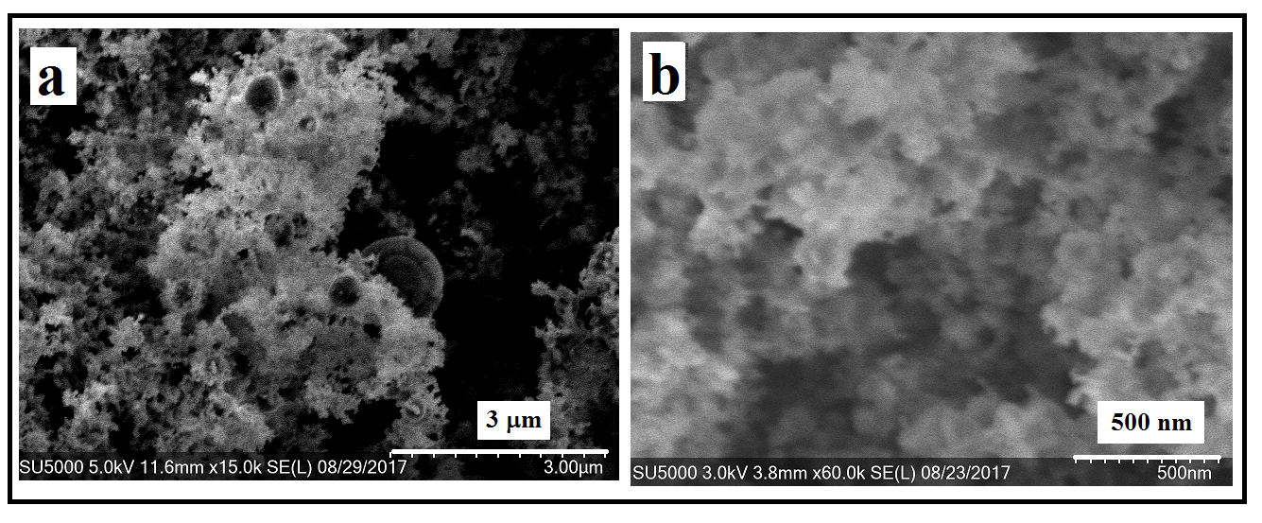
Fig. 3. SEM micrographs of precipitated ablated products at different level of magnification

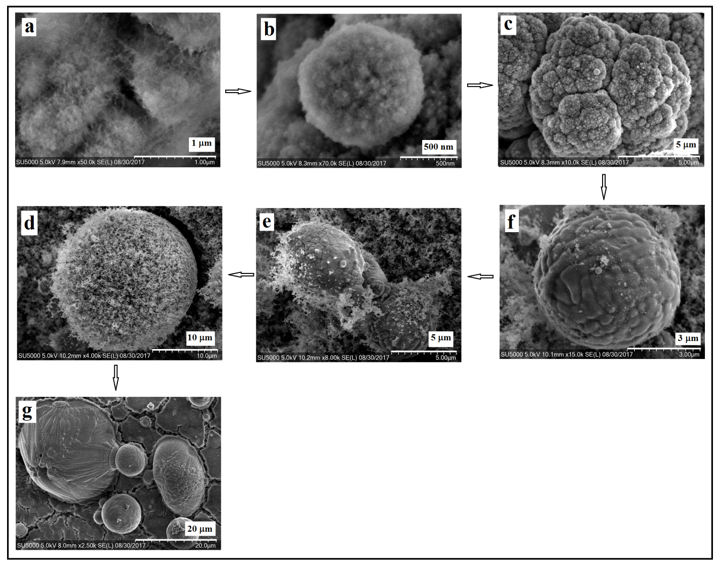

Fig. 4. SEM micrographs of different stages of globule fractal growth

