
 Sahand University of Technology
Optimization of hybrid TIG-MIG welding parameters of 316L austenitic stainless steel, and a comparison study with MIG process
Mojtaba Ostovar, M. S., Faculty of Materials Engineering, Sahand University of Technology, Tabriz, Iran
Tohid Saeid, Associate Professor, Faculty of Materials Engineering, Sahand University of Technology, Tabriz, Iran
Amir Mostafapour, Associate Professor, Faculty of Mechanical Engineering, University of Tabriz, Tabriz, Iran.
Sajad Emami, PhD, Faculty of Materials Engineering, Sahand University of Technology, Tabriz, Iran

Abstract

In the MIG-TIG hybrid welding method, better quality and efficiency is achieved compared with MIG and TIG methods. Also, in hybrid method, MIG arc is more stable in the shielding atmosphere of pure argon gas. Therefore, in this study the effects of the TIG-MIG hybrid welding parameters on the apparent quality and the depth to width ratio of 316L austenitic stainless steel were investigated using Taguchi design of experiments (DOE). Then, the microstructure of hybrid weld yielded from the optimum parameters of Taguchi DOE were compared with MIG weld under equal heat-input condition. The results revealed that the most important parameter in the hybrid method to obtain the best apparent quality and the highest depth to width ratio is the distance between the two arcs and the MIG and TIG currents are the next parameters. In hybrid welding using optimum parameters, the weld depth to width ratio increased by 92% and welding speed by 56% with respect to ordinary MIG welds. In addition, the grain size and the HAZ width in hybrid welding was smaller than that in MIG processes due to higher cooling rate in the hybrid welding method.
Key words: Hybrid Welding, Austenitic Stainless Steel, Microstructure, TIG Welding, MIG Welding

Image
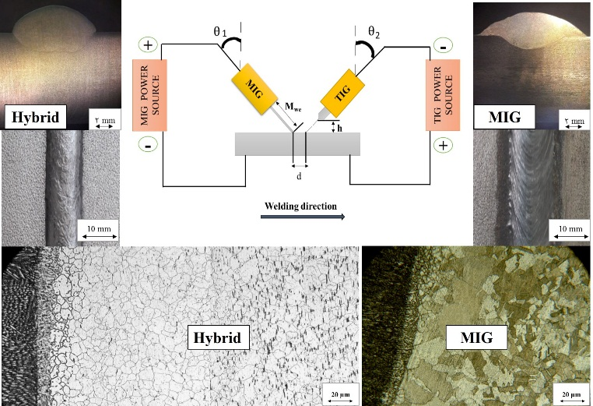
Graphical Abstract.
Recent Publications (minimum 5)
- Saeid T, Abdollah-Zadeh A, Sazgari B (2010) Weldability and mechanical properties of dissimilar aluminum–copper lap joints made by friction stir welding, Journal of Alloys and Compounds 490:652-655
- Emami S, Saeid T (2015) Effects of welding and rotational speeds on the microstructure and hardness of friction stir welded single-phase brass, Acta Metallurgica Sinica (English Letters), 28 (6):766–771.
- Emami S, Saeid T, Azari Khosroshahi R (2018) Microstructural evolution of friction stir welded SAF 2205 duplex stainless steel, Journal of Alloys and Compounds 739:678-689.

Biography
Mojtaba Ostovar is interested in investigation microstructural and mechanical properties of metallic alloys during and after any welding processes like TIG, MIG, and TIG-MIG hybrid welding techniques.

Presenting author details
Full name: Tohid Saeid
University name: Sahand University of Technology
Designation: Associate professor
Country: Iran
Mobile number: +98-9144019901
Email: Saeid@sut.ac.ir
Category: poster presentation
Research interest: Joining & welding, Characterization

