
 Sahand University of Technology

Microstructural evolution of friction stir welded AISI 304 austenitic stainless steel
Sajad Emami, PhD, Faculty of Materials Engineering, Sahand University of Technology, Tabriz, Iran
Tohid Saeid, Associate Professor, Faculty of Materials Engineering, Sahand University of Technology, Tabriz, Iran

Abstract
Hot deformation behavior of AISI 304 austenitic stainless steel was studied in friction stir welding (FSW) process at welding speed of 50 mm/min and rotational speed of 400 rpm. Microstructural observations were carried out using optical microscopy and scanning electron microscopy equipped with electron back scattered diffraction (EBSD) system. The results indicated that rough equiaxed grains of the base material (BM) were severely deformed and elongated in thermo-mechanically affected zone (TMAZ). EBSD resultsrevealed that high frequency of low angle grain boundaries (LAGBs) was formed during the occurrence of dynamic recovery (DRV) in the TMAZ. Moreover,the results showed that the concurrence of severe plastic deformation and high thermal cycles during the welding process introduced a very fine microstructure in the stir zone (SZ) of the weldment. EBSD results displayed that the frequency of the high angle grain boundaries (HAGBs) increased running from the TMAZ towards the SZ. FSW rotating tool developed simple shear texture components of A*₁, A*₂ in the SZ. The presence of loose HAGBs in the TMAZ along with the common shear texture components in the SZ suggested that the microstructure of the evolved material developed mainly through the occurrence of continuous dynamic recrystallization (CDRX) softening mechanism.

Key words:Stainless Steels, Dynamic Recovery, Shear Texture, continuous dynamic recrystallization

Image
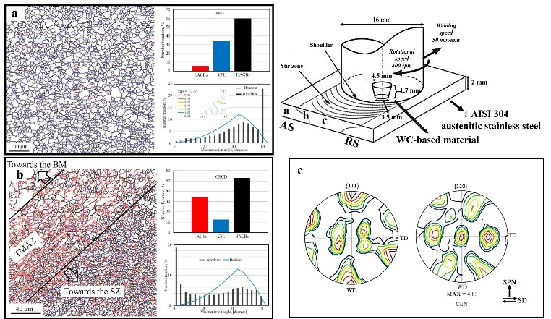
Graphical Abstract.
Recent Publications (minimum 5)
- Emami S, Saeid T, Azari Khosroshahi R (2018) Microstructural evolution of friction stir welded SAF 2205 duplex stainless steel, Journal of Alloys and Compounds 739:678-689.
- Heidarzadeh A, Saeid T, KlemmV (2016) Microstructure, texture, and mechanical properties of friction stir welded commercial brass alloy, Materials characterization 119:84-91.
- Saeid T, Abdollah-Zadeh A, Shibayanagi T, Ikeuchi K, Assadi H (2010) On the formation of grain structure during friction stir welding of duplex stainless steel, Materials Science and Engineering: A 527: 6484-6488.
- Saeid T, Abdollah-Zadeh A, Sazgari B (2010) Weldability and mechanical properties of dissimilar aluminum–copper lap joints made by friction stir welding, Journal of Alloys and Compounds 490:652-655.
- Saeid T, Abdollah-zadeh A, Assadi H, MalekGhaini F, (2008) Effect of friction stir welding speed on the microstructure and mechanical properties of a duplex stainless steel, Materials Science and Engineering A 496:262–268.

Biography
Sajad Emami is interested ininvestigation ofmicrostructural evolution of metallic alloys during and after different manufacturing processes like metal forming & joining processes, Heat treatment, and etc.

Presenting author details
Full name: Tohid Saeid
University name: Sahand University of Technology
Designation: Associate professor
Country: Iran
Mobile number: +98-9144019901
Email: saeid@sut.ac.ir
Category: Oral presentation
Research interest: Joining & welding, Characterization
Your profile page URL in your department:http://mae.sut.ac.ir/showcvmain.aspx?id=20
Year of birth:
Linked In/Facebook/twitter account:

