 Dr. Yasmina HAMMOUI   Department of Microbiology and Biochemistry, Faculty of Sciences,
University of M’sila, 28000, Algeria / Research Laboratory in
Mathematics, Biophysics and Biochemistry, 06000, Bejaia, Algeria

Effect of filler load and High-energy ball milling process on biocomposite properties.
Yasmina Hammoui, PhD, Department of Microbiology and Biochemistry, Faculty of Sciences, M'sila University, Algeria; Research Laboratory in Mathematics, Biophysics and Biochemistry, Bejaia, Algeria.
Asma Boudria, PhD, Research Laboratory in Mathematics, Biophysics and Biochemistry, Bejaia, Algeria.
Nawel Adjeroud, PhD, Research Laboratory in Mathematics, Biophysics and Biochemistry, Bejaia, Algeria.
Khodir Madani, professor, Research Laboratory in Mathematics, Biophysics and Biochemistry, Bejaia, Algeria.

Abstract (300 word limit)
The increase of particles surface area can optimize the dispersion state of of biocomposite components and enhance their properties. First in this paper, we aimed to elaborate a novel biocomposite without any treatments. Plasticized wheat gluten (WG), was filled with 0-20% of olive pomace (OP) powder. The second objective was the improvement of biocomposite properties using physical treatment. High-energy ball milling process was applied on the blend of wheat gluten and olive pomace powders (MPs). The grinding effect of particle shape, size and distribution in biocomposite was characterised by particle size distribution using a laser-light diffraction and by SEM analysis. The cryo-fractured surface of selected films, mechanical properties, moisture absorption and thermal properties of both biocomposites were described in details. It was found that the sensitivity of biocomposites to moisture absorption was reduced with the increase of filler content after the applying of high-energy ball milling process. The thermal stability of OP biocomposite decreased with the increase of loading, while that of MPs was unaffected by high-energy ball milling process. This process affects the physical and morphological characteristics of the powders. The mechanical properties were improved by grinding process at filler content lower than 15%.

Key words: wheat gluten, olive pomace powder, High-energy ball milling process, particle-size reduction, mechanical properties.

Image
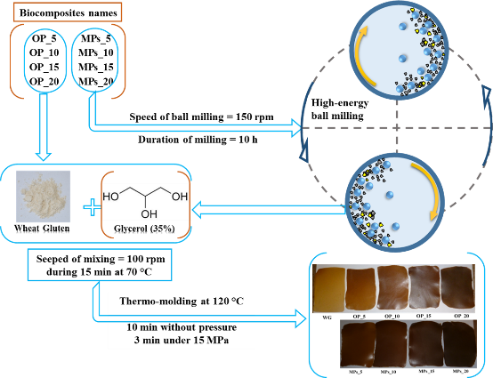
Figure 1: Characterization of composite materials based on wheat gluten and olive pomace, produced by two processes
Recent Publications (minimum 5)
- Adjeroud N, Elabbas S, Merzouk B, Hammoui Y (2018) Effect of Opuntia ficus indica mucilage on copper removal from water by electrocoagulation-electroflotation technique: Journal of Electroanalytical Chemistry 811:26-36.
- Boudria A, Hammoui Y (2018) Effect of filler load and high-energy ball milling process on properties of plasticized wheat gluten/olive pomace biocomposite: Advanced Powder Technology.
- Djerroud N, Adjeroud N, Haddache L, Hammoui Y (2017) Enhanced electrocoagulation-electroflotation for turbidity removal by Opuntia ficus indica cladode mucilage: Water and Environment Journal.
- Hammoui Y, Molina-Boisseau S, Duval A (2015) Preparation of plasticized wheat gluten/olive pomace powder biocomposite: Effect of powder content and chemical modifications: Materials and Design 87: 742–749.

Biography: Yasmina Hammoui has a good experience in manufacturing of novel materials based on by-products of food industry and on renewable sources. Her goal is to develop eco-friendly materials with good properties for different applications.
Presenting author details
HAMMOUI YASMINA
Department of Microbiology and Biochemistry, Faculty of Sciences, University of M’sila, 28000, Algeria/ Research Laboratory in Mathematics, Biophysics and Biochemistry, 06000, Bejaia, Algeria.
Designation: Associate prof. / Country: Algeria
Mobile number: 213 – 778607674; Email: yasmina.hammoui@univ-bejaia.dz
Category: Poster presentation.
Research interest: characterization and testing of materials.
Your profile page URL in your department: https://www.researchgate.net/profile/Yasmina_Hammoui
Year of birth: 1984.

