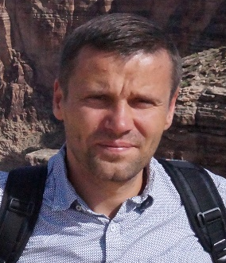

Controlling of microgel size by electrochemically induced volume phase transition
Marcin Karbarz, PhD, Kamil Marcisz, MSc, Marcin Mackiewicz, PhD, Jan Romanski, PhD, Zbigniew Stojek PhD, University of Warsaw

Abstract
Microgels are polymer hydrogels or macromolecules that form, in a micro scale, three-dimensional networks filled with a solvent. Microgels are characterized by low viscosity and very high surface area, but the most intriguing property of these materials is their ability to change substantially their volume. This phenomenon is called the volume phase transition and is observed as the response of a polymer network to an external stimuli, such as change in temperature, pH, ionic strength and magnetic/electric field.^{1,2} In microgels, the change in volume is great and it is much quicker compared to regular-size hydrogels. These properties are useful in such potential applications as controlled drug delivery systems, catalysis and sensors.³⁻⁵
We have successfully synthesized a novel microgel the volume of which could be changed by using an electrochemical trigger. At appropriate potential and at human-body temperature the volume change was unusually high - by more than one order of magnitude. The starting material was a thermoresponsive microgel built from N-isopropylacrylamide, sodium acrylate and N,N’-bisacryloylcystine as the crosslinker. The gel has been modified with aminoferrocene through amid-bond formation. The influence of oxidation state of the ferrocene groups in the micro-gel on volume phase transition temperature was determined. The -S-S- groups from the N,N’-bisacryloylcystine linker were employed in the chemisorption of the microgels on the Au electrode surface and the formation of gel monolayers. It appeared that the microgel layers could be either in the shrunken or the swollen state depending on the oxidation number of the iron atoms in the ferrocene groups. The oxidation number could be changed electrochemically and the shrunken-swollen transformation could be repeated reversibly many times. The properties of the obtained materials were examined with dynamic light scattering technique, UV-Vis spectroscopy, SEM and TEM microscopies and cyclic voltammetry.

Key words: Microgels, Smart Materials, Volume Phase Transition, Electroactive and Electrosensitive materials

Image
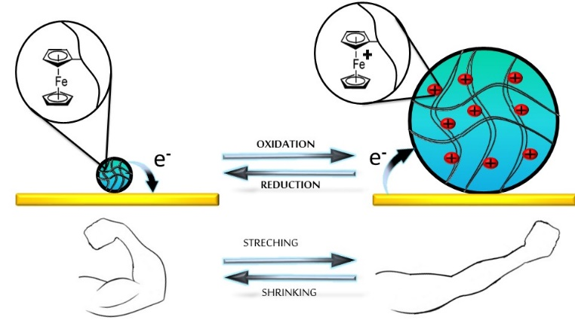
Figure. Potential-triggered microgel volume phase transition that can mimic muscle activity.

Recent Publications
- Karbarz M, Mackiewicz M, Kaniewska K, Marcisz K, Stojek Z (2017) Recent developments in design and functionalization of micro- and nanostructural environmentally-sensitive hydrogels based on N-isopropylacrylamide. Applied Materials Today 9:516-532.
- Marcisz K, Romanski J, Stojek Z, Karbarz M (2017) Environmentally sensitive hydrogel functionalized with electroactive and complexing-iron(III) catechol groups. Journal of Polymer Science, Part A: Polymer Chemistry 55:3236-3242.
- Mackiewicz M, Marcisz K, Strawski M, Romanski J, Stojek Z, Karbarz M (2018) Modification of gold electrode with a monolayer of self-assembled microgels. Electrochimica Acta 268:531-538.
- Mackiewicz M, Kaniewska K, Romanski J, Augustin E, Stojek Z, Karbarz M (2015) Stable and degradable microgels linked with cystine for storing and environmentally triggered release of drugs. Journal of Materials Chemistry B 3:7262-7270.
- Mackiewicz M, Stojek Z, Karbarz M (2017) Unusual swelling behavior of core-shell microgels built from polymers exhibiting lower critical solubility temperature. European Polymer Journal 95: 314-322.

Biography
Marcin Karbarz’s scientific interest has focused on the obtaining new, advanced gel materials with the desired properties. The research is focused on functionalization of gels to get their needed properties. Among those properties are the gel abilities to: undergo a volume phase transition under specified conditions, become electroactive and electrosensitive , undergo reversible changes in their properties upon phase transition, bind/sorb certain individuals and release them in controlled manner, become sensitive to other / new environmental factors, self-heal and self-assembly.

Presenting author details
Full name (As per the passport): Marcin Dawid Karbarz
University/Industry/Organization name: University of Warsaw
Designation: (Director/Prof/Assistant or Associate prof/Researcher/Student): Assistant prof
Country: Poland
Mobile number (country code – number) : +48 -503 101 059
Email: karbarz@chem.uw.edu.pl
Category (Oral presentation/ Poster presentation/Young researcher forum/E-poster): poster presentation
Research interest: The research interest is focused on functionalization of gels to get their needed properties. Among those properties are the gel abilities to: undergo a volume phase transition under specified conditions, become electroactive and electrosensitive , undergo reversible changes in their properties upon phase transition, bind/sorb certain individuals and release them in controlled manner, become sensitive to other / new environmental factors, self-heal and self-assembly.

