
 Official Photo 
University/Organization Logo

DESIGN OF EXPERIMENT (DOE) BASED STATISTICAL APPROACHES TO OPTIMIZED SAW WELDING PROCESS PARAMETERS
Muhammad A Ahmad, Master Student in KFUPM, Dhahran KSA

Abstract (300 word limit)
Joining of metals is very useful concept which is being utilized since Bronze Age and then gradual advancement gave rise to development of modern welding. And now welding is increasingly used in the fields of fabrication, manufacturing and construction. But productivity is the main concern in many manufacturing and industrial welding applications. Therefore selection of a welding process and its variables/parameters without sacrificing weld quality with respect to productivity and its quality is very important because an optimum blend of parameters which inevitably develop minimum or no defect will result in high productivity. Therefore this study will contribute in welding related research work by enhancing the knowledge of welding process and its analysis by utilizing DOE along with both quality loss function and desirability function. Codes and standards provide a range for weld process parameters but author experienced that still there is a window to further optimize these parameters to produce the quality weld in welding shop. For this study SAW process is selected because this versatile welding process is the first choice whenever good productivity with high quality requires. Weld quality is the level of perfection that welds exhibit pertaining to the entire volume of weldment as well as to the profile of weld surface appearance. There are many variables which affect SAW process. In this paper we shall focus on four important controllable factors of current, voltage, travel speed, and heat input to study their’s effects on ultimate tensile strength (UTS), weld hardness, deposition rate, bead width and reinforcement in order to find best weld (with high weld strength and deposition rate, minimum specified hardness, moderate bead width and reinforcement) by using orthogonal factorial method (OFM) and desirability analyses.

Key words: deposition rate, desirability, OFM, optimization, Submerged Arc Welding, weld quality
Image
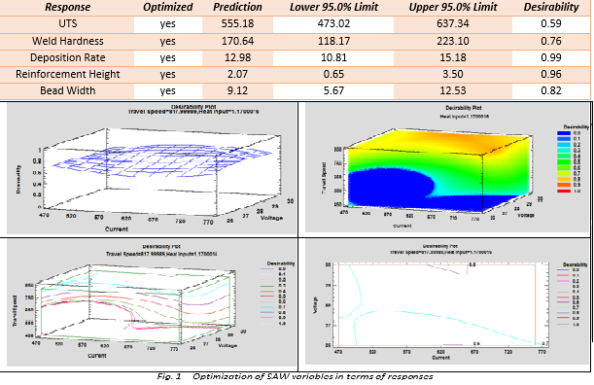
Recent Publications (minimum 5)
- Comparison of quality loss function and desirability function for optimization of welding process .
- Optimization Of Flux Cored Arc Welding (FCAW) By Cube Composite Design And Desirability Function.

Biography
Muhammad A Ahmad is ASME Authorized inspector, CSWIP 3.2, API 510/653/570 certified, ASNT Level III in RT/UT/PT/MT having more than 12 years’ experience in material/manufacturing/welding. This study shall help to enhance the knowledge of welding process and analysis by utilizing DOE along with both quality loss function and desirability function& to provide narrow window of weld process parameter to produce the quality weld
Presenting author details
Full name (As per the passport): Muhammad Asad Ahmad
University/Industry/Organization name: King Fahd University of Petroleum & Minerals Saudi Arabia
Designation: (Director/Prof/Assistant or Associate prof/Researcher/Student): Researcher (Student)
Country: Saudi Arabia
Mobile number (country code – number) :00966-535210942/599382773
Email: asadahmad13@gmail.com
Category (Oral presentation/ Poster presentation/Young researcher forum/E-poster): Oral
Research interest: materials/Manufacturing/welding
Your profile page URL in your department:
Year of birth:: 1984
Linked In/Facebook/twitter account:
Note: Please fill up the Red mark fields so that it would be easier for us to cite your details in the conference particulars. (Please do not forget to fix your photo and Logo above the title)

