Abstract Template
Title: Nanotechnology and the solar collectors future and its effect on the building construction
Ahmed Kadhim Hussein

Professor - College of Engineering -Mechanical Engineering Department - Babylon University- Babylon City - Hilla -Iraq.
E-mail addresses: ahmedkadhim7474@gmail.com

This paper gives a comprehensive overview about the recent advances related with the application of the nanotechnology in various kinds of the solar collectors. Papers reviewed including theoretical , numerical and experimental up to date works related with the nanotechnology applications in the flat plate , direct absorption , parabolic trough , wavy , heat pipe and another kinds of the solar collectors. A lot of literature are reviewed and summarized carefully in a useful tables (Tables1–7) to give a panoramic overview about the role of the nanotechnology in improving the various types of the solar collectors. It was found that the use of the nanofluid in the solar collector field can play a crucial role in increasing the efficiency of these devises.We think that this paper can be considered as an important link between the nanotechnology and all available kinds of the solar collectors. From the other side, further researches are required to study the effect of nanotechnology to enhance the solar collector industry over the next several coming years.

Keywords—Solar energy , nanofluid , renewable energy , nano in building

Prof.Dr. Ahmed Kadhim Hussein was born in Babylon City - Hilla - Iraq on 19 May 1974. Currently, he works as a professor in the Mechanical Engineering Department at the University of Babylon , Babylon City, Iraq. He received his Ph.D. in Mechanical Engineering from University of Al-Mustansiriya - Iraq in 2006. Meanwhile, he is a reviewer of many local and international journals and conferences. He has about fifteen yeas of teaching and reserch work experience .In addition, he is an editor of more than twenty-two international journals. Also , he is a member of many international scientific societies in Austria , Singapore , United States of America , Japan and United Arab Emirates . His research work concerns numerical modelling of various areas of heat transfer, CFD, aerodynamics, nanotechnology, clean energy and extended irreversible thermodynamics. He has also more than fifty five appreciation letters from different scientific organizations around the world .He has published many papers in many local and international journals and conferences.

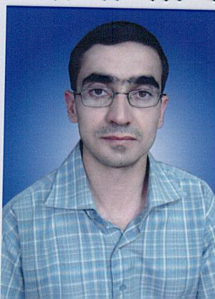

Prof.Dr.Eng. Ahmed Kadhim Hussein
College of Engineering
Department of Mechanical Engineering,
Babylon University
Babylon City, HIILA , IRAQ

E-MAIL ahmedkadhim7474@gmail.com

Any Comments:

