Abstract Title: Hydrogen Generation and Accumulation in Steel and Graphite Irradiated in Inert Environment
E. Krasikov

National Research Centre «Kurchatov Institute» 1, Kurchatov Sq., Moscow 123182, Russia

Abstract (not more than 300 words)

In traditional power engineering hydrogen may be one of the firstprimary sources of equipment damage. This problem has high actuality for both nuclear and thermonuclear power engineering. Study of hydrogen embrittlement of the irradiated steel raises the question concerning the unknown source of hydrogen in nuclear reactors. Unexpectedly high hydrogen concentrations were detected in irradiated graphite also. Consequently alloying of steel and graphite by hydrogen in nuclear reactors takes place. It is necessary to look for this source of hydrogen especially because hydrogen flakes were detected in reactor pressure vessels of Belgian Nuclear Power Plants Doel-3 and Tihange-2. As a possible initial hypothesis about the enigmatical source of hydrogen one can propose protons (hydrogen) generation during beta-decay of free neutrons inasmuch as protons are detected by researches at nuclear reactors as witness of beta-decay of free neutrons.
Keywords—enigmatic source of hydrogen, hydrogen generation and accumulation, irradiated steel and graphite

Professional Biography (100-150 words)

Education: Moscow Power Engineering Institute. Degree(s) or Diploma(s) obtained: Master’s Degree in Material Science – 1970, Ph.D. – 1974, D.Sc. -2005. Membership of professional bodies: member of Scientific Council of RAS on Radiation Damage Physics of Solids. Years within the firm: since 1974. Key qualification: responsible executor in Radiation Damage Physics of Solids. Professional experience record: since 1974 till now, Moscow, NRC "Kurchatov Institute”, Department: Reactor Materials and Technologies Institute.
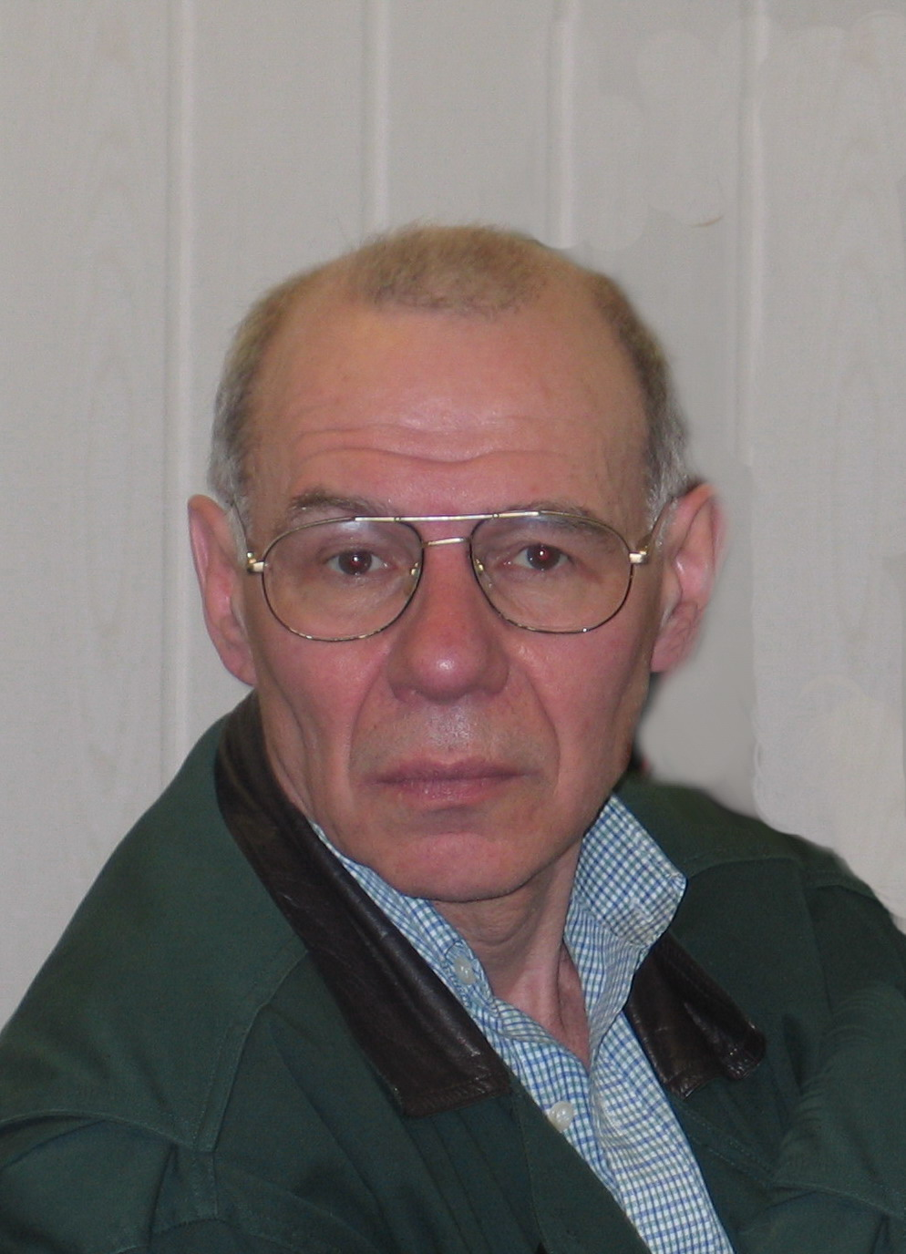
Paste your Photograph here

Email Id: ekrasikov@mail.ru

