Eco-friendly and high yield synthesis of Graphene

Prof. A.S.Khanna and K.S Aneja

Department of Metallurgy, IIT Bombay

Abstract

Applications of Graphene are continuously increasing day by day confirming its importance. We have recently found tremendous use of graphene in enhancing the properties of the organic coatings. We could make pre-treated graphene on metals which showed water permeation rate almost an order of magnitude lower than that of a silane coating of same thickness. In the same way we found that graphene dispersed in epoxy creates a epoxy primer which is twice as corrosion resistant as Inorganic Zinc Silicate primer and almost 10 times more effective than the well-known epoxy zinc rich coatings. In addition there was enhanced UV resistance when exposed to UV weathering, the fracture strength increased by several fold.

In order to use graphene for such application, one requires graphene in powder form and thus there was need to find out a cost effective, eco-friendly synthesis method of graphene. We looked into the feasibility of various methods to form powders. Graphene by oxidation method, though gives good yield is impure. Exfoliation method gives very low yield. We therefore created a special exfoliation method known as Pressure Exfoliation method, where we separate various layer of graphene from powder graphite using high pressure. The yield of this method is close to 20%. The graphene formed is a purest form of graphene with 3-4 layer thick. It is defect free graphene as confirmed by detailed Raman Spectroscopy. The details of graphene structure (TEM), Electron diffraction pattern layer structure and Raman spectrograph is shown below.

References

- Karanveer S.Aneja et. Al, FlatChem 1(2017) 11-19.
- K.S.Aneja et.al Nanoscale 7 (42) (2015) 17879-88

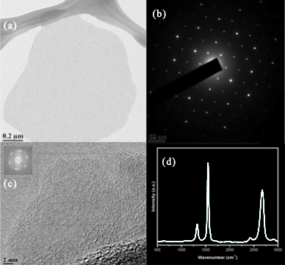

Figure 1: (a) TEM microstructure (b) Electron diffraction pattern (c) surface morphology and (d) Raman spectrogram of graphene prepared by Pressure Exfoliation mehod.

