Abstract Template
Immobilisation of Ni-Crown POM for the electrocatalysis of bromate and chlorate in water

Bushra Ali⁺, Timothy McCormac*

⁺ (Department of Applied Science, Dundalk Institute of Technology)
*(Research Development Centre, Dundalk Institute of Technology

Abstract

Polyoxometalates are versatile and attractive compounds due to their molecular and structural diversity have a broad range of applications in different fields, such as, electronics, electrocatalysis, sensors and nanotechnology. The aim of the present research work is the immobilisation of POMs onto the surface of glassy carbon electrode (GCE) to investigate their potential applications towards the electrocatalysis. A successful immobilisation of the POMs is important for their applications; two immobilisation methods are employed in this study: the Layer-by-Layer and incorporation into polymeric matrixes. These methods were investigated to immobilise Ni₄(P₈W₄₈O₁₄₈)(WO₂)]²⁸⁻) POM by using glassy carbon electrode and it’s electrocatalytic applications towards the chlorate and bromate.

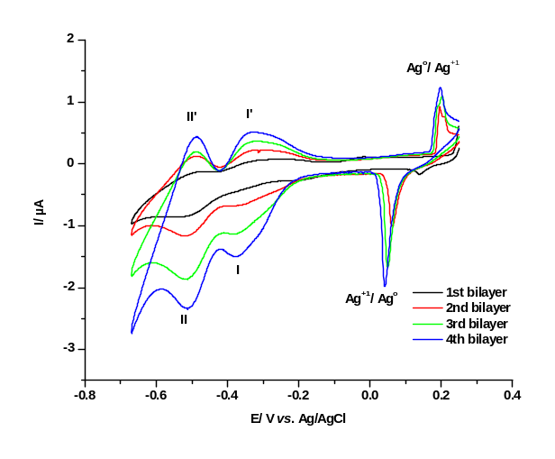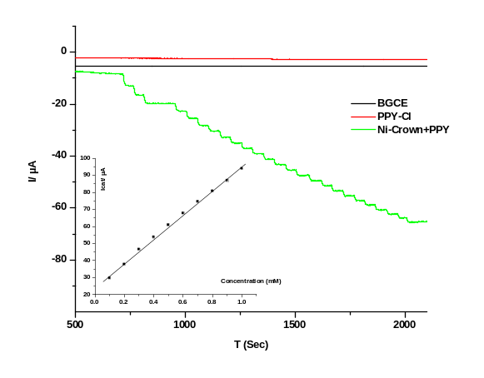
Figure 1 (a) CV of a multilayer film comprised of 4-bilayers of AgNP’s/[Ni₄(P₈W₄₈O₁₄₈)(WO₂)] ²⁸⁻ in pH 2.0 buffer at a scan rate of 10mVs⁻¹. (b) Typical amperometric response of the bare glassy carbon electrode (BGCE) (A= 0.0707 cm²) with in comparison of a chloride dopped polypyrrole (PPY-Cl) and a Ni₄ (P₈W₄₈O₁₄₈) (WO₂)]²⁸⁻ POM+ PPY in pH 2.0 buffer up to 2 mM.

For the LBL method to build the cationic layer a PEI modified silver nanoparticles (AgNP’s) were selected. It was found that the presence AgNP’s within the multilayer assemblies enhanced the electrocatalytic activities of immobilized POM on glassy carbon electrode (GCE) in aqueous solutions. Films were further characterized by cyclic voltammetry (CV), electrochemical impedance spectroscopy (EIS), X-ray photoelectron spectroscopy (XPS) and atomic force microscopy (AFM) was employed to determine their elemental composition and surface morphology. The possibility of the fabrication of polypyrrole films doped with Ni-substituted Crown-type POMs Ni₄(P₈W₄₈O₁₄₈)(WO₂)]²⁸⁻ was investigated on glassy carbon electrode by Chronocoulometry in aqueous buffer. Amperometric sensors for the detection of bromate based on the Ni-substituted crown type POM Ni₄(P₈W₄₈O₁₄₈)(WO₂)]²⁸⁻ was investigated with high sensitivity in a linear range of 0.1-5 mM bromate.

Keywords—POM: Polyoxometalates, AgNP’s: Silver nanoparticles.

Professional Biography

Bushra Ali has completed her PhD at the age of 29 years from the Dundalk Institute of Technology. She is working as a Lecture Assistant in the Dundalk Institute of Technology and working on industrial funded project as a “project scientist” and involve in cross exchange skills within collaborative universities and colleges of Dublin and Dundalk. She attended many conferences and workshops internationally. She worked with many Research centres e.g. MiCRA and as a staff scientist to Mulroy Environmental company. She is also an active member of Steam education within the Ireland. She won many award/Honours and achieved scholarships. She is also a member of Elsevier Journal and RCS.



Bushra.ali@dkit.ie

Any Comments:
If you have further queries about biography please ask for my CV/Resume.

