Title: Significance of Carbon Nanostructures towards Multifaceted Applications
Name: Dr. Shrikant S Maktedar
Affiliation: National Institute of Technology, Srinagar

Abstract (upto 300 words)
Carbonaceous materials have gained the attention of global scientific community to address multifaceted applications. Owning to their astonishing properties, all in one approach have been executed to explore the application of these carbonaceous materials. Energy, environment & healthcare are the utmost important areas of concern for sustainable human development. Therefore, these materials have been deliberately designed & developed to serve the purpose extensively. Furthermore, they have been characterized by using various sophisticated analytical techniques such as near edge X-ray adsorption spectroscopy (NEXAS), ¹³C solid state NMR, HR-XPS, HR-TEM, SAED, XRD, SEM, AFM, Raman, TG-DTA, FTIR, UV-Vis etc. Structural confirmation & electrochemical exploration have ascertained their potential towards energy storage and conversion devices. Thermal stability, antimicrobial activity & cytocompatibility studies have certified their suitability for biological applications. Hence, herein, the methods for design & development of such materials for multifaceted applications have been extensively studied with special emphases on their relevant application.

Biography (upto 150 words)
Dr. Shrikant S Maktedar is an Assistant Professor at Dept. of Chemistry, National Institute of Technology, Srinagar, J&K, India. He received B.Sc. Degree in Chemistry from Ramkrishna Paramhansa Mahavidalaya, Osmanabad (Dr. Babasaheb Ambedkar Marathwada University, Aurangabad) in 2008 and M.Sc. Degree in Physical Chemistry from Dept. of Chemistry, Dr. Babasaheb Ambedkar Marathwada University, Aurangabad in 2010. He has completed his Ph.D. from Central University of Gujarat, Gandhinagar, India. In last 10 years he is working in the field of carbonaceous materials with emphasis on their multifunctional applications. Dr. Shrikant has published more than 10 research publications in peer-reviewed international journals of repute, one book chapter and two full length conference papers. He has served as reviewer for few international journals of repute. After his joining to NIT Srinagar he is serving as Ph.D. supervisor and has established Materials Research Laboratory at Dept. of Chemistry.

Email ID: shrikant@nitsri.ac.in

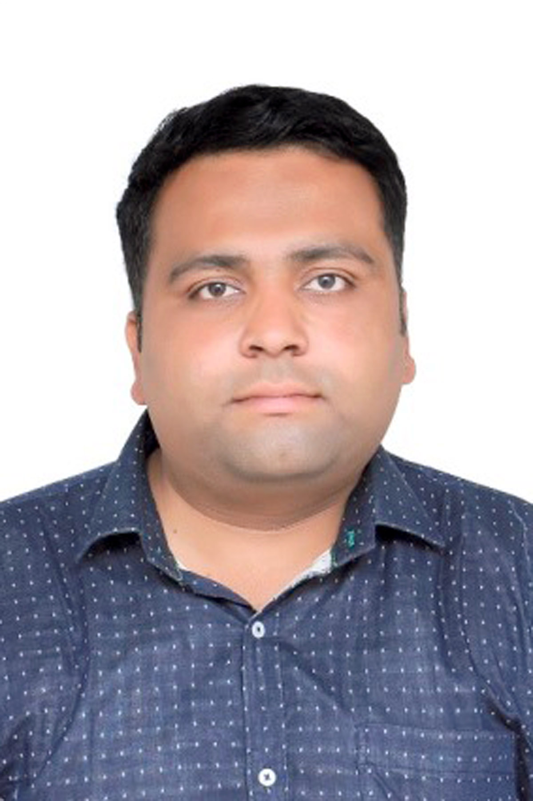
Presenter Name: Dr. Shrikant S Maktedar
Type of Presentation: Speaker
Contact Number: +91-9978-500944

