Development of a new air filtering to save energy in HVAC systems from Hospitals and Commercial Buildings
Mr. Francisco de Paula Pinheiro, MSc, USP, Brazil
Dr Bruno Fernando Gianelli, PhD, IFSP, Brazil

Abstract (300 word limit)

Nosocomial infections also referred to as healthcare-associated infections (HAI), a disproportionate immune system response to an infectious disease, is caused by bacteria, viruses, fungi, or protozoa when receiving health care. Most of these pathogens are partially airborne, a means of propagation that can also lead to contamination of sterile medical equipment. Surveys estimate global cases of HAI at 19.4 million/year, of which 27% lead to death - the main cause of death in ICU's in the World, with Brazil having a higher percentage of deaths, around 55% of the 420,000 cases /year, showing that this is an especially important problem in the country. There’s been lot of works focused on finding a way of reducing the transportability of such pathogens by HVAC system in the hospital environment, with a better energy efficiency than the current technology (HEPA filters). The purpose of this work is to provide the same efficiency in removing particles as HEPA filters (MERV-16) with lower energy consumption, a result of a smaller pressure drop. Technology route: The adoption of electrostatically charged metallic foam boards as filtrating media and also the incorporation of biocide surface nanolayer through a special chemical process, providing the filter with a required biocide effect for application in hospital systems. Findings: the laboratory scaled prototype presented a pressure drop 10x lower than MERV-16 filter media, with an equivalent efficiency in the protection of particulate matter (PM2.5). Conclusion & significance: Our estimates indicate a possibility of reducing the electricity consumption of HVAC systems at least in 5% with the adoption of the proposed technology. Due to its mechanical and chemical resistance, the possibility of washing and reusing the filters will add value to the product, bringing benefits due to the longer lifespan compared to the HEPA filters currently used.
Image
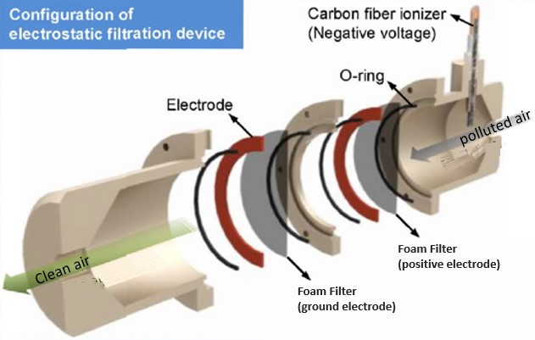
Recent Publications (minimum 5)
- Curtis, L. T. J Hosp Infect. 2008, 69, 204-219 .
- P.K. Sen, P. Sen, Indoor Environ. Qual. 2020, 60, 53-66.
- Che, W. W.; Tso, C. Y.; Sun, L.; Ip, D. Y. K.; Lee, H.; Chao, C. Y. H.; Lau, A. K. H. Energy Build. 2019, 201, 202-215.
- Fisk, W. J.; Faulkner, D.; Palonen, J.; Seppanen, O. Indoor Air 2002, 12, 223–234.
5. Liu, J.; Zhu, X.; Huang, Z.; Yu, S.; Yang, X. J. Coat. Technol. Res. 2012, 9, 357–363.

Photograph

 Biography
Metallurgical engineer with over 19 years’ experience in aluminium industry, covering areas such as foundry, rolling and extrusion of aluminium/alloys. During 9 years he was primarily responsible for the development of new products, processes and technology at CBA, the largest aluminium producer in Brazil. Now he has his own company (Al7) which is his first experience of starting a business. For me, it was about challenging myself to develop something new and inspiring others to take the same risk and pursue their dreams. He also supported the technological development of large companies in Brazil working together the universities and research centers.
Email:francisco.pinheiro@al7.tec.br

Notes/Comments:

