NUMERICAL OPTIMIZATION OF THE POROUS STRUCTURE OF ACTIVATED CARBONACEOUS MATERIALS FOR THE SOLAR ADSORPTION REFRIGERATION SYSTEMS

Mirosław Kwiatkowski

AGH University of Science and Technology, Poland

Abstract:
The cooling and freezing adsorption systems are the assemblies in which the transformation of heat is performed with the help of adsorbate circulating in the closed cycle. The individual transformations are realized in the system of solar collector - adsorber, condenser and evaporator. An increased interest has also been observed recently in employing activated carbonaceous materials in the adsorption refrigerator and air-cooling systems. Obtaining sufficiently high efficiency of the discussed systems requires optimal selection of the porous structure of the adsorbate, which is the main focus of the paper presented below. In particular, the paper presents the results of numerical analysis of the structure of the activated carbonaceous materials and its optimization in terms of using it in the solar adsorption refrıgeratıon systems.
Keywords: Adsorption, Numerical Methods, Micropores, Activation, Solar systems.

Acknowledgments: The work was financed from the Research Subvention from the Polish Ministry of Science and Higher Education for the AGH University of Science and Technology in Krakow No. 16.16.210.476.

Professional Biography:
Dr. hab. eng. Mirosław Kwiatkowski in 2004 obtained Ph.D. degree at the AGH University of Science and Technology in Kraków (Poland), and in 2018 D.Sc. degree at the Wrocław University of Technology (Poland). In addition, he obtained a certificate of completion of postgraduate studies: Professional Research and Development Project Manager at the Krakow University of Agriculture (Poland), Research and Development Project Manager at the University of Economics and Innovation in Lublin (Poland), and Electrical Energy Markets at the AGH University of Science and Technology in Krakow (Poland). His published work includes more than 45 papers in reputable international journals and 90 conference proceedings. He is the editor in chief of The International Journal of System Modeling and Simulation (United Arab Emirates), an associate editor of Micro & Nano Letters Journal (United Kingdom) and a member of the organizing committees international conferences. Dr. hab. eng. Mirosław Kwiatkowski is also a reviewer in a most reputable scientific journals.
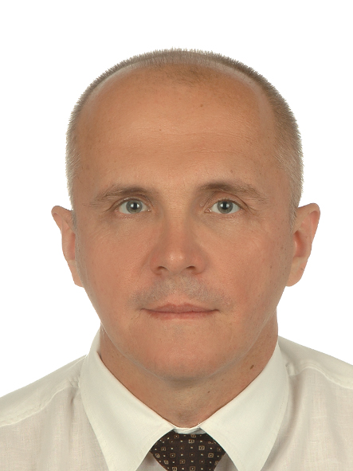
Email Id: kwiatkow@agh.edu.pl

