Flexible Sensors based on Carbon Nanomaterials
Saeed Ahmed Khan¹, A Q Rahimoon¹, Shamsuddin¹

¹ Department of Electrical Engineering (Sukkur IBA University, Pakistan)

Abstract:
In various fields such as robotics, consumer electronics, space flight, energy harvesting, environmental monitoring, healthcare, prosthetics and homeland security, the flexible sensors could be exciting components because of their transparent, soft, less weight, less cost, easy fabrication, biocompatibility, bendability and flexibility behaviour, which has opened the new fronts in the field of smart sensing.
In spite of the fact that silicon innovation has been the primary main impetus for scaling-down devices and their dimensions for improvement in cost and better performance, for flexible and stretchable applications, the Si has been investigated as limited due to its rigidity in structure. Therefore, different imminent materials have been proposed to deal with this problem of Si. Specifically, nano-carbon materials, for example, carbon nanotubes (CNTs) and graphene are promising because of remarkable versatile properties and additionally a fantastic blend of electronic, optoelectronic, and thermal properties contrasted with ordinary silicon. The uniqueness of these nano-carbon materials has opened new potential outcomes for flexible electronics, which is another innovative pattern in the market. Semiconductor industry has reflects outstanding impacts in our daily life, since the invention of transistor and more miniaturization of devices has been significant in the silicon industry.
The new materials which are easily bendable, flexible and stretchable could be investigated for developing. Various structures of the materials have been investigated for stretchability. Figure. 1 depicts the development of flexible electronics materials from the traditional silicon.

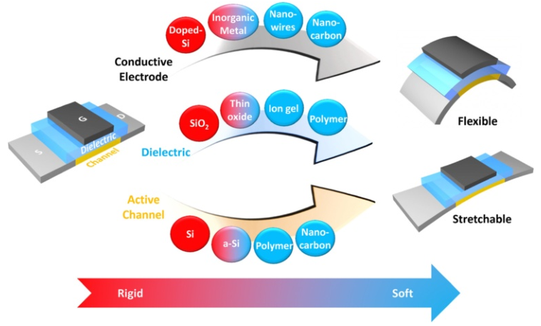
Figure 1 Classification of materials from rigid to soft
Conventional Si-based materials need to be replaced by new materials to realize soft (flexible/stretchable) electronics. With good electrical and mechanical properties, materials such as a-Si, organic polymer, nanowires, and nano-carbon materials are good candidates for next-generation soft applications.
For high mobility, high transmittance and bendability, one-dimensional carbon nanotubes and two-dimensional graphene nanomaterial have been studied and investigated by many researchers to open the fronts of flexible electronics, due to their remarkable physical, electrical and chemical properties. Figure 2 shows various types of carbon-based materials - fullerene, CNT, graphene, graphite, graphene oxide (GO), and diamond.

Keywords—Sensors, CNTs, Nanogenerators, Triboelctric

Professional Biography

Saeed Ahmed Khan has completed his PhD at the age of 34 years from University of Electronic Science and Technology of China in June 2017. He is working as Assistant Professor at Department of Electrical Engineering Sukkur IBA University since 2012. He has extensive research background on developing flexible sensors, electronic thin films and integrated devices, granular materials, energy harvesting sensors, carbon nanotubes growth, image processing, communication and signal processing. He has published 19 articles in reputed journals, 15 conference papers. He is serving as chief editor of Sukkur IBA Journal of Emerging Technologies (SJET) and has been serving as an editorial board member of repute journals.



Email Id: saeed.abro@iba-suk.edu.pk

Any Comments: N/A

