Efficient Synthesis of Iron-oxide Nanostructures at Room Temperature and Accurate Determination of Materials Conjugated.
Tajudeen A. Adebileje¹, Rahimeh Rasouli ². Reza Faridi-Majidi³

^{1, 2, 3} Tehran University of Medical Sciences, Tehran, Iran.

Abstract

Utilizing the principles of mass balance chemical equation and the co-precipitation technique, stable iron oxide nanospheres and nanorods were synthesized at room temperature. Prior to synthesis, molecular dynamics simulation/modelling of materials involved in synthesis steps were performed and results were applied to synthesis procedures. The amount of molecules conjugated to nanostructures per specific formulation volume were then accurately determined by utilizing the principles of capillary electrophoresis device. During the synthesis steps, nanospheres were obtained with or without the inclusion of dextran in the formulation followed by stirring for 15 hours while nanorods were obtained with the exclusion of dextran and inclusion of sodium dodecyl sulfate into the formulation, followed by mild stirring for 5 hours. Utilizing the principles of electro-osmotic flow and pressure differential of capillary electrophoresis with Tris-HCl as a buffer, samples were injected into the capillary with a pressure of 100mbar for 3 seconds followed by the application of voltage (14kv) for the separation of nanospheres. During separation, it was observed that there is variation in the graphical orientation of Fe₃O₄-dextran with or without prior isolation with external magnetic field. However, isolation of magnetic nanospheres prior to sample injection enhances the characterization of the Fe₃O₄-dextran nanospheres with capillary electrophoresis.

Keywords—Capillary Electrophoresis, Fe₃O₄ Nanostructures.

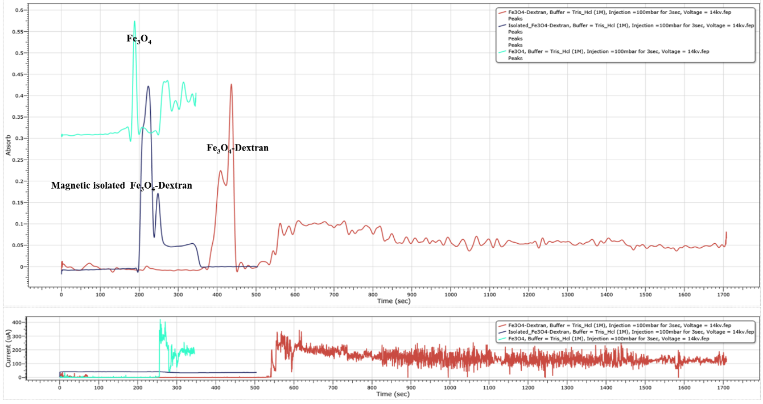

Figure 1: Absorbance-time and Current-time graph showing the characterizations of Fe3O4 nanospheres (green), Fe3O4-Dextran nanospheres (red) and Fe3O4-dextran Nanospheres isolated with Neodymium Magnetic and dispersed in distilled water (blue). Capillary properties: internal diameter = 100micrometer, total length = 60 cm length to UV-Vis detector = 50centimeters.

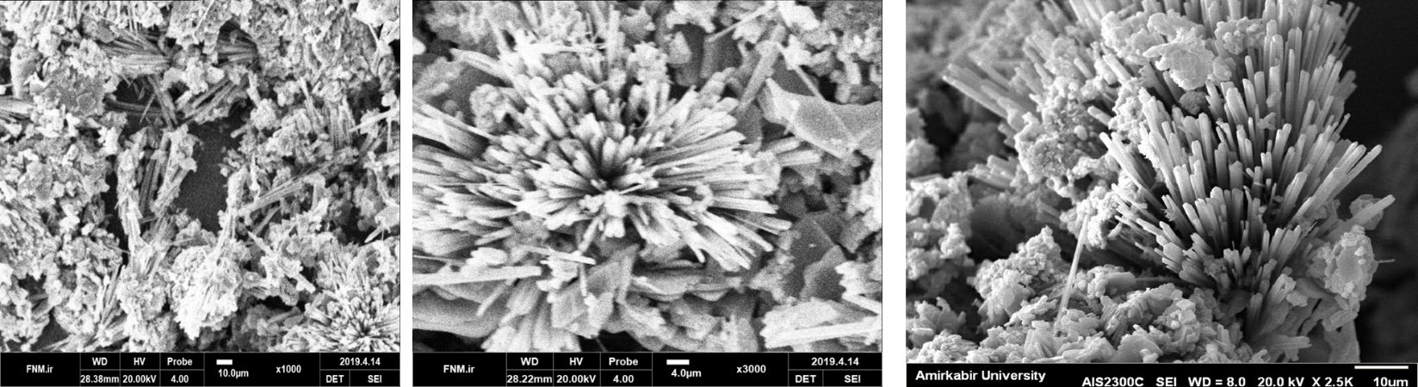
Figure 2: Scanning Electron Microscope images of Synthesized Fe₃O₄ Nanorods

Professional Biography

Tajudeen Ayodele Adebileje has completed both BSc Industrial Mathematics and MSc Medical Nanotechnology at the age of 24 years. He is a PhD student in Medical Nanotechnology at the School of Advanced Technologies in Medicine, Tehran University of Medical Sciences. His current research focus on the optimization of nanotechnology products, he has publish more than 10 research and conference articles in this area. He is also the CEO of Jojo Investments, Productions and Marketing Unlimited in Nigeria, a pragmatic knowledge based organization, where he tries to seek valuable contributions.


Email Id: tajudeenadebileje@gmail.com ; t-ayodeleadebileje@razi.tums.ac.ir

