Nanocolumnar coatings: sustainable manufacturing and applications in biomedicine
Dr. Jose Miguel Garcia-Martin
Institute of Micro and Nanotechnology, Spanish Research Council (CSIC), Spain

Abstract (300 word limit)

In this lecture I will show how nanocolumnar coatings are manufactured by oblique deposition using magnetron sputtering, see Figure. This technique is environmentally friendly, since it is carried out at RT in a single step with low energy consumption and does not involve chemical products (therefore, without recycling problems). It will be seen that the formation of nanocolumns is the result of the effects of atomic shadowing when the atoms reach the surface along an inclined direction and kinetic-energy-induced relaxation processes. Depending on various parameters (such as gas pressure, the angle of inclination of the substrate and its possible rotation), the nanocolumnar structure can be controlled, giving rise to different properties¹. A model that explains the deposition rate and the different morphologies obtained will be discussed. Moreover, it will be shown that the proposed methodology represents a valid approach for industrial production².

Next, I will show two applications in biomedicine of these nanocolumnar coatings. On the one hand, titanium nanocolumns have been used for the development of metallic implants with antibacterial properties, since the strong corrugation hinders the adhesion of bacteria and prevents the formation of the biofilm³. Moreover, in combination with tellurium nanorods, additional bactericidal effects are observed⁴ both against Gram-positive and Gram-negative bacteria (Staphylococcus aureus and Escherichia coli, respectively) whilst the biocompatibility is preserved.

On the other hand, gold nanocolumns exhibit specific optical properties related to the existence of localized surface plasmons. When vertical nanocolumns are produced, the coatings show black metal behavior in the visible range⁵. When short tilted nanocolumns are fabricated, hot spots of electromagnetic field develop and provide a strong enhancement of the fluorescence or Raman signals⁶. As a result, these nanostructures serve as substrates for surface enhanced Raman spectroscopy (SERS) that allow for detecting the presence of biomolecules with low concentration.

Image
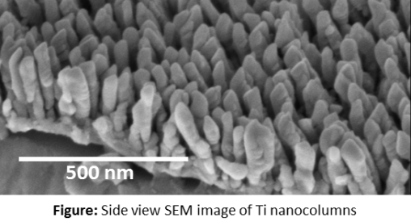
Recent Publications (minimum 5)
- Alvarez R et al. (2016) Nanostructured Ti thin films by magnetron sputtering at oblique angles. J. Phys. D: Appl. Phys. 49:045303.
- Alvarez R et al. (2019) Antibacterial Nanostructured Ti Coatings by Magnetron Sputtering: From Laboratory Scales to Industrial Reactors. Nanomaterials 9:1217.
- Izquierdo-Barba I et al. (2015) Nanocolumnar coatings with selective behavior towards osteoblast and Staphylococcus aureus proliferation. Acta Biomater. 15:20.
- Medina-Cruz D et al. (2019) Synergic antibacterial coatings combining titanium nanocolumns and tellurium nanorods. Nanomed.-Nanotechnol. Biol. Med. 17:36.
- Vitrey A et al. (2017) Fabrication of black-gold coatings by glancing angle deposition with sputtering. Beilstein J. Nanotechnol. 8:434.
- Diaz-Nuñez P et al. (2019) On the large near-field enhancement on nanocolumnar gold substrates. Sci. Rep. in press.
Photograph

 Biography (150 word limit)
Dr. Jose Miguel Garcia-Martin is Research Scientist and Head of the Department of Fabrication and Characterization of Nanostructures at IMN. In 2017 he was a Fulbright Visiting Scholar at Northeastern University (Boston, USA). His research work focuses on the study of different nanostructures (such as nanoparticles, nanocolumns, lithographed elements and thin films) with applications in various fields: magnetism, plasmonics and biomedicine. In particular, in this latter field, he studies antibacterial coatings, substrates for SERS and nanostructured electrodes for cell stimulation. In the last few years, he has led the projects entitled “Magnetic antidots”, “Large area advanced materials based on nanopillars and nanoparticles”, “NeuPES (Electrical stimulation with nanostructured electrodes)” and “Nanoimplant”, which won the IDEA²Madrid Award (a partnership of the Madrid Government and the Massachusetts Institute of Technology, MIT). He has co-authored 82 articles (which have received more than 3000 citations) and 2 patents and has given about 30 invited conferences.
Email: josemiguel.garcia.martin@csic.es

Notes/Comments:

