Investigation of possible pharmacokinetic interaction between ivabradine and carvedilol in rats using High Performance Liquid Chromatography/Mass Spectroscopy
Saif S. Abbas (Al-Ahliyya Amman University (Amman, Jordan)
Israa H. Al-Ani Al-Ahliyya Amman University (Amman, Jordan)
Wael A. AbuDayyih (University of Petra (Amman, Jordan)

Abstract
Ivabradine is a new hyperpolarization-activated cyclic nucleotide-gated channel blocker. It has been approved by the FDA in 2015 in management of stable angina and congestive heart failure. The aim of this study was to investigate the possibility of pharmacokinetic interaction of a proposed combination of ivabradine and the β-blocker carvedilol in rats using spectroscopy technique.
A simple, rapid and sensitive method for validation and determination of ivabradine and carvedilol in the ratsʼ plasma was developed using HPLC/MS. The method was successfully developed and validated in terms of linearity, precision and accuracy which were within the values accepted by EMEA and ICH.
Ivabradine and carvedilol were given both intravenously and orally each alone and as oral combination to fasted Sprague-Dawley rats. Blood samples were withdrawn on scheduled time intervals up to 36 hours and analyzed for each drug.

Both compartmental and non-compartmental kinetic analysis were performed on plasma level-time data and the kinetic parameters were calculated from non-compartmental analysis. Results showed significant increase in bioavailability of both drugs in combination (94% for carvedilol and 58% for ivabradine. Also, C_{max} was changed significantly from by 165% for carvedilol and 56% for ivabradine when given in combination. There was also a significant decrease in elimination of both drugs expressed as 48% decrease in clearance and 41% increase in the half-life for carvedilol and 32% decrease in clearance and 37% increase of the half-life of ivabradine when given in combination. These changes suggested an interaction on metabolic function of the liver on both drugs by some kind of enzyme inhibition. Also, the rate of absorption of ivabradine was slowed by concomitant administration of carvedilol suggesting an interaction on absorption level.
In conclusion, a significant kinetic interaction occurred when ivabradine was given orally with carvedilol which makes dose adjustment of both drugs of much importance.

Image

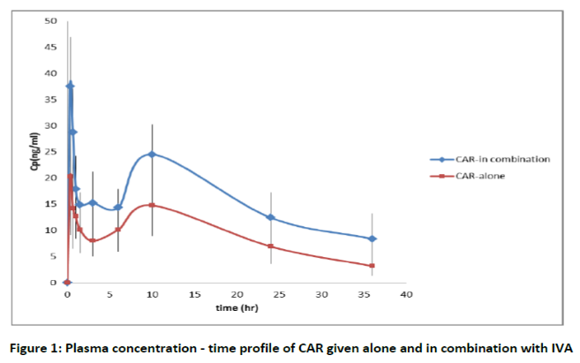

Recent Publications
- Bagriy A. E., Shchukina E. V., Malovichko S. I., Prikolota A. V. (2013). Addition of Ivabradine to carvdilol reduces duration of carvedilol uptitration and improve exercise capacity in patients with chronic heart disease. J Am CollCardiol.;61(10_S):. doi:10.1016/S0735-1097(13)60700-7.
- Bocchi E. A., Böhm M., Borer J. S., Ford I., Komajda M., Swedberg K., Tavazzi L. (2015). Effect of Combining Ivabradine and β-Blockers: Focus on the Use of Carvedilol in the SHIFT Population.Cardiology.131(4):218-24.
- Custodis F., Schirmer S. H., Baumhäkel M., Heusch G., Böhm M., Laufs U. (2010) Vascular pathophysiology in response to increased heart rate. JAm Coll Cardiol.56:1973–83.
- Ogawa R. and Echizen H. (2010). Drug-drug interaction profiles of proton pump inhibitors.ClinPharmacokinet. 49(8):509-33.
- Pinto D. S and Kociol R. D. (2014). Evaluation of acute decompensated heart failure. http://www.uptodate.com/home. Accessed.

Biography
Saif Salah Abbas is a master degree student in Al-Ahliyya Amman University in Jordan. He graduated from Faculty of Pharmacy and Medical Sciences in Al-Ahliyya Amman University/Jordan in 2013. He is finishing his master degree in Pharmaceutics/Pharmacokinetics. He worked as a senior pharmacist in retail pharmacies and drug stores in Amman/Jordan
Email:saif_s_abbas90@yahoo.com

Notes/Comments

