Lifestyle and genome of an exopolysaccharide producing UV-resistant Bacillus altitudinis SORB11of Southern Ocean (Indian Sector) origin
Urmi Halder* and Rajib Bandopadhyay$
UGC- centre of Advanced Study, Department of Botany, The University of Burdwan, Burdwan, Pin-713104, West Bengal, India.
Abstract
Understanding the functional role of microbes in the extreme environment is diverse because of their numerical abundance is much higher than all existing species. Here, we collected B. altitudinis SORB11 from the Indian Sector of the Southern Ocean (50°S, 47°E) at a depth of 3.8 km.The whole genome of SORB11 is 3,692,443 bp in size with a 41.2% mean GC content. Based on a complete 16S rDNA sequence analysis of the genome, SORB11 showed 100% similarity to type strain B. altitudinis 41KF2b which was ﬁrst reported from an air sample collected at the height of 41 km in the stratosphere. Moreover, calculations for ANI and dDDH showed 98.4% and 86% values, respectively. A total of 3,867 coding genes were annotated, with 2 rRNAs and 22 tRNAs. It has a unique capacity to resist UV-B (260nm) more than 10J. A total of 102 genes belong to DNA metabolism, out of which 55 were associated with DNA repair. Further, a total of 97 genes encoding stress response were identiﬁed. Morphological change was visualized under TEM before and after UV stress. EPS producing genes were also present in the genome. Glucomannan type of EPS containing glucose and mannose was produced by this strain. Antileukemic activity was performed to estimate the cell viability after treated with the EPS.
In this seminar, I will discuss about various techniques to characterization and structural elucidation of bacterial EPS and its applications. Mining the genome of B. altitudinis SORB11 including the genes responsible for the UV resistance and EPS production will also be discussed.
Biography
Urmi did her M.Sc. in Botany in 2015 from The University of Burdwan, INDIA. Now she has enrolled herself as PhD student at the same University and continuing her research work as Junior Research Fellow in the field of microbiology, specially focused on deep sea microorganisms of Southern Ocean.
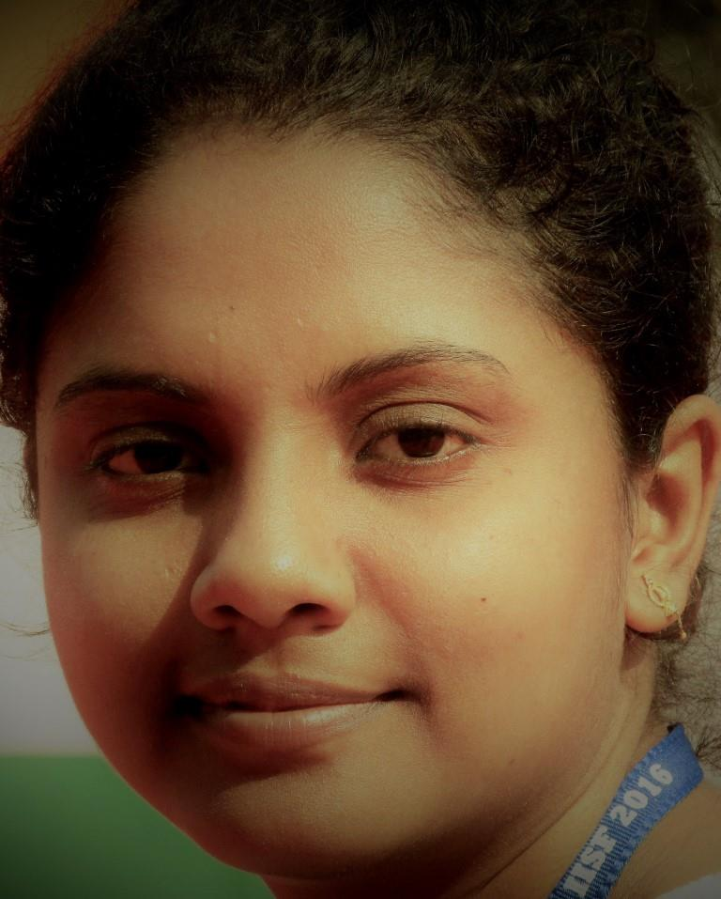
*Presenting author: URMI HALDER
Email id: urmi.microbio@gmail.com
Mobile: +91-8167014064
$Corresponding author: RAJIB BANDOPADHYAY
Email id: rajibindia@gmail.com
Mobile: +91-8170995469

