Molecular architecture and characterization of an actin gene from the pacific abalone, Haliotis discus hannai
Md Rajib Sharker, Chonnam National University, Republic of Korea
Soo Cheol Kim, PhD, Chonnam National University, Republic of Korea
Kang Hee Kho*, PhD, Chonnam National University, Republic of Korea

Abstract (300-word limit)
Statement: Actins are highly conserved protein of ATPases super family that involved in the ATP binding domain of the Hsp70-related proteins, sugar kinases, actin-related proteins and prokaryotic actin homolog. In this study, a 976- bp sequence was cloned from the neural ganglion of pacific abalone, Haliotis discus hannai. The coding sequence of 270 bp translated into a protein of 89 amino acid residue. A BLAST search indicated that this protein represents 68% and 56% identity with rainbow abalone and pacific oyster respectively. Moreover, alignment of two or more sequences revealed that the amino acid sequence of Haliotis has 42-56% similarity with mammalian and other abalone actin sequences. Phylogenetic analysis demonstrates that our predicted clone formed cluster with rainbow abalone due to intense similarity of amino acid signature. Semi quantitative reverse transcription (RT)-PCR, quantitative PCR (q-PCR) confirmed that actin gene is highly expressed in cerebral ganglion (CG) which indicates CG might be correlated with abalone cell motility, structure, integrity, and intercellular signaling.
Methodology and Theoretical Orientation:
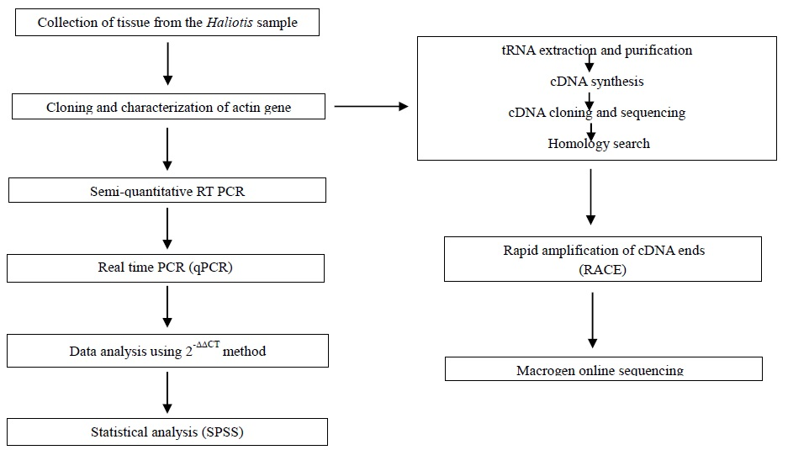
Findings: Isolation of a 976- bp actin gene from the cerebral ganglion of pacific abalone, containing 270-bp coding region of 89 amino acid residue. Our cloned gene and Haliotis iris actin gene formed cluster due to similar taxonomic classification and sequence identity.
Conclusion and Significance: Actin sequence of our clone might have a potential to regulate cell movement, formation, integrity and signaling mechanism.
Image:
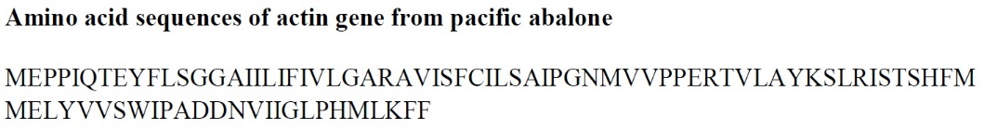
Recent Publications (minimum 5)
- Sumi KR, Kim SC, Howlader J, Lee WK, Choi KS, Kim HT, Park JI, Nou IS, Gilmour KM, Kho KH (2018) Molecular cloning and characterization of carbonic anhydrase XII from pufferfish (Takifugu rubripes). Int J Mol Sci 842:1-18.
- Kim SC, Sumi KR, Sharker MR, Kho KH (2018) Molecular identification and expression of myosin light chain in shortspine spurdog (Squalus mitsukurii). J Marine Life Sci 3: 1-8
- Sumi KR, Kim SC, Natarajan S, Choi KS, Choi MR, Kim HT, Park JI, Noi IS, Gilmour KM, Kho KH (2018) Molecular cloning and characterization of secretory carbonic anhydrase VI in pufferfish (Takifugu rubripes). Gene 640:57-65.
- Kim SC, Sumi KR, Kim JW, Choi MR, Min BH, Kho KH (2016) Carbonic anhydrase I in a cartilaginous fish, the shortspine spurdog (Squalus mitsukurii). Ocean Sci J 51:373-379.
- Sumi KR, Nou IS, Kho KH (2016) Identification and expression of a novel carbonic anhydrase isozyme in the pufferfish Takifugu vermicularis. Gene 588:173-179.



Biography (150-word limit)
I have completed graduation from the Fisheries Biology and genetics. During my graduation program I have published research article regarding biology of fishes in peer reviewed journal. Now I am conducting PhD program in the molecular physiology lab under the division pf Fisheries Science, Chonnam National University. Currently, I am working on molecular cloning and isolation of growth and reproduction related gene from the pacific abalone, Haliotis discus hannai. I also gain insight of knowledge concerning larval and embryonic development of abalone species which will be assisted on rearing and culture technology of abalone.

Email:
mrsharker@pstu.ac.bd

Notes/Comments

