A Satoumi practice to the semi-enclosed bay after the hit of huge tsunami on 11 March 2011 for realizing sustainable aquaculture and sound marine environments: An example of Shizugawa Bay, Japan.
Teruhisa KOMATSU, Dr. of Agriculture, Yokohama College of Commerce, Japan
Shuji SASA, PhD, Yokohama College of Commerce, Japan
Shigeru MONTANI, Dr. of Fisheries, Yokohama College of Commerce, Japan
Takahumi Sakamaki, PhD, Tohoku University, Japan
Osamu NISHIMURA, Dr. of Technology, Tohoku University
Chihiro YOSHIMURA, PhD, Tokyo Institute of Technology, Japan
Manabu FUJII, PhD, Tokyo Institute of Technology, Japan
Tetsuo YANAGI, Dr. of Science, EMECS Center, Japan

Abstract
Rias-type bays are one of the most common coasts in Japan where aquacultures without feeding have been active. The huge tsunami hit Sanriku Coast consisting of open rias-type bays near the epicenter facing Pacific Ocean on 11 March 2011. For recovering Sanriku Coast, it is important to include sustainability in its program. Satoumi practice is defined as a human use and management of coastal seas for high productivity while maintaining high biodiversity. We studied a typical rias-type bay, Shizugawa Bay, in southern Sanriku Coast, where oyster and Undaria pinnatifida are mainly cultured. The tsunami flushed out most of all aquaculture facilities. Just after the tsunami, they deployed seed oysters, which fortunately escaped from the tsunami, on the sea in 2011. The oysters grew to a commercial size in ten months due to good prey condition while they needed two to three years before the tsunami because of insufficient prey condition. After long discussion among fishermen, Committee for Shizugawa Bay Management of Fishermen’s Cooperative of Miyagi Prefecture decided to decrease oyster culture facilities based on this experience of oyster growth. We conducted scientific researches on mapping of coastal habitats and aquaculture facilities, hydrography, and material flows of nutrients, a minor element (Fe) and particulate organic matters in the bay including those from the rivers and the offshore waters. Based on these data, a physical-biological coupling model was used for calculating the number of aquaculture facilities that are suitable not only for yields but also for environments. A council for discussing on sustainable aquacultures and sound marine environments in Shizugawa Bay was established by a fishermen’s’ cooperative, local governments, WWF and scientists. Discussion based on scientific researches promoted sustainable aquaculture. This Satoumi practice may help to realize sustainable coastal use of a rias-type bay.
Methodology and Theoretical Orientation:
We conducted scientific researches on hydrography, and material flows of nutrients, a minor element (Fe) and particulate organic matters (POM) in the bay including those from the rivers and the offshore waters. Coastal habitats and aquaculture facilities were mapped with a remote sensing technique before and after the tsunami. A physical-biological coupling model was used for calculating the number of aquaculture facilities that are suitable not only for yields but also for environments using data obtained with above-mentioned methods. We organized meetings for realizing sustainable use and sound marine environments in Shizugawa Bay with local fishermen cooperative, local governments, WWF and us by using the research results.
Findings:
An in-situ experiment of oyster culture in two areas showed growth rates of oysters in an area with a lower density of oyster culture facilities were greater than in an area with a higher density. A physical-biological coupling model could reproduce the growths of oysters before and after the tsunami and showed that oxygen content in bottom layer after the tsunami was maintained at a sufficient oxygen level.
Conclusion and Significance:
The tsunami event gave a chance to fishermen to change their aquaculture practices to ones that are economically and environmentally sustainable through their experiences and discussions together with our scientific researches and WWF’s supports. Thanks to this change, oysters in Tokura Branch of fisheries cooperative in Shizugawa Bay obtained ASC certificate from Aquaculture Stewardship Council in March of 2016. This success story may permit to broaden such kind of Satoumi practice to other rias-type bay where aquaculture without feeding are mainly conducted.
Image:

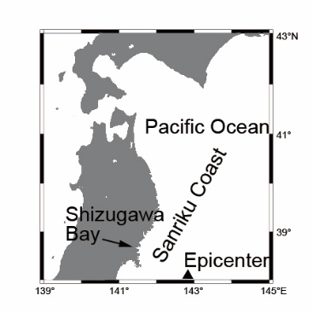
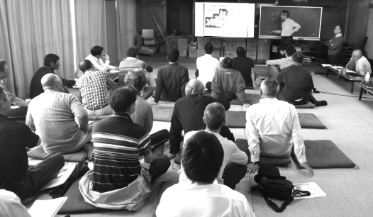
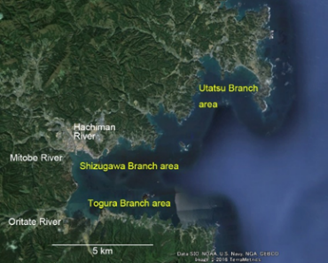

Recent Publications (minimum 5)
- Komatsu, T., Fukuda, M., Mikami, A., Mizuno, S., Kantachumpoo, A., Tanoue, H. and Kawamiya, M. (2015) Possible change in distribution of seaweed, Sargassum horneri, in northeast Asia under A2 scenario of global warming and consequent effect on some fish. Marine Pollution Bulletin, 85, 317-324.
- Alabsi, N. and Komatsu, (t. (2014) Characterization of fisheries management in Yemen: A case study of a developing country׳s management regime. Marine Policy, 50, 89–95.
- Komatsu, T. and Yanagi, T. (2015) Sato-umi: An integrated approach for sustainable use of coastal waters, lessons from human-nature interactions during the Edo Period of eighteenth-century Japan. In Marine productivity: perturbations and resilience of socio-ecosystems, edited by Ceccaldi, H.J., Hénocque, Y., Koike, Y., Komatsu, T., Stora, G. and Tusseau-Vuillemin, M.-H., Springer International Publishing Switzerland, Cham, p. 283-290.
- Sagawa, T. and Komatsu, T. (2015) Simulation of seagrass bed mapping by satellite images based on the radiative transfer model. Ocean Science Journal, 50(2), 335-342.
- Hamana, M. and Komatsu, T. (2016) Real-time classification of seagrass meadows on flat bottom with bathymetric data measured by a narrow multibeam sonar system. Remote Sensing, 8(2), 96(16p) (online publishing) doi:10.3390/rs8020096 17.
- Uto, K., Seki, H., Saito, G., Kosugi, Y. and Komatsu, T. (2016) Development of a low-cost hyperspectral whiskbroom imager using an optical fiber bundle, a swing mirror and compact spectrometers. IEEE Journal of Selected Topics in Applied Earth Observations and Remote Sensing, 9(9), 3909-3925.
- Noiraksar, T., Manthachitra, V., Buranapratherprat, A. and Komatsu, T. (2017) Growth and reproductive seasonal pattern of Sargassum polycystum C. Agardh (Sargassaceae, Phaeophyceae) population in Samaesarn Island, Chon Buri Province, Thailand. La mer, 55, 11-23.
- Sakanishi, Y. and Komatsu, T. (2017) Growing depth limit of Zostera caulescens in coastal waters along the Japan Sea coast of Honshu, Japan. Fisheries Science, 83(6), 977-986.
- Xu, M., Sasa, S., Otaki, T., Huc, F.X., Tokai, T. and Komatsu, T. (2018) Changes in drag and drag coeﬃcient on small Sargassum horneri (Turner) C. Agardh individuals, Aquatic Botany, 144, 61-64.
- Komatsu, T., Sasa, S., Hamana, M., Sakamoto, S., Asada, M., Terauchi, G., Tsujimoto, R. and Yanagi, T. (2018) Temporal and spatial changes in a coastal ecotone in Shizugawa Bay, Sanriku Coast due to the impacts of the tsunami on 11 March 2011 and the following artificial impacts. In The 2011 Japan Earthquake and Tsunami: Reconstruction and Restoration, edited by Santiago-Fandiño, V., Sato, S., Maki, N. and Iuchi, K., Springer, Cham, p. 265-278.

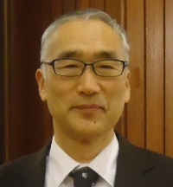

 Biography (150-word limit)
Teruhisa KOMATSU has his expertise in marine ecology and fisheries oceanography. He graduated Kyoto University. He has studied marine environments in seaweed and seagrass forests. He is extending his research to cartography of seagrass and seaweed forests using acoustic and optic methods. He has been a leader of Ocean Remote Sensing Project on Coastal Habitat Mapping of Subcommission of Western Pacific, Intergovernmental Oceanographic Commission/UNESCO since 2010. He has worked at Atmosphere and ocean Research Institute, the University of Tokyo since 1990 and moved to Yokohama College of Commerce in 2017. Now, he is a theme leader of a research project of the Japanese Ministry of Environment on “Development of coastal environmental management methods on Sanriku Coast, which has a succession of open inner bay”.

Email: komatsu@shodai.ac.jp

Notes/Comments

