Infection status of Mytilus galloprovincialis (Bivalvia, Mytilidae) with trematode Parvatrema sp. (Digenea, Gymnophallidae) in Kaštela Bay, Adriatic Sea
Sanja Puljas, PhD, Department of Biology, Faculty of Science, University of Split, Croatia
Jelena Burazin, Department of Biology, Faculty of Science, University of Split, Croatia

Abstract :

Species Mytilus galloprovincialis Lamarck, 1819 is a dominant mussel on the rocky intertidal of the Adriatic Sea, Croatia. The beds of M. galloprovincialis were in regression during 2014, but the population recovered. In 2018, a new population decline was recorded. Due to those fluctuations, trematode infection was noticed. Based on morphology and observation of the sporocysts, cercariae and metacercariae in mussel's mantle and gonads, the trematode species is identified as Parvatrema sp. A total of 40 individuals were collected during February and March 2014 and 2018 from the rocks at Kaštel Stari. In the laboratory, the mantle and gonads of each measured mussel were macroscopically and microscopically examined and photographed with Axio Camera MRc5. Trematode morphology was observed and measured using the Axio Vision Release 482SP3 program (08-2013). Mussel tissues with different developmental stages of trematode have been fixed in 4% formaldehyde, and following routine histological procedures, sections have been stained in Ehrlich's haematoxylin and eosin. Based on histology, an infection prevalence (number of infected mussels / total number of mussels) and weighted infestation (infection intensity / total number of mussels) were calculated according to year of sampling, sex and length of mussels. Results showed that the prevalence of infection for 2014 was 100% while in 2018 it was 65%. During both years, there was no significant difference in the prevalence of infection among males and females nor between different shell lengths, presuming high infectious potential. Weighted infestation was not much lower in 2018, indicating that the number of individuals in this population could be reduced again due to new infection. Since the definitive host of Gymnophallids are known to be marine and coastal birds and assuming that in Croatia the relationship between birds and trematode infection has not been reported previously, more attention should be paid to this subject.

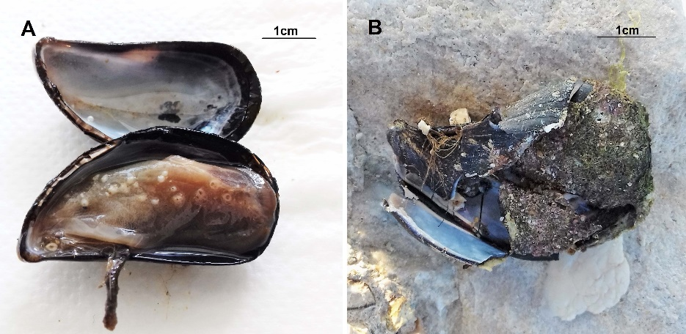

Figure 1. Mantle of Mytilus galloprovincialis with encapsulated metacercariae of Parvatrema sp. (A). Broken valve of mussel eaten by a bird (B)

F

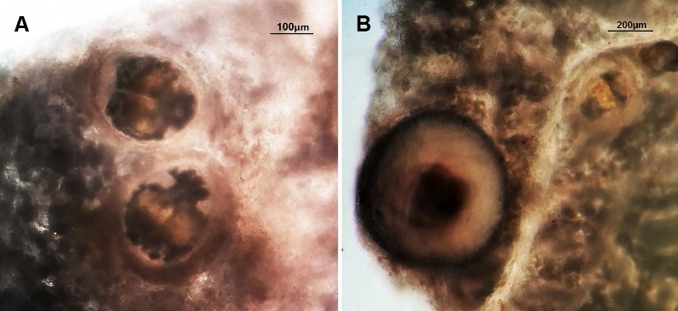

Figure 2. Metacercariae (A) and encapsulated metacercaria (B) of Parvatrema sp. detected in Mytilus galloprovincialis mantle and gonad tissue.

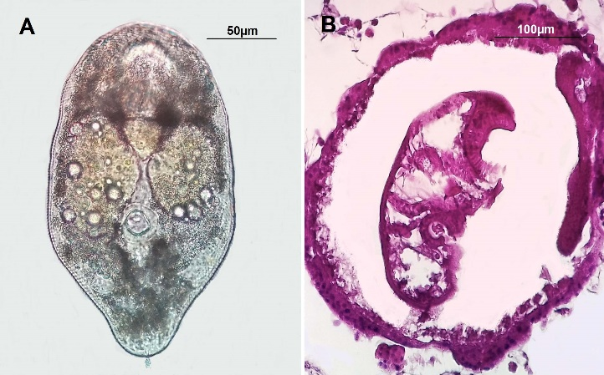

Figure 3. Metacercaria of Parvatrema sp. detected in Mytilus galloprovincialis mantle and gonad tissue (A). Histological sections of Parvatrema sp.(B)

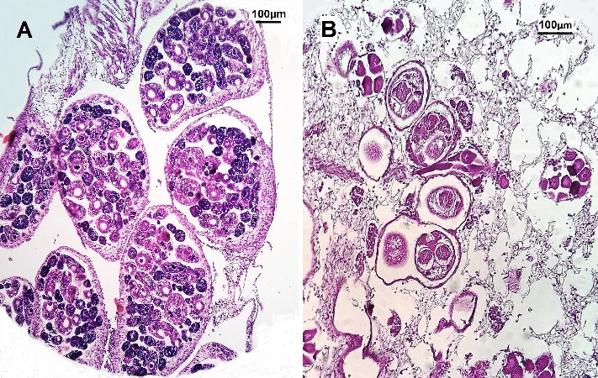

Figure 4. Histological sections of sporocysts with different developmental stages of cercariae (A) and metacercariae (B) of Parvatrema sp. detected in Mytilus galloprovincialis mantle and gonad tissue

Table 1. Results of histopathological study for evaluation of trematode infection

 | February  2014. | March  2014. | February  2018. | March  2018.
N | 10 | 10 | 10 | 10
Males | 3 | 2 | 6 | 6
Females | 7 | 8 | 4 | 4
Infection prevalence | 100% | 100% | 70% | 60%
Males | 100% | 100% | 83% | 67%
Females | 100% | 100% | 50% | 50%
Infection prevalence- shell length (2-4 cm) | 60% | 50% | 70% | 50%
Infection prevalence- shell length (4-6 cm) | 40% | 50% | 30% | 50%
Weighted infestation | 0.13 | 0.15 | 0.11 | 0.10

Recent Publications:
- Woon-Mok S, Byoung-Kuk N, Shin-Hyeong C, Won-Ja L (2017) Prevalence and Density of Digenetic Trematode Metacercariae in Clams and Oysters from Western Coastal Regions of the Republic of Korea. The Korean Journal of Parasitology 55:399-408.
- Morton B, Puljas S (2017) The biology and functional morphology of Mytilaster minimus (Bivalvia: Mytiloidea: Mytilidae) from the intertidal dinaric karst of Croatia (Adriatic Sea). Journal of the Marine Biological Association of the United Kingdom 1-18. doi:10.1017/S0025315417001497.
- Cremonte F, Gilardoni C, Pina S, Rodrigues P, Cristián I (2015) Revision of the family Gymnophallidae Odhner, 1905 (Digenea) based on morphological and molecular data. Parasitology International 64:202–210
- Özer A, Güneydağ S (2014) First report of some parasites from Mediterranean mussel, Mytilus galloprovincialis Lamarck, 1819, collected from the Black Sea coast at Sinop. Turkish Journal of Zoology 38:486-490.
- Paulin R, Cribb TH (2002) Trematode life cycles: shorter is sweet? Trends in Parasitology 18:176–183.

 Biography

Sanja Puljas is an assistant professor at the University of Split, Croatia, Faculty of Science. Her research is related to bivalve ecology with special attention to reproduction, growth dynamics, sclerochronology and population dynamics of bivalves. She obtained a Master’s degree in Biology from University of Zagreb, Croatia, Faculty of Science and PhD in in Applied Marine Sciences, University of Split, Croatia. Her doctoral research focused on the ecology of the troglodytic ‘living fossil’ Congeria kusceri (Bivalvia: Dreissenidae) from the subterranean Dinaric Alpine karst. She has extensive experience of fieldwork in the underground habitat and Adriatic Sea. Her research activities cover the skills of histology and preparation of shell acetate peel replicas, including the interpretation of bivalve growth data and anatomy.
Email: spuljas@pmfst.hr

