Taiwan Kenting National Park "Houbi Lake Marine Resource Conservation Ecological Demonstration Zone(HLMRCEDZ)" - "Sea slugs' Biodiversity Survey and Behavior Study".

TAI, Y.C. and Wu, S. H.NKUST, TAIWAN
.
Abstract
Purpose: The HLMRCEDZ was established on March 30, 2005. The total area is approximately 180 hectares. This area is a protected area established for the conservation of biological diversity. It starts with the protection of sea urchins and then expands to the full protection of all marine organisms. The aim of this study was to investigate the sea slugs biodiversity and distribution in HLMRCEDZ. Methods: A few centuries ago, naturalists and philosophers had observed and thought about the "why," "how," "when," and "what" issues in animal behavior. Therefore animal behavior can be described as a branch of a long history in the history of biological research.
Fourteen 50M * 20M Bio Phase areas were selected, visual strip-transects and GPS positioning were applied to search the species, body length and numbers. Record all the data and perform behavioral analysis and identification. Plymouth Routines In Multivariate Ecological Research software (Clarke and Warwick, 2001) was used to analysis the distribution. Results: These surveys were found 8 Orders, 29 Families and 119 species, 74 species accounted for effective species and 45 species accounted of unknown species, body length between 1mm and 80mm, numbers from 1 to 3000. Conclusion: The study indicated that the sea slugs biodiversity and distribution are very high in HLMRCEDZ, especially in the sand area, 26 degrees seawater temperature and 12-15M depth. Order Cephalaspidea have a numbers of advantages in the sand area of 12 to 15 meters in the area of the “Houbi Lake Marine Resource Protection Demonstration Zone” in Kenting National Park.

Image:
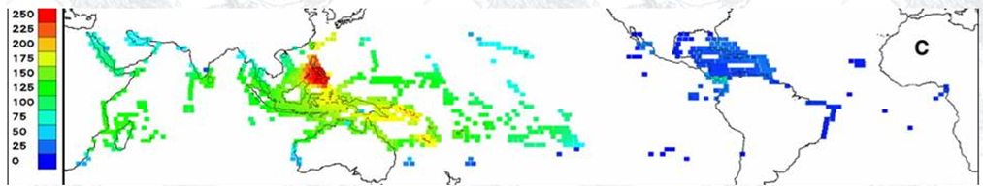
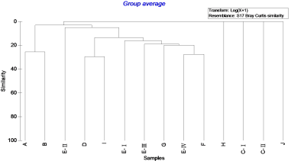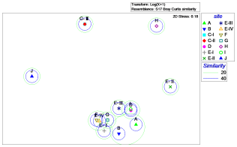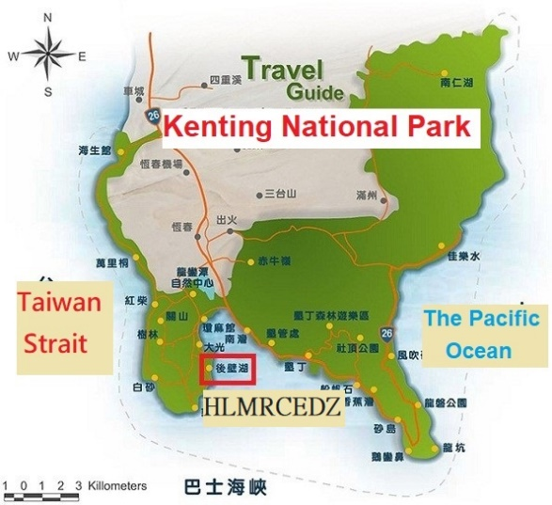

Recent Publications (minimum 5)
Aerts, L., 1994. Seasonal distribution of nudibranchs in the Southern Delta Area, S.W. Netherlands. Journal of Molluscan Studies 60, 129–139.
BENJAMIN S. HALPERN1, SARAH E. LESTER2 AND JULIE B. KELLNER 2010 .Spillover from marine reserves and the replenishment of fished stocks) (spillover ) Environmental Conservation 36 (4): 268–276.
Bertsch, H., 2010. Nudibranch feeding biogeography: ecological network analysis of inter- and intra- provincial variations. Thalassas: An International Journal of Marine Sciences 27, 155–168
Sung-Hung Wu,2015. " The Penghu Southern Four Islands National Park Marine Area" Study on the biodiversity and distribution of the Sea Slugs.
DAVID W. BEHRENS ,2005.NUDIBRANCH Behavior
GARY and RICHARD C. WILLAN ,2006.UNDERSEA JEWELS (A Colour Guide to Nudibranchs)

 Biography (150-word limit)
Tai Yao-Chung has his expertise in SCUBA diving, commercial diving, exercise physiology and marine biology. He is the vice-professor in NKUST and teach exercise physiology, SCUBA and commercial diving, many project plans with student focus on marine biology, especially in Taiwan Kenting National Park, and sea slugs is the one of the projects. The purpose of the sea slugs project is wanted to realize the relationship between climate changes and habitat, further to teach the diver’s behavior.
Email: yctai21@gmail.com

Notes/Comment

