Assessment of the High-Resolution Paleoseismicity Record from Sediment Gravity Flows in Prince William Sound, Alaska
Joshua R. Williams¹, Elisabeth R. Clyne^{1,2}, Steven A. Kuehl^{1*}, Mohammad Al Mukaimi³
¹Virginia Institute of Marine Science, Gloucester Point, VA USA
²Pennsylvania State University, State College, PA USA
³Kuwait University, Kuwait City, Kuwait

Abstract (300-word limit)
Located along the Aleutian Megathrust Boundary, South-Central Alaska is one of the most seismically active areas in the world. Central to this region, Prince William Sound is a glacially carved basin that receives abundant sediment from multiple sources. Primary inputs include the Columbia Glacier and the Copper River, which have diagnostic signatures of Sr/Pb, Cu/Pb, K/Ca, Rb/Sr, and Rb/Ca. As a result, earthquake induced sediment gravity flows originating from different locations deposit event layers that have distinct provenance signatures. A previous study (Kuehl et al., 2017) identified five such event layers preserved in two cores from the southern part of the deep central channel of Prince William Sound that were attributed to large historical earthquakes. To better understand the spatial continuity of these event layers along the entire length of the central channel, seven new gravity cores were collected in a north-south transect. Sedimentation rates were determined by ²¹⁰Pb, ¹³⁷Cs, and ^{239,240}Pu geochronology, and cores were assessed for variations in elemental content, grain size patterns, bulk organic and stable isotopic signatures (C/N, δ¹³C, δ¹⁵N). Based on a spatial analysis of these cores, local earthquakes of Mw < 7.0 deposit event layers in the central channel with signatures reflecting the epicenter location, and those of Mw >7.0 (including an event layer from the 1964 great Alaskan earthquake) have mixed signatures resulting from the widespread generation of numerous flows throughout Prince William Sound. Complete gravity flow records are captured within deep ponded sediment basins and the area spanning the southern end of the central channel. Considering the thick (>100m) late-Holocene sequence, the approach utilized in this study has the potential to provide a rich record of earthquake recurrence intervals to 4ka.
Methodology and Theoretical Orientation:
Findings:
Conclusion and Significance:

Image:
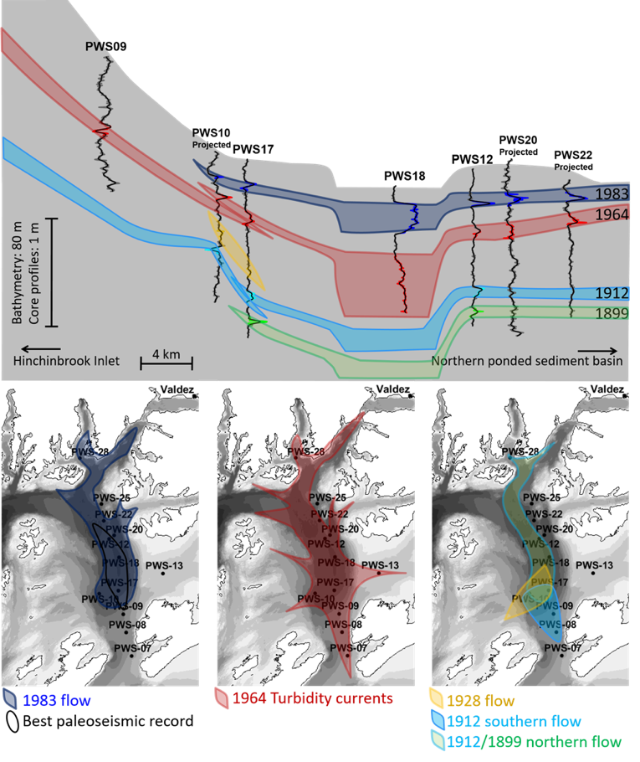

Recent Publications (minimum 5)
- Al Mukaimi M., Kaiser K., Williams J., Dellapenna T., Louchouarn P., Santschi P., (2018) Centennial record of anthropogenic impacts in Galveston Bay: Evidence from trace metals (Hg, Pb, Ni, Zn ) and lignin oxidation products. Environmental Pollution 237 (887-899).

- Al Mukaimi M., Dellapenna T., Williams J., (2018) Enhanced Land Subsidence in Galveston Bay, Texas: Interaction Between Sediment Accumulation Rates and Relative Sea Level Rise. Estuarine, Coastal and Shelf Science 207 (183-193)

 Biography (150-word limit)
Mohammad Al Mukaimi is a marine geochemist at the Marine Science Department of Kuwait University. He received his PhD in Oceanography from Texas A&M University 2016. During his PhD, he worked on Geochemical and Sedimentary Record of Urbanization and Industrialization of the Galveston Bay Watershed with Dr Dellapenna.His research focuses on: 1) Marine sediments geochemistry, 2) Seabed dynamics and sedimentary processes 3) Trace metals in aquatic system.
Email: malmukaimi@hotmail.com

Notes/Comment

