Methane occurrence in sediments of the Gdańsk Basin (southern Baltic Sea)
Jerzy Bolałek, Prof., Institute of Oceanography, University of Gdańsk, Poland
Aleksandra Brodecka-Goluch, PhD, Institute of Oceanography, University of Gdańsk, Poland
Damian Jaśniewicz, MSc, Institute of Oceanography, University of Gdańsk, Poland
Zygmunt Klusek, Prof., Institute of Oceanography, University of Gdańsk, Poland

Abstract (300-word limit)

Methane is regarded as an important gas not only from the economic but also environmental point of view (e.g. as a greenhouse gas it has several times greater ability to absorb infrared radiation than carbon dioxide). Besides marshes, wetlands and rice paddies, also oceans and inland waters play a very important role in the processes of methane generation. The areas of the World Ocean characterized by large input of organic matter – mainly sediments of coastal and shelf seas, are considered the key regions in terms of methane production and emission. Methanogenesis occurs as a result of anaerobic decomposition of organic matter (two pathways: carbon dioxide reduction or acetate fermentation), mostly in the shallow sediments of high productivity zones. The Gdańsk Basin, located in the southern Baltic Sea, is an ideal area for methane occurrence in sediments. Research studies carried out over the years 2009-2017 enabled to indicate potential methane emission hot spots within this part of the southern Baltic Sea. Sediment cores were collected from 10 locations in the Gdańsk Basin. The following analyses were carried out: methane and LOI (“loss on ignition” – as a proxy for organic matter) in sediments; sulfate, total dissolved sulfide (TDS), ammonium and dissolved inorganic carbon (DIC) or total alkalinity (TA) in near-bottom and pore waters. Additionally, areas with shallow methane in sediments were investigated acoustically using singlebeam echosounder and side-scan sonar (pockmark areas). Geochemical results showed that methane in sediments of the Gdańsk Basin is predominantly of the microbiological origin and the depth in sediments below which methane production takes place is relatively shallow (in some areas even 10-20 cm bsf). Acoustic data were used to prepare a map of the Gdańsk Basin with the areas of shallow gas occurrence in sediments. These areas are potential hot spots where methane emission into the water column and the atmosphere may occur.
Methodology and Theoretical Orientation:
Data on methane occurrence in marine sediments were collected during five research campaigns in the area of the Gdańsk Basin, carried out in the years 2009-2017, onboard ORP Arctowski (in cooperation with the Polish Navy) and s/y Oceania (in cooperation with the Institute of Oceanology of the Polish Academy of Sciences). Sediment cores were collected at 10 stations, using a Rumohr Lot corer (core length: 80-150 cm) and a Niemistö-type corer (core length: 30-50 cm). At each station, separate cores were taken for: 1) methane analysis, 2) water content and loss on ignition (LOI), 3) pore water extraction for the analyses of SO42-, TDS, NH4+ and DIC (or total alkalinity). Methane in sediment samples was analyzed based on headspace techniques on the gas chromatograph with FID detector. Water content was obtained by sediment drying at 60 0C, and LOI – by sediment combustion at 450 0C for 8 hours. Pore waters were extracted using Rhizon samplers. Sulfates, total sulfides and ammonium in pore waters were measured spectrophotometrically, with standard procedures used in marine chemistry (e.g. SO42- - US EPA method 9038; TDS – methylene blue method; NH4+ - indophenol blue method). Dissolved inorganic carbon was measured on HyPerTOC analyzer and total alkalinity of samples was obtained by titration with HCl to pH=3.5. The results were plotted against sediment depth and compared. The depth of the sulfate-methane transition zone (SMTZ) was indicated. Additionally, areas with shallow methane in sediments (central Gulf of Gdańsk and outer Puck Bay) were investigated acoustically using singlebeam echosounder and side-scan sonar (pockmark areas). The obtained echograms enabled to classify gas structures within the sediments.
The current study (2017-2020) on methane in sediments of the Gdańsk Basin is financed by the National Science Centre, Poland, project no. UMO-2016/21/B/ST10/02369.
Findings:
It was found that methane is common in shallow sediments of the Gdańsk Basin. It is predominantly of the microbiological origin and its production starts already at sediment depths of 10-20 cm bsf. Although methane concentrations in sediments are high, its values in near-bottom waters are relatively low, which point to effective methane oxidation processes that prevent the emission of this gas to surface waters and the atmosphere.
Conclusion and Significance:
Shallow sediments of coastal sea waters can be considered as methane production hot-spots and thus such marine areas should be monitored in terms of methanogenesis zone depth, methane emission from the sea bottom (especially gas ebullition events) and the area of gas abundance in the bottom. The occurrence of methane in marine sediments is the effect of advanced mineralization processes taking place at the bottom of eutrophicated sea zones, which in turn is the result of intensive primary production in the water column and limited availability of sulfates. Methane production in surface sediments can serve as some kind of proxy for the impact of humans and/or climate change on the marine environment. For the Gdańsk Basin, it has been observed that in the period from 2009 to 2017, the amount of methane in sediments decreased, the depth of methane production increased and the constant gas outflow (previously observed at one of the stations) finished.
Image: 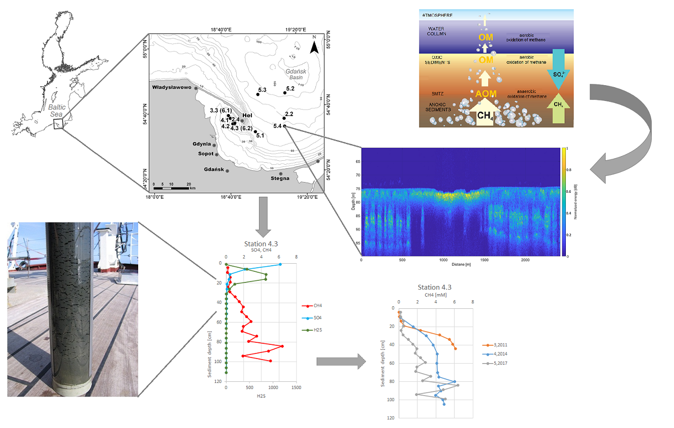
Recent Publications (minimum 5)
- Radke B., Piketh S., Wasik A., Namieśnik J., Dembska G., Bolałek J. (2013) Aspects of pollution in Gdansk and Gdynia harbours at the coastal zone of the South Baltic Sea. TransNav: International Journal on Marine Navigation and Safety of Sea Transportation, Vol. 7, no. 1, 11-18.
- Brodecka A., Majewski P., Bolałek J., Klusek Z. (2013) Geochemical and acoustic evidence for the occurrence of methane in sediments of the Polish sector of the southern Baltic Sea. Oceanologia, Vol. 55, no. 4, 951-978.
- Kiełczewska J., Burska D., Bolałek J. (2013) Occurrence of hydrogen sulfide in sediments of the Puck Bay [in]: 2nd Young Scientist Conference, World Water Day: threats, protection and management of water resources, March 21-22, 2013, Poznań, Poland: book of abstracts, 49.
- Reindl A., Bolałek J., Falkowska L. (2013) Persistent organic pollutants (POPs) in the marine food web: herrings from the southern Baltic Sea (Clupea harengus) - penguins from the zoo (Spheniscus demersus). Oceanological and Hydrobiological Studies, Vol. 42, no. 1, 51-58
- Łukawska-Matuszewska K., Kiełczewska J., Bolałek J. (2014) Factors controlling spatial distributions and relationships of carbon, nitrogen, phosphorus and sulphur in sediments of the stratified and eutrophic Gulf of Gdansk. Continental Shelf Research, Vol. 85, 168-180.
- Reindl A., Bolałek J. (2014) Methane flux from sediment into near-bottom water and its variability along the Hel Peninsula - Southern Baltic Sea. Continental Shelf Research, Vol. 74, 88-93.
- Bolałek J. (2016) Protection of the marine environment - from theory to practice, Gdańsk University, 313p.
- Reindl A., Bolałek J. (2017) Biological factor controlling methane production in surface sediment in the Polish part of the Vistula Lagoon, Oceanological and Hydrobiological Studies, Vol. 46, no. 2, 223-230.
- Reindl A., Bolałek J. (2018) Organochlorine contaminants in the Vistula Lagoon sedimentation zone as possible source of lagoon recontamination, Environmental Monitoring and Assessment, Vol. 190 (7), art no. 442, 1-8.

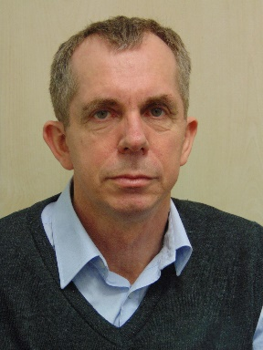 Biography (150-word limit)
Jerzy Bolałek is a full professor at the Gdańsk University and head of the Department of Marine Chemistry and Marine Environment Protection at the Faculty of Oceanography and Geography. He specializes in the field of chemical oceanography, hydrochemistry and environmental protection. The most important scientific achievements are: authorship or co-authorship of about 150 works, of which about 60 are original works published in English in international journals. He is also the author and co-author of a number of expert reports on the quality of marine waters as well as two Polish standards. He is a member of the Research Committee of the Polish Academy of Sciences and editorial committees of the Journal of Marine Science and Research (since 2016) and Oceanological and Hydrobiological Studnies. He also has extensive experience in assessing the quality of education at Polish universities.

Email: ocejb@ug.edu.pl

Notes/Comments

