Manufacturing of alkene phosphatases from marine organisms with potential functions and industrial applications
Vereshchaka AL D.Sci. Shirshov Institute of Oceanology, Moscow, Russia
Lunina AA PhD, Shirshov Institute of Oceanology, Moscow, Russia

Abstract (300-word limit)
The deep-sea ocean zone is the most voluminous and very specific part of biosphere. The composition, structure and functions of the deep-sea communities are influenced by the absence of illumination, high pressure, and low temperature. As any field data of the deep-sea zooplankton are inevitably local, we should find an indicator that is correlated with elements of the deep-sea zooplankton and that can be assessed over large water areas/volumes. We state that this is an averaged concentration of the surface chlorophyll a. The zooplankton wet biomass in the epipelagic has been shown to be correlated with surface chlorophyll concentration. It remains, however, unclear, if this dependence is valid for the deep sea below 200 m. Our studies have shown a statistically significant correlation between the biomass of the major plankton groups (non-gelatinous, gelatinous plankton, shrimps) and the averaged concentration of the surface chlorophyll a within all studied strata (0-3000 m). This correlation allows assessment of the integral standing crop of the major plankton groups at various depth strata. Preliminary results show that the main bulk of the total biomass occurs in the upper bathypelagic, between the lower boundary of the main thermocline (800-1000 m) and 1500 m, not in the epi- or the mesopelagic as was believed before. We have also discovered an unexpectedly high role of the shrimps (approximately 50 %) in deep plankton biomass. We further found robust correlations between averaged surface chlorophyll concentrations (satellite data) and shrimp biomass in separate depth zones and in the whole water column. We assessed shrimp biomass in major regions of the Atlantic, extrapolated our data on a global scale, and found that the pelagic shrimp biomass is highly underestimated and comparable to that of fishes.
Methodology and Theoretical Orientation:
In theory, the standing stock of zooplankton should remain correlated with surface productivity and the correlation should decrease with depth. No large-scale data, however, are available on this subject. Here we attempt to fill that void by examining the relationship between remotely sensed sea surface data and in situ, discrete depth sampling data across the majority of the Atlantic Ocean. Surface chlorophyll-a concentration (Chl), derived from satellite imaging, was used as a proxy of surface productivity. Chl a data were taken from Aqua MODIS (level 3, 4-km resolution) and averaged over one year preceding the sampling date and over a 5º × 5º square (with the sampling site in the center). In order to estimate the actual plankton biomass in the deep, we used a closing Bogorov-Rass (BR) plankton net: 1-m² opening, 500-μm mesh size, towed vertically at a speed of 1 m s⁻¹. This gear was proven to successfully sample both deep-sea mesozooplankton of the size range of 1–50 mm and larger shrimps.
Findings:
Depth and Chl are the main factors affecting the wet biomass of the main plankton groups. Wet biomass of all major groups was significantly correlated with Chl.
Zooplankton biomass in the upper bathypelagic domain is higher than expected.
The majority of this biomass comprises macroplanktonic shrimps, which have been historically underestimated. The shrimp wet biomass comparable to that of fishes.
Conclusion and Significance:
The global ramifications are that energy transfer efficiency from phytoplankton to intermediate and higher trophic levels in oceanic ecosystems has been underestimated, and that both zooplankton and fishes are likely respiring a large portion of the primary production in the deep-pelagic realm. Our results suggest that the contribution of the deep-ocean pelagic fauna for biogeochemical cycles maybe more important than previously thought.
Image:
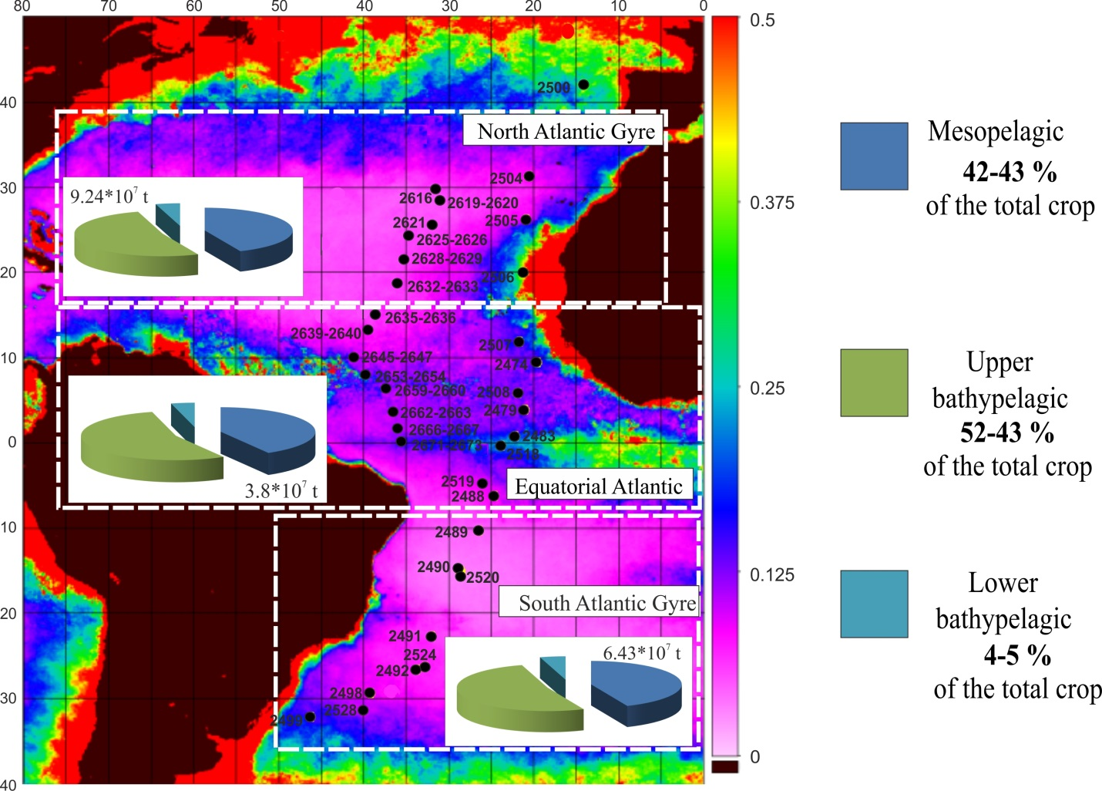

Stations (black circles) sampled, with assessed standing crop (wet biomass) of the pelagic shrimps and contributions (%) of the vertical depth strata in the North, Equatorial, and South Atlantic. Background: surface chlorophyll a concentration averaged over 2013; scale (mg m⁻²) is given on the right
Recent Publications (minimum 5)
Irigoien, X., Klevjer, T. A., Røstad, A., Martinez, U., Boyra, G., Acuña, J. L., Bode, A., Echevarria, F., Gonzalez-Gordillo, J. I., Hernandez-Leon, S., Agusti, S., Aksnes, D. L., Duarte, C. M., & S. Kaartvedt . (2014) Large mesopelagic fishes biomass and trophic efficiency in the open ocean. Nature Communications 5, doi: 10.1038/ncomms4271.
Sutton, T.T., Clark, M.R., Dunn, D.C., Halpin, P.N., Rogers, A.D., Guinotte, J., Bograd, S.J., Angel, M.V., Perez, J.A.A., Wishner, K., Haedrich, R.L., Lindsay, D.J., Drazen, J.C., Vereshchaka, A., Piatkowski, U., Morato, T., Błachowiak-Samołyk, K., Robison, B.H., Gjerde, K.M., Pierrot-Bults, A., Bernal, P., Reygondeau, G. & Heino. M. (2017) A global biogeographic classification of the mesopelagic zone. Deep Sea Research I 126, 85-102.
Vereshchaka, A., Abyzova, G., Lunina, A., & Musaeva, E. (2017) The deep-sea zooplankton of the North, Central, and South Atlantic: Biomass, abundance, diversity. Deep Sea Research Part II 137, 89-101.
Vereshchaka, A., Abyzova, G., Lunina, A., Musaeva, E., & Sutton, T. (2016) A novel approach reveals high zooplankton standing stock deep in the sea. Biogeosciences 13, 6261.
Vinogradov, M. E., Vereshchaka, A. L., Vinogradov, G. M., & Musaeva, E. I. (2000) Vertical distribution of zooplankton at the periphery of the North Atlantic subtropical gyre. Biology Bulletin-Russian Academy of Sciences 27, 417-429.
Vinogradov, M.E., Vereshchaka, A.L., Shushkina, E.A. (1996). Vertical structure of the zooplankton communities in the oligotrophic areas of the Northern Atlantic, and influence of the hydrothermal vent. Okeanologiya 36, 71-79.

 Biography (150-word limit)
A.L.Vereshchaka, born in 1965, the head of the Plankton Laboratory (Institute of Oceanology, Russian Academy of Sciences), Doctor of Biology, Prof., Member of the Russian Academy of Sciences. Principal research interests are focused at vertical distribution of the pelagic and benthopelagic fauna, deep-sea ecology (plankton and hydrothermal vents), the crustacean taxonomy, systematics, phylogeny, and biology (over 30 new species and higher taxa described).
Email: alv@ocean.ru

Notes/Comments

