Sea surface as a source for bioaerosols in the coastal zone of the southern Baltic Sea
Anita U. Lewandowska, Prof., Institute of Oceanography, University of Gdansk, Poland
Sylwia Śliwińska-Wilczewska, PhD, Institute of Oceanography, University of Gdansk, Poland
Kinga Wiśniewska, Institute of Oceanography, University of Gdansk, Poland
Dominika Woźniczka, Institute of Oceanography, University of Gdansk, Poland

Abstract (300-word limit)
Since oceans cover a significant portion of the earth's surface, they play a crucial role in microorganism emission to the atmosphere. While cyanobacteria and algae living in sea water are well recognised, those that are the components of aerosols are rarely the focus of scientific research, especially in the Baltic Sea region. However as biological components of aerosols they can penetrate into the human organism via the respiratory system and impact human health. That’s why the aim of this study was to determine whether among the identified microalgae and cyanobacteria there were any capable of posing a potential threat to human.
Bioaerosols were collected using six-step microbiological pollutant sampler in the period between April and November 2015 on land (Gdynia) and at sea (Southwestern Baltic). Obtained results establish that diversity of the microorganisms identified in bioaerosols grew with the increase in primary production and phytoplankton concentration in sea. Picoplanktonic cyanobacteria of the genus Synechococcus, Synechocystis, Aphanocapsa, Aphanothece, Microcystis, Merismopedia, Woronichinia and Cyanodictyon were the most commonly found in aerosols. Chlorophyta were also numerous (Chlorella vulgaris, Stichococcus bacillaris), as were Bacillariophyta and Ochrophyta (Phaeodactylum sp., Navicula cf. perminuta and Nannochloropsis cf. gaditana). Over the sea cyanobacteria and microalgae were mainly the components of large aerosols (>3.3 μm). Over the coastal zone of the southern Baltic Sea they occurred more often in smaller particles. Species capable of producing harmful secondary metabolites as well as potentially toxic ones were identified in smallest particles, which can enter respiratory system. We assume that bioaerosols pose the actual threat to human health in Baltic Sea region.
Methodology and Theoretical Orientation: Aerosol studies were conducted in cycles ranging from 30 minutes (June, sea stations) to 1.5 hours (land station), from April to November 2015 on land (Gdynia) and at sea (Gulf of Gdansk, Southwestern Baltic) (Fig. 1, Table 1). In Gdynia, measurements were performed on the roof of the Institute of Oceanography, where the atmospheric chemistry coastal station together with the meteorological station have existed for several years. Sea stations were located along the Polish sea coast. Station 1 was located the closest to the sea shore, in the internal water of the Puck Bay. All samples were collected using a six-step microbiological pollutant particle sampler by Tisch Environmental, Inc. The air was aspirated by a vacuum pump characterised by constant air flow of 28.3 l·min⁻¹. Each of the impactor nozzles directed the exhaust air onto a Petri dish covered with agar (27 ml of the liquid standard sterile mineral f/2 culture medium, on the basis of sea water with a salinity of 8 PSU), collecting particles of various sizes depending on the impactor cascade (1. >7μm; 2. 4.7 – 7 μm; 3. 3.3 – 4.7 μm; 4. 2.1 – 3.3 μm; 5. 1.1 – 2.1 μm and 6. < 1.1 μm in diameter). Analysed samples were grown for 30 days under constant conditions of 20°C, on a 16:8 h light:dark cycle at 10 μmol photons·m⁻²·s⁻¹. The intensity of PAR was measured using a quantum-meter (LI-189, LI-COR Inc., Nebraska, USA) with a cosine collector. The taxonomic composition and number of identified taxa were analysed under a Nikon eclipse 80i microscope at a magnification of 1000x (objective = 100x). In addition, in order to verify the studied material, an epifluorescence microscope (Nikon Eclipse 80i) with green excitation/ block filter (EX 510-560, DM 575, BA 590, 6-2A) was used. The latter proves chlorophyll a content in identified taxa and in turn the ability to photosynthesis process conduction. Phytoplankton organisms were identified to the species level or, if this was impossible, assigned only to a genus. Taxa were identified using keys and world literature.
Findings: It was found that cyanobacteria and microalgae, having been identified both in the atmosphere over the sea and over land during the entire study period, are omnipresent microbiological air pollutants. Some of them had been transported from remote areas, such as Gloeothece sp. - a species not typical for the Southern Baltic Sea.
Conclusion and Significance: The higher the primary production in sea water and the concentration of phytoplankton in it, the greater the diversity in terms of the microorganisms observed in the collected bioaerosol samples. Other important factors were: water temperature, accessibility of light and the amount of available phosphorus and nitrogen in the surface water. In the atmosphere over land, microorganisms dominated in aerosol particles of smaller dimensions (<3.3 µm in diameter). Over the sea, there was a reverse situation. That resulted from the fact that smaller aerosols could be better distributed over long distances. Among the identified microorganisms were species which pose a threat to human health and life: Synechocystis sp., Synechococcus sp., Microcystis sp. and C. vulgaris. Seeing as in the surrounding air, part of the everyday environment of the human habitat, those species were incorporated into small, respirable particles, it is necessary to conduct further research. Only in this way will it be possible to gauge the risk related to bioaerosols in terms of their influence on human health. Future characterisations should focus on the role of microalgae and cyanobacteria present in the air in the transportation of radionuclides, heavy metals, pesticides and herbicides, as well as carcinogenic and mutagenic substances, into living organisms including humans.

Image:
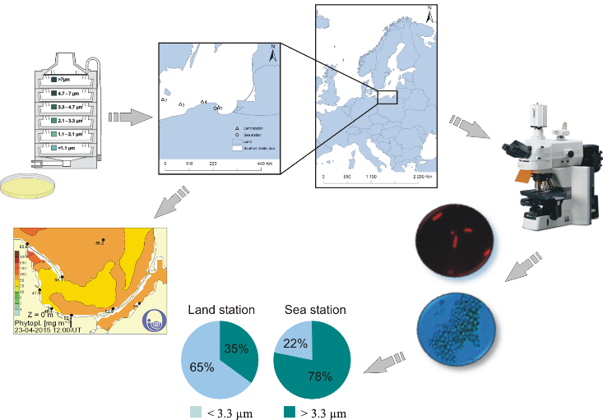
Recent Publications
1. Falkowska L., A.R. Reindl, E. Szumiło, J. Kwaśniak, M. Staniszewska, M. Bełdowska, A. Lewandowska, I. Krause, 2013. Mercury and chlorinated pesticides on the highest level of the food web in the Southern Baltic as exemplified by herring from the Southern Baltic and African penguins from the zoo. Water Air and Soil Pollution 224, 15-49.
2. Falkowska L., A. Witkowska, M. Bełdowska, A. Lewandowska, 2013. Waste disposal sites as sources of mercury to the atmosphere in the coastal zone of the Gulf of Gdańsk (southern Baltic Sea). Oceanological and Hydrological Studies 42(1), 99-109.
3. Lewandowska A.U., L. Falkowska, 2013. High concentration episodes of PM10 in the air over the urbanized coastal zone of the Baltic Sea (Gdynia - Poland). Atmospheric Research 120–121, 55-67.
4. Lewandowska A., L., Falkowska, J. Jóźwik, 2013. Factors determining the fluctuation of fluoride concentrations in PM10 aerosols in the urbanized coastal area of the Baltic Sea (Gdynia, Poland). Environmental Science and Pollution Research 20, 6109–6118.
5. Lewandowska A., L., Falkowska, 2013. Sea salt in aerosols over the Southern Baltic. Part 1. The generation and transportation of marigenic particles. Oceanologia 55(2), 279-298.
6. Lewandowska A., L. Falkowska, 2013. Sea salt in aerosols over the Southern Baltic. Part 2. The neutralizing properties of sea salt and ammonia. Oceanologia 55(2), 299-318.
7. Witkowska A., A.U. Lewandowska, D. Saniewska, L.M. Falkowska, 2016. Effect of agriculture and vegetation on carbonaceous aerosol concentrations (PM2.5 and PM10) in Puszcza Borecka National Nature Reserve (Poland). Air Quality, Atmosphere and Health 9(7), 761–773.
8. Witkowska A., A. Lewandowska, L.M. Falkowska, 2016. Parallel measurements of organic and elemental carbon dry (PM1, PM2.5) and wet (rain, snow, mixed) deposition into the Baltic Sea. Marine Pollution Bulletin 104, 303–312.
9. Falkowska L., A. Reindl, A. Grajewska, A.U. Lewandowska, 2016. Organochlorine contaminants in the muscle, liver and brain of seabirds (Larus) from the coastal area of the Southern Baltic. Ecotoxicology and Environmental Safety 133, 63–72.
10. A. Witkowska, A.U. Lewandowska, 2016. Water soluble organic carbon in aerosols (PM1, PM2.5, PM10) and various precipitation forms (rain, snow, mixed) over the southern Baltic Sea station. Science of the Total Environment 573, 337–346.
11. Wiśniewska K., A.U. Lewandowska, A. Witkowska, 2017, Factors determining dry deposition of total mercury and organic carbon in house dust of residents of the Tri-city and the surrounding area (Baltic Sea coast), Air Qual Atmos Health, 10, 821–832.
12. Lewandowska A.U., S. Śliwińska-Wilczewska, D. Woźniczka, 2017, Identification of cyanobacteria and microalgae in aerosols of various sizes in the air over the Southern Baltic Sea, Marine Pollution Bulletin, 125, 30-38.
13. Lewandowska A.U., M. Bełdowska, A. Witkowska, L. Falkowska, K. Wiśniewska, 2018, Mercury bonds with carbon (OC and EC) in small aerosols (PM1) in the urbanized coastal zone of the Gulf of Gdansk (southern Baltic), Ecotoxicology and Environmental Safety, 157, 350-357, DOI: 10.1016/j.ecoenv.2018.03.097
14. Lewandowska A.U., M. Staniszewska, A. Witkowska, M. Machuta, L. Falkowska, 2018, Benzo(a)pyrene parallel measurements in PM1 and PM2.5 in the coastal zone of the Gulf of Gdansk (Baltic Sea) in the heating and non-heating seasons, Environmental Science and Pollution Research, DOI: 10.1007/s11356-018-2089-9.

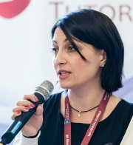 Biography
Anita Lewandowska is Associated Professor in the Marine Chemistry and Environment Protection Department, Faculty of Oceanography and Geography, the University of Gdansk. Her primary research interests are in the field of atmospheric chemistry and oceanography with the special focus on processes of aerosol and gases exchange between the sea and the atmosphere under the influence of abiotic and biotic factors in the coastal regions of the sea. She is interested mainly in issues related to the Baltic Sea and Antarctica. Anita Lewandowska is a member of the Sea Research Committee of the Polish Academy of Sciences. She is author and co-author of dozens of scientific publications in the field of atmospheric chemistry and co-author of the book Aerosols and Gases in Earth's Atmosphere - Global Changes and a Practical Guide for Students Aerosols and Gases.

Email:
a.lewandowska@ug.edu.pl

