Red seaweeds effectiveness against dengue vector mosquito, Aedesaegypti (L) and its chemical constituents’ analysis
Rabia Bibi, M.Phil.MarineBiology,UOK,Pakistan
Munawwer Rasheed, PhD, Marine Biology,UOK,Pakistan
Muhammad Tariq RajputPhD, Zoology Department. UOK, Pakistan

Marine flora produce a rich source of secondary metabolites that are biologically active against predators, pests and pathogens. Wide range of chemically interesting and novel compounds has been explored from the red seaweeds. The Pakistan coast at the northern boundary of Arabian Sea is enriched with a variety of red seaweeds. Although, the exploration of these bioactive compounds has been done to the limited extent. Therefore, in the present study, a particular attempt has been made to assess the toxicological effects of seaweeds against the dengue vector mosquito, Aedes aegypti (L). Dengue is the most prevalent vector-borne viral disease and has affected nearly half of the world population. Its adult is also the primary carrier of Chikungunya, and Zika virus. Application of synthetic pesticides on the insect pest and disease vector resulted in negative environments and hazardous health impact. To elevate this problem, the current approach is to utilize the marine derived natural product. In this experimental work, four species of red seaweeds [L. obtusa, G. folifera, J. rubens, A. taxiformis] were collected from the Karachi coast and soxhlet extracted with hexane, chloroform and methanol. The efficiency of red seaweeds extracts against Ae. aegypti [larval, pupal and adult] stages were determined by using dose-response bioassay method. The comparative study showed that the hexane extracts possess toxic larvicidal effects against the Ae. aegypti 4th instar larvae. Based on the LC₅₀ value, J. ruben hexane extracts exhibited the potent toxic effect [LC₅₀ = 32 ppm] after 24 h of treatment.Study proven, constituents having a toxic effect against mosquito larvae are lipophilic and halogenated compounds. The active fraction was subjected to chromatography techniques to determine the bioactive compounds involved in the larvicidal activity so that it could be projected as a weapon for the control of mosquito populations
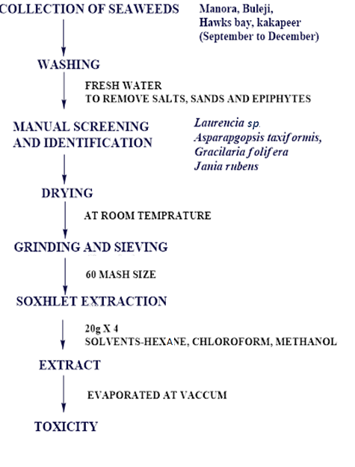

Publication:
- Siddiqui BS, Rasheed M, Faizi S, Ali ST, Tariq RM, Naqvi SN. Transformation of Azadiradione to Nimbocinol and 17β‐Hydroxynimbocinol, and Structure Pesticidal‐Activity Relationship of Triterpenoids isolated from Azadirachta indica A. Juss.(Neem). Helvetica chimica acta. 2003 Oct 1;86(10):3342-53.

- Kabir KE., Choudhary MA, Ahmed S, & Tariq R M(2013). Growth-disrupting, larvicidal and neurobehavioral toxicity effects of seed extract of Seseli diffusum against Aedes aegypti (L.)(Diptera: Culicidae). Ecotoxicology and environmental safety, 90, 52-60.

- Bibi R (2015). Insecticidal activity of red seaweeds against pests. March 2015, 35th Pakistan Congress of Zoology (Internationa

- lKhan A, Uddin N, Khaliq S, Nawaz S, Rasheed M, Dar A, Hanif M, Siddiqui PJ. Brown seaweeds administration generate psychotherapeutic response associated with brain norepinephrine modulation in rats. Journal of Pharmacognosy and Phytotherapy. 2017 Jan 31;9(1):11-8.

- Qasim M, Abideen Z, Adnan MY, Gulzar S, Gul B, Rasheed M, Khan MA. Antioxidant properties, phenolic composition, bioactive compounds and nutritive value of medicinal halophytes commonly used as herbal teas. South African Journal of Botany. 2017 May 31;110:240-50.

Biography (150-word limit)
Rabia Bibi is a PhD student at the center of excellence in marine biology, university of Karachi, Karachi Pakistan. She has her expertise in Marine chemistry, toxicology, biodiversity. She was an organizer of the 35th zoology conference held in Pakistan Besides, she has studied the ecology and biodiversity of marine seaweeds along the Arabian coast with detailed taxonomy and parameter analysis. She also has two years experience in the establishment of mosquito colonies under the laboratory condition. She has also been working as data analyzer in different statical software.

Email: rabiacemb@gmail.com

