Molluscs community associated with marine algae along the rocky shore of Karachi, Pakistan (Northern Arabian Sea)
Saedul bibi M.Phil/PhD, Centre of Excellence in Marine Biology, University of Karachi, Pakistan
Pirzdada J.A.Siddiqui, PhD, Centre of Excellence in Marine Biology, University of Karachi, Pakistan
Seema Shafique, PhD, Centre of Excellence in Marine Biology, University of Karachi, Pakistan
Zaib-Un-Nisa Burhan, PhD, Centre of Excellence in Marine Biology, University of Karachi, Pakistan

Marine algae are considered as primary producers in aquatic ecosystem and contribute a significant role in the food web. They provide a habitat and food to diverse communities and protect them from wave exposure, desiccation and predators. Algae also attract several marine organisms due to their sufficient value of nutrients. Among them mollscs are the most abundant organisms present in the tidal and sub-tidal zone. They are highly visible and commercially important group use as a food and non-food resources on the world global scale. The present study was designed to assess mollusc community associated with seaweed (Cystoseira spp., Sargassum spp., Padina spp.) at the rocky shore of Buleji and Hawks bay from November 2015 to February 2016 respectively. Five replicates in each month were taken from quadrate (25x25cm) during low tide and associated mollusc was carefully sorted and preserved in 70-75% ethanol. The specimens were identified under the stereo-microscope on the basis of the external morphology of shell shape and size. A total of 3658 mollusc specimens were observed showing that Sargassum spp., support more diversity of gastropods as compare to other seaweeds whereas bivalve shows high density in the dense bed of Cystoseira spp. During the study period different environmental variables were considered such as temperature, DO, salinity, pH, and chlorophyll a ranged between 17.5-24.6ºC, 5.98-12.31 mg/L, 40-45‰, 8.44-9.16 and 4.54-33.73 ug/L, respectively. Mollusc algal fauna could be varied due to different algal morphology, environmental parameter and/or either influence by anthropogenic influence. This is the preliminary work and needs more detail study is required to understand the relation between diversity and distribution of molluscs with seaweed and correlate with the environmental parameter.
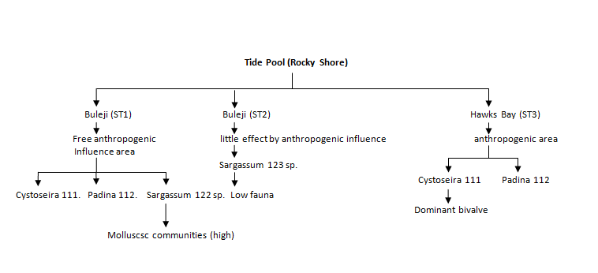

Recent Publications:
Ali, Amjad, Pirzada Jamal A. Siddiqui, and K. Aisha. "Characterization of macroalgal communities in the coastal waters of Sindh (Pakistan), a region under the influence of reversal monsoons." Regional Studies in Marine Science(2017).
Amir, Shabir Ali, Pirzada Jamal A. Siddiqui, and Rafaqat Masroor. "Finfish diversity and seasonal abundance in the largest arid mangrove forest of the Indus Delta, Northern Arabian Sea." Marine Biodiversity (2016): 1-12.
Khokhar, Farah Naz, Z. N. Burhan, Pervaiz Iqbal, Javed Abbasi, and PIRZADA JAMAL AHMED Siddiqui. "Distribution and abundance of diatom species from coastal waters of Karachi, Pakistan." Pak. J. Bot 48, no. 2 (2016): 799-811.
Ali, Amjad, Pirzada Jamal A. Siddiqui, Kate Bromfield, Athar Ali Khan, and Pervaiz Iqbal. "Quaternary fossil coral communities in uplifted strata along the Balochistan coast of Pakistan: understanding modern coral decline in the Arabian Sea." Arabian Journal of Geosciences 10, no. 23 (2017): 520.
Siddiqui, Pirzada JA, Sumera Farooq, Seema Shafique, and Zafar Farooqi. "Conservation and management of biodiversity in Pakistan through the establishment of marine protected areas." Ocean & Coastal Management 51, no. 5 (2008): 377-382.

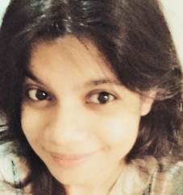 Biography:
Saedul bibi graduated with a Master degree in Marine Zoology from the University of Karachi, Pakistan. She continued to obtain her PhD in Marine biology from Center of excellence University of Karachi. Her research experience is based on the coastal beach surveys including qualitative as well as quantitative analysis, laboratory techniques and methodologies. In addition to the research field Saedul has been heavily involved in research assessment of faunal communities, biodiversity as well as distribution along the coastal beaches of Pakistani water.

Email:
Saedulku@yahoo.com; Saedulbukhari@gmail.com

