Development of portable high-mobility ROV for inspection of underwater structure

Dr.Ikuo Yamamoto, Professor, Nagasaki University, Japan

Abstract (300-word limit)
Underwater structures, such as renewable energy, port, dam are required to inspect cracks and damages periodically. The author developed portable high-mobility ROV (Remotely Operated Vehicle) for inspection and successfully tested in the sea and in the deep dam. The ROV has features of small scale, stable, light weight. Also, it has underwater compact camera, LED light, tether cable, GPS in the body, and base monitor & operation station in the small case. In addition, small tidal velocity sensor is euipped for sensing current speed and used for its feedforward control. The ROV won the best ROV in Techno-ocean world competetion of underwater robotics in 2012 and Okinawa offshore robotics contest in 2014, 2015, and 2016.
Methodology and Theoretical Orientation: The frame of ROV is first designed by CAD to be a structure based on the principal of upper float and lower weight, which provides a well-balanced body. The ROV is controlled by thrusters and a micro computer is utilized as a controller. The size of ROV is small, which specifications are length 60cm, width 40cm, height 20cm, weight 6kg. The depth of cruising is 100m. The frame is made of an inpact-resitant polyvinyl chloride pipe.
Findings: The ROV is designed to be light (portable) and high maneuverbility (stable and quick response of moving) in the sea. The cruising tests have been successfully conducted in the sea.
Conclusion and Significance: The ROV can cruise in strong tidal current condition (2.0 m/s) and record moving precise target and 2D barcode in the sea.
Image:
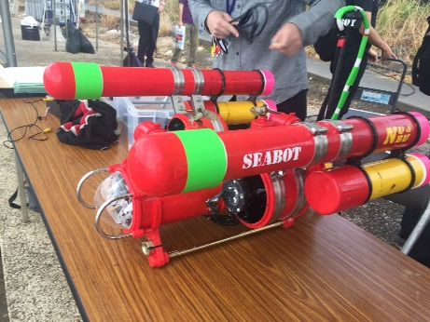
Recent Publications (minimum 5)
- Ikuo Yamamoto, Development of High-Mobility Unmanned Remotely Operated Underwater Vehicle, Proc.BIT’s 6th Annual World Congress of Ocean-2017,Shenzhen,China,Session 5 Advanced Offshore and Underwater Technology,pp.066,2017
- Ikuo Yamamoto, Development of Bio-inspired Robotic Fish Technology for the Next Generation Machinery,Proceedings of BIT’s 3rd Annual World Congress of Smart Materials-2017,Bankok,Tailand ,pp.281,2017
- Masahiko Mizui,Ikuo Yamamoto,Shunsuke Kimura,Masato Maeda, Research on Hammering Test System by Unmanned Aerial Vehicles for Infrastructure Serveillance,Proc.ISER,Aerial Robots 1,No.3,pp1-10,2016
- Ikuo Yamamoto, Robotic Fish Development for the Next Generation Underwater Vehicle,Proc.CIMTEC 2016,Special Session O-9/P-5,BIOMIMETIC AND MOTION CONTROL IN AUTONOMOUS AND REMOTELY OPERATED UNDERWATER VEHILCES,pp.1-8,2016
5. Ikuo Yamamoto, Practical Robotics and Mechatronics: Marine, Space and Medical Applications,IET(The Institution of Enginnering and Technology,UK,ISBN 978-1-84919-968-1,pp.1-192

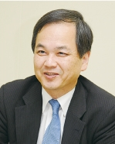 Biography (150-word limit)
Ikuo Yamamoto is a Professor of Nagasaki University, Japanand has developed many world-class practical examples of robotics and mechatronics during his 30 years of experience as an engineer and a professor. His experience comprises of working with Mitsubishi Heavy Industries Ltd. , JAMSTEC , and as Professor at Kyushu, Kitakyushu, and Nagasaki University .He was leader of AUV “Urashima”, which established the world record for autonomous cruising; developed “Kaiko&Seabot”, which was crowned champion remotely operated vehicle at 10000m depth cruising and at the World convention 2012,2014,2016 and his robotic fish ‘swam’ in the International Space Station in 2009.He firstly sucessfully flied multi-rotor flight robotics with real-time monitoring and environmental sensor systems in Japan,2008.
International Awards for developing medical robotics in 2014 and 2015.He is nominated as GlobalScot,Scotland Government,UK in 2017.
Most of the robotics and mechatronics developed continue to be used safely in real-world environments.
Email: iyamamoto@nagasaki-u.ac.jp

Notes/Comme

