Semiconductor oxide nanoparticles enhanced luminescence of lanthanide-codoped silica glasses
Ping Chen, doctoral candidate, Huazhong University of Science and Technology, China
Nengli Dai, PhD, Huazhong University of Science and Technology, China
Shaodong Hou, doctoral candidate, Huazhong University of Science and Technology, China

Abstract
Lanthanide-codoped silica glasses have drawn extensive attention because of their great applications in solar cells, lighting, and biomedical imaging. However, they still cannot satisfy the requirement of various practical applications caused by the relatively low upconversion efficiency, the saturation effect, the temperature quenching phenomenon, the concentration quenching, and rather narrow excitation band. Development of novel methods and mechanisms to enhance their emission has been a pursuit of researchers in recent years. In this work, we developed an in situ synthetic method using mesoporous silica glasses to form highly monodisperse semiconductor oxide nanoparticles (NPs) such as In₂O₃, SnO₂, and ITO NPs in lanthanide-codoped silica glasses, firstly. The energy transfer from semiconductor oxide nanoparticles to lanthanide ions has significantly enhanced the luminescence of silica glasses. In Er³⁺/Yb³⁺-codopoed silica glasses, the formation of In₂O₃, SnO₂, and ITO NPs yielded increases in the upconversion emission intensities by 5.9, 5.7, and even 42.2 times at 651 nm, respectively. In Eu³⁺-codoped silica glasses, the introduce of SnO₂ ITO NPs greatly enhanced the orange emission and sharp emission peaks centered at 588, 593, and 598 nm which correspond to the ⁵D₀-⁷F₁ transitions of Eu³⁺ appeared. While in the sample without SnO₂ ITO NPs, only two broad peaks centered at 574, and 620 nm were detected. These results indicate that semiconductor oxide NPs can also tune the luminescence of lanthanide-doped silica glasses. And we conclude that the energy transfer from semiconductor oxide NPs arises from the excess free carriers associated with vacancies or dopant impurities in the crystal lattice. Our work has provided an original way to synthesize NPs in glasses and improve the luminescence which can be used to greatly extend the applications of semiconductor oxides in optoelectronics in an efficient and straightforward way.

Image
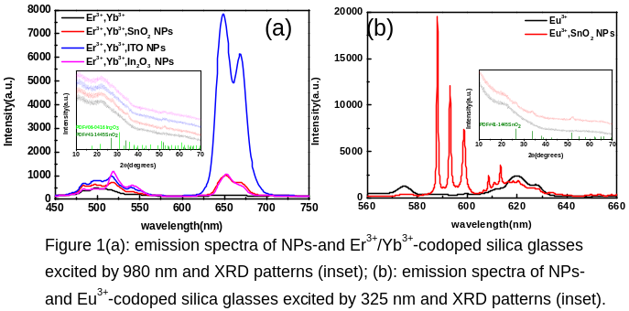
Recent Publications
- Chen P, Hou S, Yang Y, Chen Z, Yang L, Li J, et al (2018) ITO nanoparticles enhanced upconversion luminescence in Er ³⁺/Yb ³⁺-codoped silica glasses. Nanoscale 10:3299-306.
- Pramata AD, Suematsu K, Quitain AT, Sasaki M, Kida T (2018) Synthesis of Highly Luminescent SnO₂ Nanocrystals: Analysis of their Defect-Related Photoluminescence Using Polyoxometalates as Quenchers. Advanced Functional Materials 28(4):1704620.
- Wu J, Cao B, Rino L, Fang Y, Hu L, Zhang Z, et al (2018) Strong up-conversion luminescence of rare-earth doped oxide films enhanced by gap modes on ZnO nanowires. Nanoscale 10(2):726-32.
- Zhang XW, Lin T, Zhang P, Song HC, Jin H, Xu J, et al (2018) Tunable quantum dot arrays as efficient sensitizers for enhanced near-infrared electroluminescence of erbium ions. Nanoscale 10(8):4138-46.
- Zhou J, Wen S, Liao J, Clarke C, Tawfik SA, Ren W, et al (2018) Activation of the surface dark-layer to enhance upconversion in a thermal field. Nature Photonics 12(3):154-8.

Biography
Ping Chen is a doctoral candidate at Huazhong University of Science and Technology, majoring in nanoparticle optics. Her latest article has been published in Nanoscale named “ITO nanoparticles enhanced upconversion luminescence in Er 3+/Yb 3+-codoped silica glasses”.
Email: d201577579@hust.edu.cn

Notes/Comments:

