Numerical simulations of the optical gain of crystalline fiber doped by rare earth and transition ion
A. K. Daoui, B. Boubir
Research Unit in Advanced Materials (URMA) ANNABA, Research Center in industrial technologies CRTI, ex – CSC, ALGERIA
E-mail: daouiabdelkader@yahoo.fr

Abstract
A fiber laser is a laser whose gain medium is a doped fiber, although lasers whose cavity is made wholly of fibers have also been called fiber lasers. The gain media in a fiber laser is usually fiber doped with rare-earth ions, such as erbium (Er), neodymium (Nd), ytterbium (Yb), thulium (Tm), or praseodymium (Pr), which is doped into the core of the optical fiber, similar to those used to transmit telecommunications signals. Fiber lasers find many applications in materials processing, including cutting, welding, drilling, and marking metal. To maximize their market penetration, it is necessary to increase their output power. In this work, we present a detailed study based on the numerical simulation using MATLAB, of one of the principal characteristics of a fiber laser doped with rare earth ions and transition ion. The gain depends on several parameters such as the length of the doped fiber, the density, the pump power, noise, etc.). The used program resolves the state equations in this context together with those governing the light propagation phenomena. The developed code can also be used to study the dynamic operating modes of a doped fiber laser.
Keywords: Optical gain, fiber laser, fiber doped, optical amplifiers, rare earth.
1. Optical gains for crystalline fibers of 500 microns in diameter:
As a first step, we calculated the gain for different crystal fibers doped Chrome Cr3+ and Nd3+ of 500 microns in diameter by acting on the different lengths of crystalline fibers (figure 1).
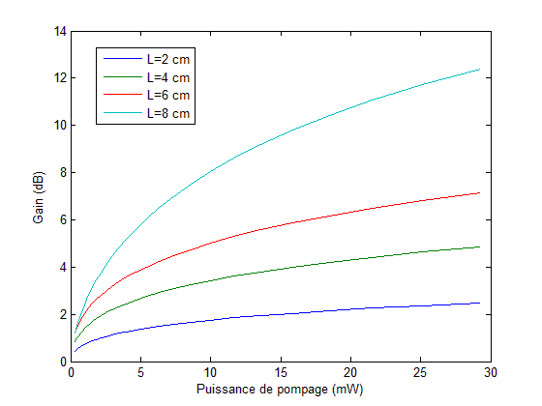
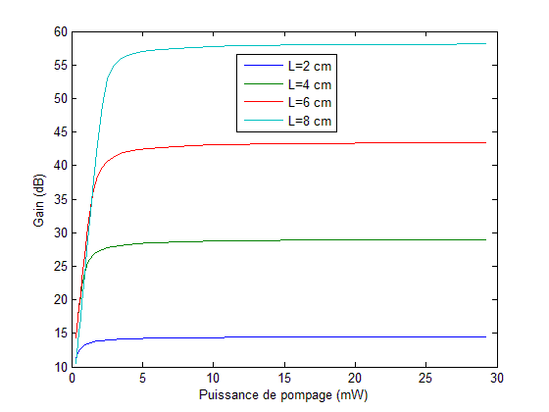
(b)
(a)

Figure 1: Evolution of the optical gain as a function of absorbed pump power by different crystal fiber of 500 microns in diameter: a) Cr3+: YAG, b) Nd3+: YAG.

The above figures show the optical gain of these fibers where it is clear that when the fiber is longer, the gain becomes more important.
The evolution curve of the simulated gain as a function of the pumping power in a fiber of 8 cm is illustrated in figure 1, a very important gain for both dopant ions. We enjoy very high gains in the crystal fiber with good emission cross section of Cr3+ and Nd3+ at 809 nm and 1064 nm, respectively. The figure 1.a demonstrate that when the pump power increases the gain increases against in figure 1.b it is seen that for low values of the pump power is obtained a very importantly gain.

2. Optical gains for crystalline fibers of 400 microns in diameter:

The second part of this work is to simulate crystalline fibers doped YAG Cr3+ and Nd3+ of different lengths(figure 2), these curves show that the optical gain depends on the parameters of the geometry of the fiber such that the length of the fiber.

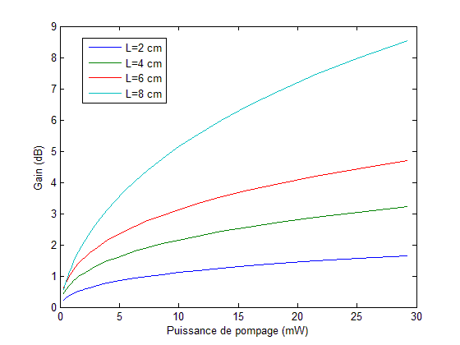
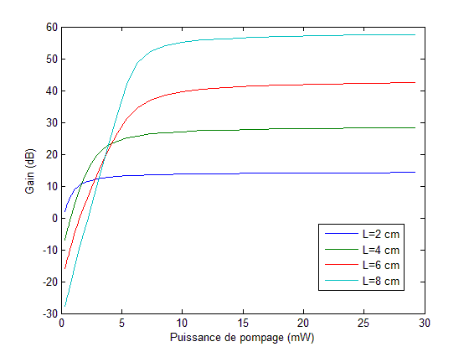
(b)
(a)

Figure 2: Evolution of gain as a function of absorbed pump power by different crystal fiber of 400 microns in diameter: a) Cr3+: YAG, b) Nd3+: YAG.

For a fiber Cr3+: YAG of the length of 8cm, the optical gain is the order of 55 dB for a pump power of 10 mW (figure 2.a) which means that for low pumping, we get a very high gain, by against for a fiber Nd3+: YAG of the same length, the gain increases as the pump power increases (figure 2.b). For two figures, it is found that the length of the crystal fiber is a very important parameter for high gains.
We have shown that the diameter of the fiber is a very important parameter for important gains, taking the figure 1.a which gives a gain for low pumping which is the same case in figure 2.a, here we shows that the evolution of the gain increases for low pumping in these two cases.

Conclusion:
Our work shows clearly a study based on the numerical simulation using MATLAB, the used program resolves the state equations in this context together with those governing the light propagation phenomena. These optical gains are highly promising for the realization of lasers and crystalline fiber amplifiers YAG doped Cr3+ and Nd3+, even if these calculations are theoretical and must be confronted to the experience. The calculations of optical gains also showed us the strong potential of YAG crystal fibers, particularly for use in amplifier. The important gains for our YAG crystalline fiber allows us to easily obtain the laser effect, which is then carefully optimized by playing on all various parameters.

REFERENCES
- M. A. Noginov, V. G. Ostroumov, I. A. Shcherbakov, V. A. Smimov, and D. A. Zubenko, "Interaction of excited Cr3+ ions in laser crystals" OSA Proceedings on Advanced Solid State Lasers, H. P. Jensen and G. Dube, eds, vol. 10, pp. 21-24, Washington, DC: Optical Society of America, (1991).
- K. Y. Huang "Growth system improvement and characterization of chromium-doped YAG crystal Fiber" National Sun Yat-sen University (2008).


Biography
Daoui Abdel Kader is a Researcher in Research Unit in Advanced Materials (URMA) ANNABA, ALGERIA. Research Center in industrial technologies CRTI, ex – CSC, ALGERIA. I have a Diploma of Higher Studies in Physics (DES Physique 2005). I obtained my Magister Degree in Radiation Physics (2009) And Finally, I got my Doctorate Degree in Physics, nonlinear optics (2016) from Badji Mokhtar university. My topics are : Fiber Laser, nonlinear optics, exact solution of non linear equations, Optics and Photonics, ..so on.

Email:daouiabdelkader@yahoo.fr

