CEUS deriving parameters as new predictor of AVF stenosis recurrence post-PTA

Dr Taurisano Marco, Nephrology department, ospedale “Di Venere” Bari, Puglia, Italia.
Dr Mancini Andrea, Nephrology department, ospedale “Di Venere” Bari, Puglia, Italia.

Abstract

Background: Stenosis represents the main cause of hemodialysis fistula malfunction. The ultrasound-guided angioplasty with ecographic contrast (CEUS) could provide further advantages to the classical ultrasound guided method improving the morphological characterization of the stenosis and providing quantitative data with the creation of time intensity curves (TIC) collecting functional data comparable between pre and post procedure.

Methods: A total of 21 CEUS-guided angioplasties were performed on malfunctioning fistulas. Were collected data for 6 months follow-up with evidence of 3 stenosis recurrence. Primary patency was 85.7%. Were generated TIC curves, obtained by positioning a ROI in correspondence with the post-stenotic tract of the efferent vein. The data collected, regarding the peak intensity reached by the signal (PI) and the time to reach the peak signal intensity (TTP), were evaluated in the pre and post-procedural phase in two different group: with (Group A) and without (Group B) recurrence of stenosis. Were evaluated the increase of flow (Qa%), the reduction of TTP (TTP%) and the increase of PI (PI%) regardless pre and post-procedural phases and compared in both groups.

Results: Statistically significant differences (p<0.05) was observed between Group A and Group B in Qa% (165 % vs 132 %) in TTP% (23.1% vs 60.6%) and in PI% (5.9% vs 8.5%).

Conclusion: The collected data showed an unexpected post procedural increase of flow (Qa%) more in group A (recurrence of stenosis) then in group B (not recurrence of stenosis). Instead new parameters derived from quantitative CEUS analysis showed that PI increased less and TTP decreased less in group A than in group B respectively. Quantitative data deriving from the CEUS analysis provide new parameters for evaluating the success of the procedure, which could also be used as predictive markers of stenosis recurrence maybe better then classical one.

Image
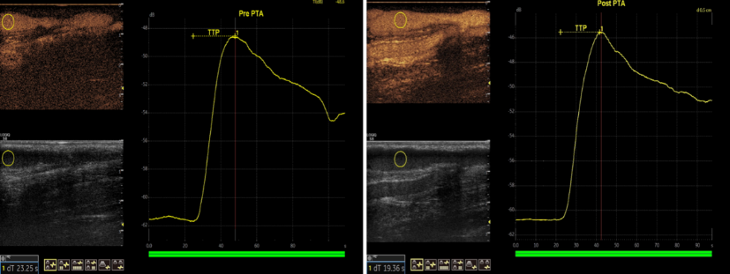
Figure 1Quantitative assay: Region of interest during post-production analysis with calculation of TTP and PI in pre e post PTA time.
Recent Publications
- Taurisano M, Mancini A, D'elia F. CEUS-guided PTA on stenotic AVF: Morphological and functional point of view. J Vasc Access. 2022 Oct 10:11297298221126289.
- Dixa B Thakrar, Muhammad Junaid Sultan. The Role of Contrast-Enhanced Ultrasound in Managing Vascular Pathologies. J Med Imaging RadiatSci 2019 Dec; 50(4):590-595.
- Mario Meola, Antonio Marciello, Gianfranco Di Salle, Ilaria Petrucci. Ultrasound evaluation of access complications: Thrombosis, aneurysms, pseudoaneurysms and infections. J Vasc Access. 2021 Nov; 22(1_suppl):71-83.
- Marco T, Andrea M, Filomena D. Percutaneous ecoguided endovascular lithotripsy to recruit failed-to-mature arteriovenous fistula due to completely calcified radial artery. J Vasc Access. 2023 Jan 4:11297298221147600.
5. Mancini A, Taurisano M, D'elia F. Sonographic artifacts in nephrology. G Ital Nefrol. 2022 Aug 29; 39(4):2022-vol4. Italian. PMID: 36073328.

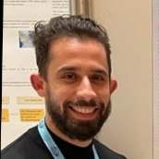
Biography
Dr. Taurisano has acquired experience in the field of vascular access, starting from emergency access to the preparation of arteriovenous fistulas. As he acquired proficiency in ultrasound he expanded his expertise with endovascular procedures on malfunctioning AVFs. Performs ultrasound and x-ray guided angioplasty, with ultrasound contrast medium. He has several publications in both national and international journals.
Email: taurisanomarco@tiscali.it

